National College of Ireland

HDip Sc in Computing

2023/2024

Sérgio Vinício da Silva Oliveira

x23170981

x23170981@student.ncirl.ie

AluControl

Technical Report



**Table of Contents**

Executive Summary 3

1 Introduction 3

1.1 Background 3

1.2 Aims 3

1.3 Technologies 3

1.4 Structure 3

2 System 3

2.1 Requirements 3

2.1.1 Functional requirements 3

2.1.2 Data requirements 3

2.1.3 User requirements 3

2.1.4 Environmental requirements 3

2.1.5 Usability requirements 3

2.2 Design and Architecture 3

2.3 Implementation 3

2.4 Testing 3

2.5 Graphical User Interface (GUI) Layout 3

2.6 Customer testing 3

2.7 Evaluation 3

3 Conclusions 3

4 Further development or research 3

5 References 3

6 Appendix 3

6.1 Project Proposal 3

6.2 Project Plan 3

6.3 Requirement Specification 3

6.4 Monthly Journal 3

6.5 Other Material Used 3

# Executive Summary

Maximum 300 words. The abstract should mention the problem being addressed, describe the technical solution and briefly report the findings of the evaluation.

# Introduction

## Background

A report by Grand View Research (2024) predicts that the global market for enterprise resource planning (ERP) software will grow by 11.0% annually between 2023 and 2030. This growth is driven by companies' need to enhance operational efficiency and transparency in business processes, coupled with the rise of mobile and cloud applications.

The implementation of ERP within an organization has the potential to decrease inventory costs by 25% to 30% and raw material costs by approximately 15% (Grand View Research, 2024). Furthermore, it can significantly increase profitability, resulting in an increase in the overall demand for ERP solutions.

Cloud-based solutions are becoming more popular due to their flexibility, scalability and cost savings, crucial features for small and medium enterprises (SMEs) operating with limited resources. Despite the positive outlook, there are obstacles such as the high initial investment and the complexity of integrating ERP systems with existing infrastructures. Nevertheless, the benefits of integrating data management, accessing real-time information and simplifying processes make ERP solutions a strategic investment for SMEs that want to compete in an increasingly digital market, moving towards modernization and making strategic decisions to ensure sustainable growth and success in the future.

AluControl, the solution developed in this project, aims to enhance operational efficiency and decrease costs, providing real-time reporting and analytics capabilities that meet the growing demand for affordable digital solutions. The cloud deployment of this solution provides modern SMEs with the scalability and flexibility they need to compete in today's digital marketplace.

## Aims

The main purpose of this project is to produce a centralized business automation system that enables users to manage their sales and inventory operations efficiently. To be more specific, the AluControl application is meant to do:

* **Manage Inventory**: Make tracking and inventory management easier with automation.
* **Sales and Rental Reports:** Deliver detailed reports on sales and rental operations, allowing for a better comprehension of the business's performance.
* **Dashboards** Provide data visualization tools, like charts and dashboards, to keep track of performance metrics in real-time.
* **Automate Business Processes:** Minimize the use of manual processes, avoid errors, and improve operational efficiency.
* **Increase productivity:** Eliminate repetitive tasks to focus on activities that bring more value to the business.
* **Facilitate the Decision-Making:** Offer access to cutting-edge analytics and real-time reporting that can assist with strategic decision making.
* **Financial Reports:** Provide detailed reports of expenses, providing a clearer understanding of the company's financial condition.
* **Cash Flow Control:** Ensure more effective financial control by managing the company's cash flow, which includes paid and receivable items.

Although AluControl's current version has the mentioned features, there are plans to expand and enhance the system in future versions. Future goals include:

* **Optimization of Stock Levels:** Apply a sophisticated algorithms to maintain precise stock levels of products and prevent shortages and overstocks.
* **Expansion of Financial Control:** Integrate additional functionalities for detailed management of revenues and expenses, as well as more comprehensive financial reports.

## Technologies

The AluControl is supported by a robust technology set that ensures efficient and scalable development and deployment.

**Frontend Development**

* **HTML** and **CSS**: The frontend interface of AluControl is built with HTML for structure and CSS for styling. Moreover, Bootstrap features are utilized to guarantee a responsive and visually appealing design.
* **JavaScript:** JavaScript is employed to enable real-time interaction with backend services, significantly enhancing the user experience. By allowing updates to specific parts of the page without a full reload, JavaScript uses dynamic interface behavior and AJAX requests to facilitate asynchronous data exchanges. The user interface is faster and more responsive, resulting in a seamless and efficient experience for users when they interact with the system.

**Backend Development**

* **Java**: The core application is built on Java, which makes it ideal for business applications and has been the foundation of this course.
* **Spring Boot:** This framework is employed to make configuration and backend development easier. It facilitates the creation of standalone applications that can run with minimal configuration.
* **Maven:** Maven is utilized for managing projects and dependencies, and also facilitates the integration of necessary libraries and plugins.
* **Jakarta:** The creation of entities and business objects was made possible by using this API to build the project models.
* **JPA (Java Persistence API):** This tool was applied to create and manage tables in the database.
* **RESTful API**: The backend services were created using the RESTful API to facilitate communication and integration with the frontend. This enable system components to communicate effectively and efficiently, enabling operations like data creation, reading, updating, and deletion.

**Hosting**

* **Heroku:** The application is hosted on the Heroku platform, which provides a reliable and scalable cloud infrastructure. This approach simplifies the deployment and management process, enabling me to focus on developing functionalities instead of maintaining the infrastructure.

**Database**

* **MySQL:** The database was developed through the MySQL tool. The course provided a valuable guide that demonstrated the simplicity and efficiency of managing data, which is why it was selected and utilized during the test and construction phases of the system.
* **PostgreSQL:** Hosting and production services are no longer possible due to the non-availability of MySQL within Heroku, so the server hosts the PostgreSQL relational database. However the tool is known for its robustness and efficiency in data management, providing secure storage and quick recovery of information, essential for the commercial operations managed by AluControl.

## Structure

Brief overview of each chapter

# System

## Requirements

This section describes the requirements of the AluControl system. The requirements were initially defined in the requirements specification document and grew as the project was developed. The necessary changes to the requirements are explained.

### Functional requirements

Functional requirements specify what the system should do. It is crucial to make sure that AluControl meets the needs of users and project objectives.

* **Inventory Management**
  + Users should have the ability to add, edit, and remove items from the inventory via the system.
  + The system needs to monitor inventory levels and prevent sales or rentals from taking place when there is insufficient balance.
* **Customer Management**
  + The system should permit users to add and modify customers.
* **Sales and Rental Reports** 
  + The system should produce detailed reports on sales and rentals, permitting the selection of monthly and annual data.
* **Dashboards** 
  + It is important for the system to provide dashboards that display real-time graphical views of key performance metrics.
* **Process Automation**
  + The system must automate repetitive tasks to minimize manual errors and improve operational efficiency. Link sales to specific customers and product records.
* **Cash flow control**
  + The system must manage cash flow by recording items paid and receivable.
* **Expense Management**
  + The system should enable the user to record expenses related to the business.
* **Management of Sales and Rental**
  + Users must be given the ability to register and edit sales or rentals through the system.

### Data requirements

Data requirements are the guidelines for managing and storing data in the system.

* **Data Structure**
  + A relational database is the ideal solution to store inventory, sales, users, and expenses data in the system. Tables like Products, Customers, Sales, and Expenses are used to organize and relate data efficiently.
* **Data Recovery**
  + Regular backup of the data and testing of restoration procedures can ensure data recovery in case of failure.
* **Data Integrity** 
  + Appropriate validations and restrictions in the database will be implemented by the system to ensure data integrity.

### User requirements

The needs and expectations of end users of the system are specified in user requirements.

* **User Interface**
  + The system should provide an intuitive and responsive interface, allowing access to all types of users and devices.

### Environmental requirements

The environmental requirements describe the conditions in which the system is to operate.

* **Development Environment**
  + Tools like IntelliJ IDEA were employed for Java development and GitHub was used for version control while in development.
  + The system was developed using modern tools and frameworks such as Java, Spring Boot, and Maven.
* **Production Environment**
  + The system is deployed on a trusted cloud platform like Heroku, ensuring scalability and ease of management.
* **Universal Access**
  + The application was developed as a web application using HTML, CSS and JavaScript instead of a desktop application via JavaFX or Swing. This choice allows universal access to the application through web browsers, facilitating accessibility and eliminating the need for local installations.

### Usability requirements

The system must meet usability requirements to be user-friendly and accessible for users.

* **Accessibility**
  + The system should be accessible to users with different levels of technical skill.
* **Performance**
  + The system should be responsive, with fast load times and a fluid user experience.

## Design and Architecture

This section describes the design and architecture of the AluControl system, explaining how the system components integrate and work together to meet specified requirements.

Describe the design, system architecture and components used. Describe the main algorithms used in the project. (Note use standard mathematical notations if applicable).

An architecture diagram may be useful. In case of a distributed system, it may be useful to describe functions and/or data structures in each component separately.

### System Architecture

The AluControl system uses a layered architecture that distinctly divides the different software responsibilities, facilitating maintenance, scalability, and development. Among the various architectural approaches, the three-layer (three-tier) architecture, frontend, backend and database, stands out for its clarity in the separation of responsibilities, making a significant contribution to software development's modularity and flexibility.

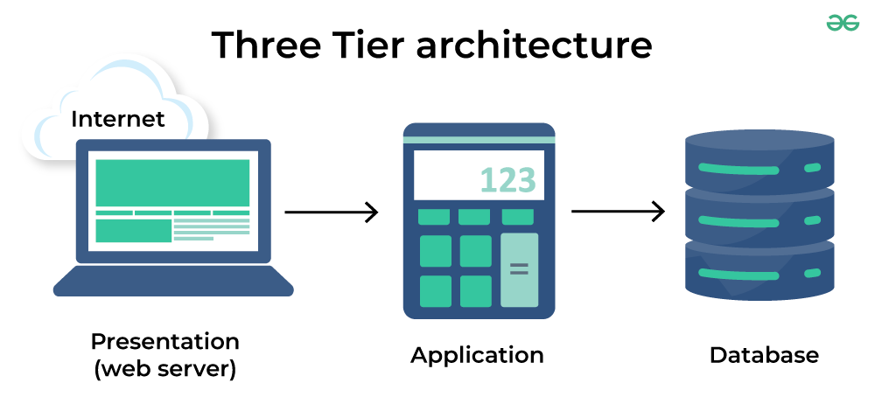

*Figure 2.2.1: Three Tier Architecture*

Geeks for Geeks (2024) *Three Tier Architecture*. Available at: <https://www.geeksforgeeks.org/three-tier-client-server-architecture-in-distributed-system/> (Accessed 24 July 2024).

**Frontend – Presentation Layer:** The presentation layer is the frontend layer that handles the user interface. It consists of all the visual and interactive components that end users use to interact with the system.

**Backend - Business Logic Layer or Application:** This layer manages the system's business logic, implemented using Java, Spring Boot, Jakarta, JPA, and Maven.

**Database Layer:** Data storage and retrieval is handled by this layer, which utilizes MySQL for development and PostgreSQL for production.

#### Frontend - Presentation Layer

The presentation layer of AluControl is responsible for the user interface. By using Making use of technologies like HTML, CSS, and JavaScript, this layer ensures that the interface is intuitive, responsive and friendly. Responsibilities include:

* **Interactivity and User Experience (UX):** Build interfaces that are intuitive, responsive, and user-friendly.
* **Rendering and Data Manipulation:** Display data from the backend in a clear and organized manner, allowing users to view and manipulate information as needed.
* **Data Validation:** Perform initial checks on the user data before sending it to the backend.

The frontend’s contribution to software architecture is crucial, as it is the layer that defines the first impression of the user on the system. The success of this interface can significantly increase usability and user satisfaction, and this web approach promotes immediate access without the need for local installation. In addition, this structure facilitates the maintenance and evolution of the interface, allowing quick adaptations to changes in user needs or market.

#### Backend - Application Layer

The AluControl backend architecture is designed in layers to promote a clear separation of responsibilities and make it easier to maintain and scale the system. The main layers and components of the backend are described below:

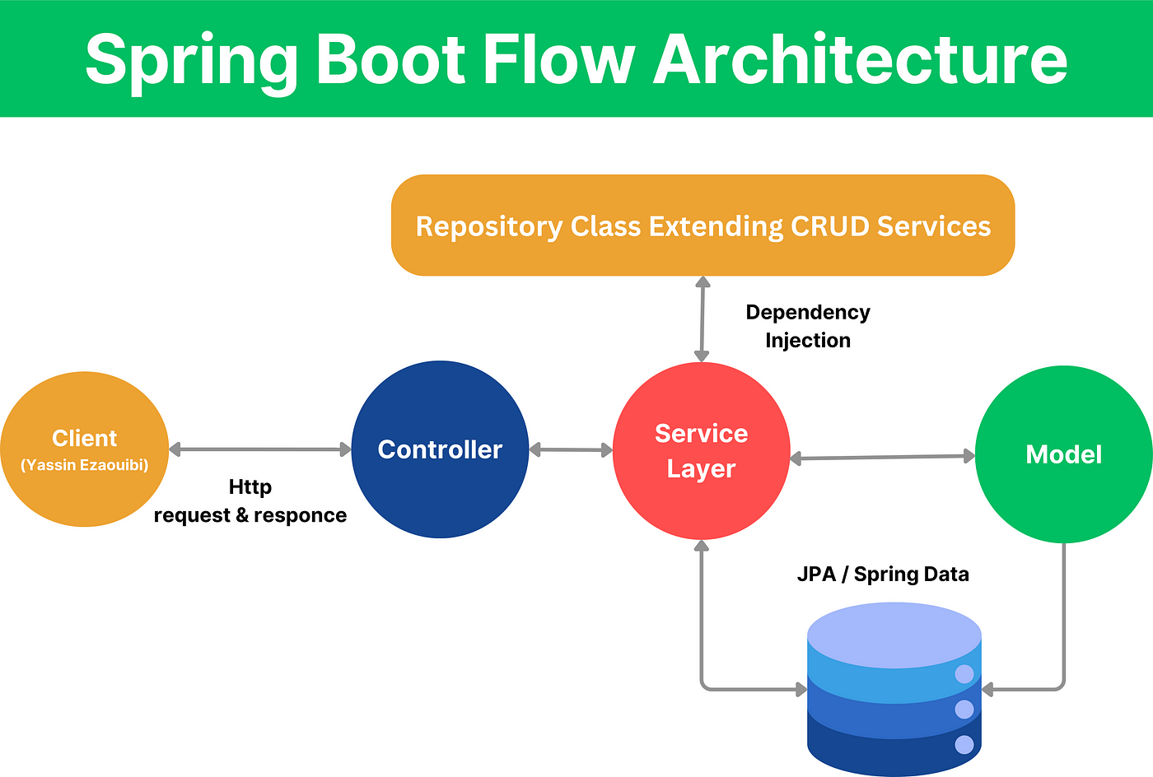

*Figure 2.2.2: Spring Boot Flow Architecture*

Ezaouibi Yassin (2024) *Spring Boot Flow Architecture*. Available at: <https://ezaouibiyassin.medium.com/spring-boot-architecture-annotations-e4f5dd5c7a66> (Accessed 24 July 2024).

The image above demonstrates how Spring Boot works, as a diagram of how all its components work together. Details of each component are described below:

* **Controllers:** The purpose of this layer is to handle HTTP requests received from the frontend and send them to the correct services. Returning formatted responses to the frontend while creating, updating, reading, and generating statistics is your main responsibility.
* **Model:** They represent the system entities and are implemented with Jakarta Persistence API (JPA). Its main responsibility is to define the data structure and mapping between Java objects and database tables, as well as ensuring the persistence and recovery of database data.
* **Projections:** The purpose of this layer is to determine which fields of an entity or dataset should be included in the responses or queries. Providing specific and customized views of the data is your main responsibility, which promotes efficiency during database queries.
* **Repository:** Implemented with Spring Data JPA, the repositories manage access to data, offering methods for CRUD operations and complex queries.
* **Service:** Integrate the system's business logic and coordinate activities between controllers and repositories.

This layer, which is made up of Java, Spring Boot, Jakarta, JPA, and Maven, ensures system efficiency and robustness, manages business logic, and integrates seamlessly with the frontend and database.

#### Database

The AluControl database layer is responsible for managing data storage and retrieval. The system was originally created with MySQL, but it was moved to PostgreSQL for production because MySQL was unavailable on the Heroku platform. The responsibilities include:

* **Data Structure:** Store inventory, sales, rent, customers, and expenses data in a relational database.
* **Data Retrieval:** Performing routine backups and restore tests to guarantee data integrity.
* **Data Integrity:** Putting in place appropriate validations and restrictions in the database.

AluControl operations require this layer to ensure security and efficiency in managing business data.

The three-tier software architecture provides a clear separation of responsibilities, contributing to modularity, maintenance, and scalability of the system. AluControl's frontend is focused on user experience and utilizes technologies like HTML, CSS, and JavaScript to create intuitive and responsive interfaces. The backend, which is built on Java and Spring Boot, manages business logic and connects efficiently with the database. The data layer, which was initially based on MySQL and later shifted to PostgreSQL, is responsible for storing and managing crucial system data. Each layer plays a crucial role and works together to create a system that is cohesive and efficient. Understanding the responsibilities and contributions of each layer is critical to developing high-quality software that can meet the dynamic needs of users and the market.

## Implementation

### *Deployment Overview*

The AluControl system was implemented using a structured approach that was based on the functional and non-functional requirements previously defined. Using a three-layer architecture, the development was divided into frontend, backend and database, ensuring a clear separation of responsibilities and facilitating system maintenance and scalability.

### *Frontend Implementation*

The frontend was built with user experience in mind, using modern technologies to create interfaces that are intuitive, responsive, and friendly. The implementation of the main frontend requirements is detailed below.

#### Design Structure

The frontend project was structured using HTML, CSS, and JavaScript. The structure of the documents was consistent with that of modern web projects, including separate directories for components, styles, and scripts.

* **HTML**: The basic structure of the pages.
* **CSS**: The design and layout of interfaces, with Bootstrap support.
* **JavaScript**: Interactions with the backend and dynamic behaviour.

#### User experience (UX) and interactivity

To guarantee excellent user experience, responsive styling was achieved by utilizing libraries and frameworks like Bootstrap and manipulating DOM and AJAX requests with jQuery. Here's an example of how the backend interaction was implemented:

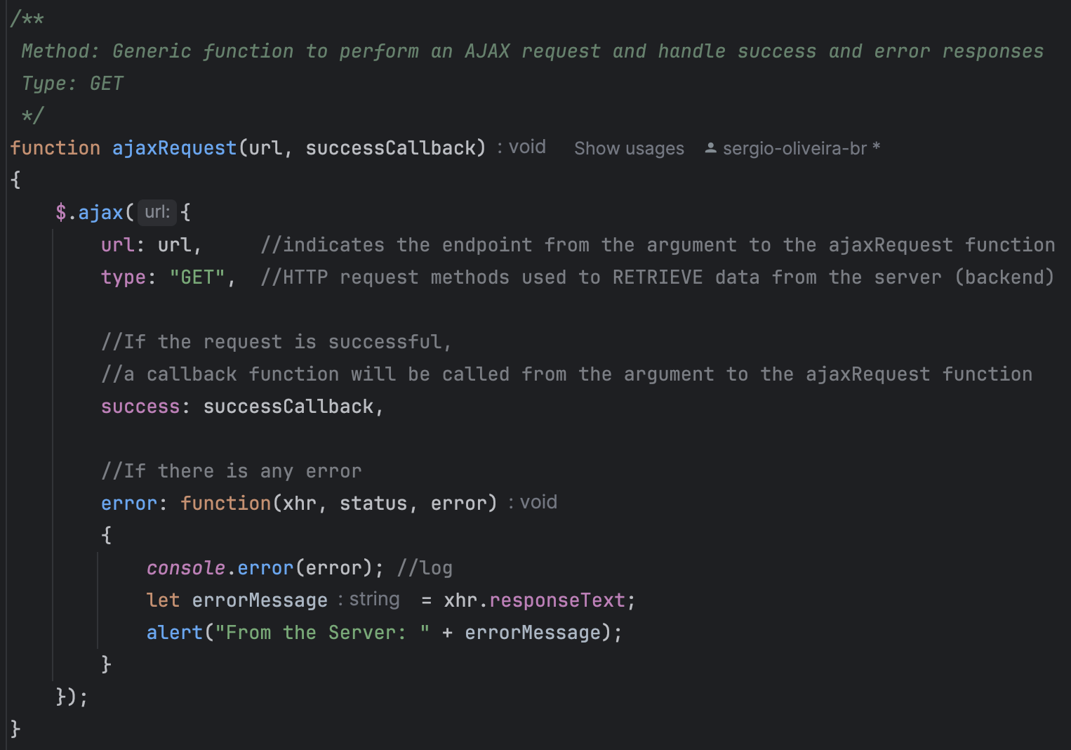

*Figure 2.3.1: JavaScript function to execute AJAX requests using the GET method.*

#### Data Validation

The integrity of information has been ensured by implementing data validation on both the frontend and backend. In the frontend side, basic validations were performed using HTML5 attributes and JavaScript scripts.

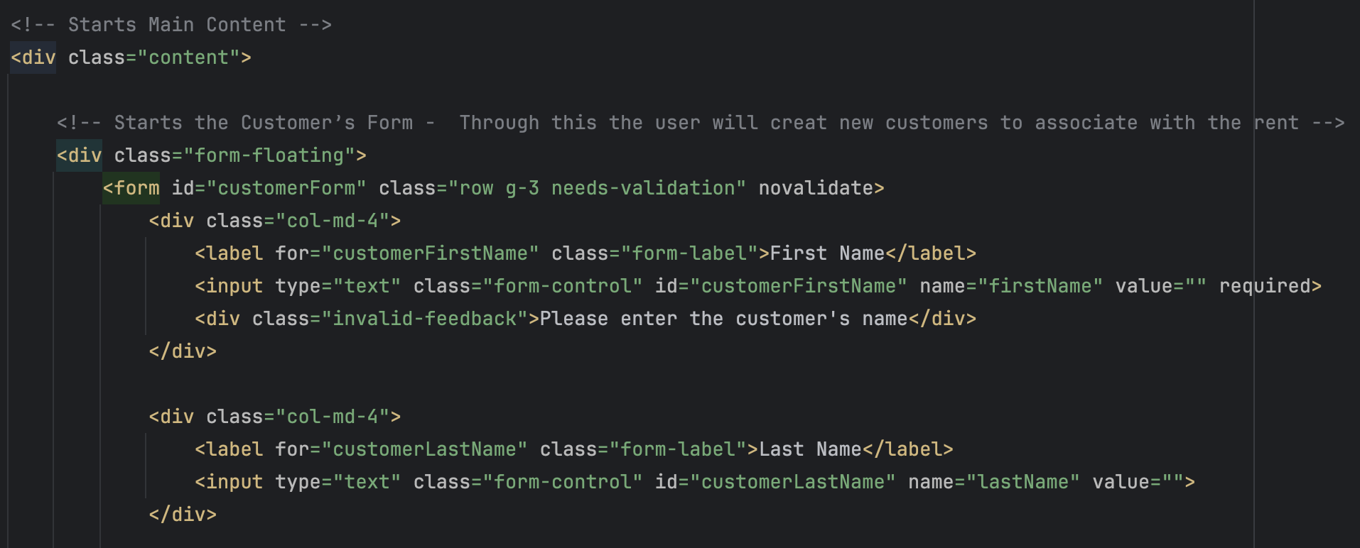

*Figure 2.3.2: Form for creating new customers. The "First Name" field is required and includes a validation that displays an error if the user does not fill it in correctly.*

### *Backend implementation*

The AluControl backend was developed using Java and Spring Boot, with multiple layers of code to divide responsibilities and make maintenance easier.

#### Project Structure

The backend project was structured with specific packages for drivers, services, repositories, data models, projections, utilities, and exceptions. This approach enabled clear and modular organization of the code.

* **Controllers**: Manage HTTP requests and coordinate responses.
* **Services**: Contain the business logic of the system.
* **Repositories**: Manage access to persisted data.
* **Models**: Represent the entities of the system.
* **Projection**: Define specific views of the data.
* **Utilities**: Contain auxiliary features, such as logging.
* **Exceptions**: Manage the handling of errors.

#### Controllers

Controllers handle requests received from the frontend and forward them to the appropriate services. Below is an example of a controller responsible for managing endpoints that save customers data, and it uses a repository to access and persist information in the database.

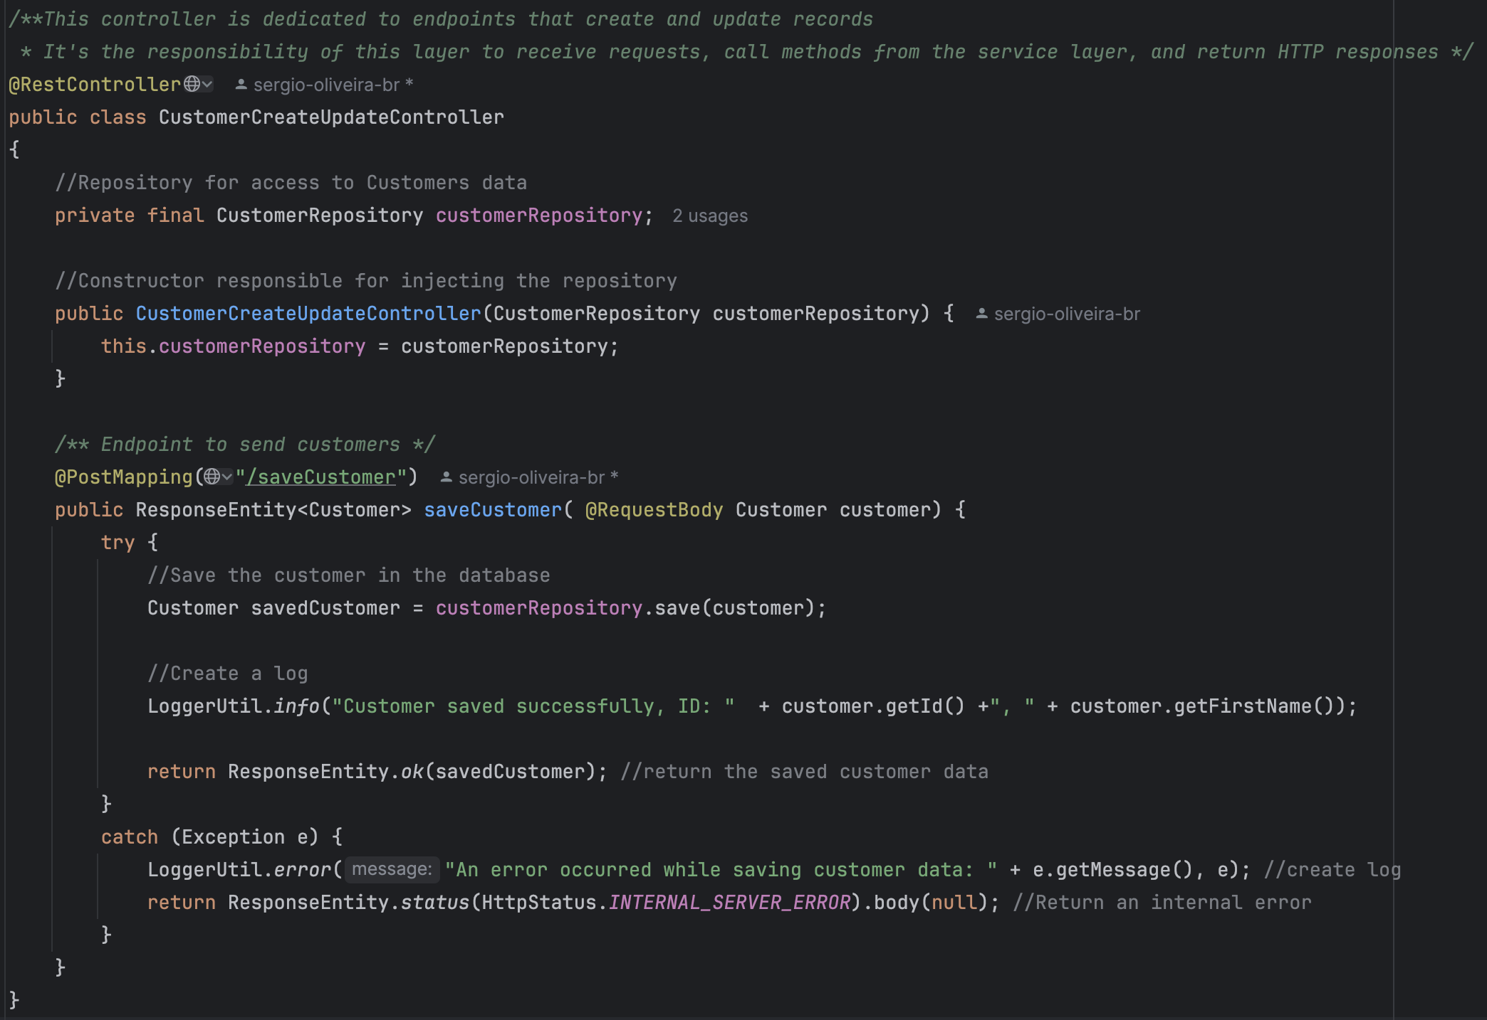

*Figure 2.3.3:* *Java controller responsible for creating and updating client records.*

#### Services

Services encapsulate the business logic of the system. In the example below, the method subtracts stock based on rental status.

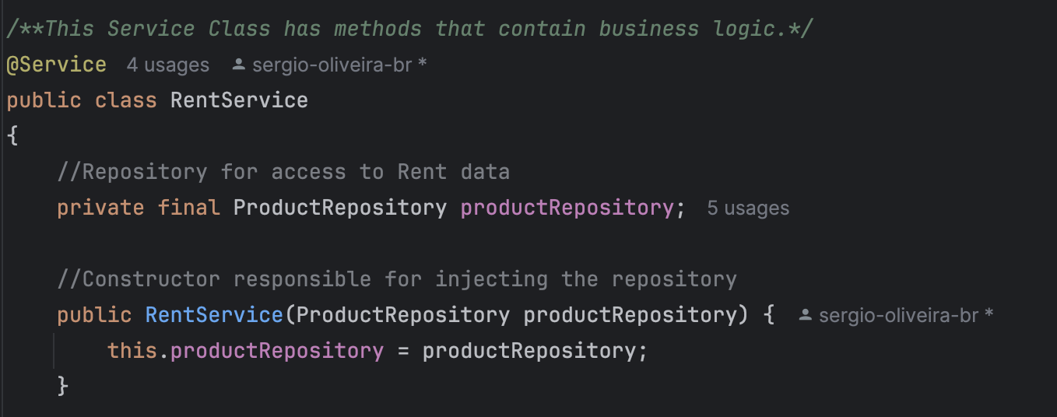

*Figure 2.3.4: RentService Class is responsible for encapsulating the business logic related to product rental.* *The product repository is used by this class to access and manipulate data, and it is injected with it through its constructor.*

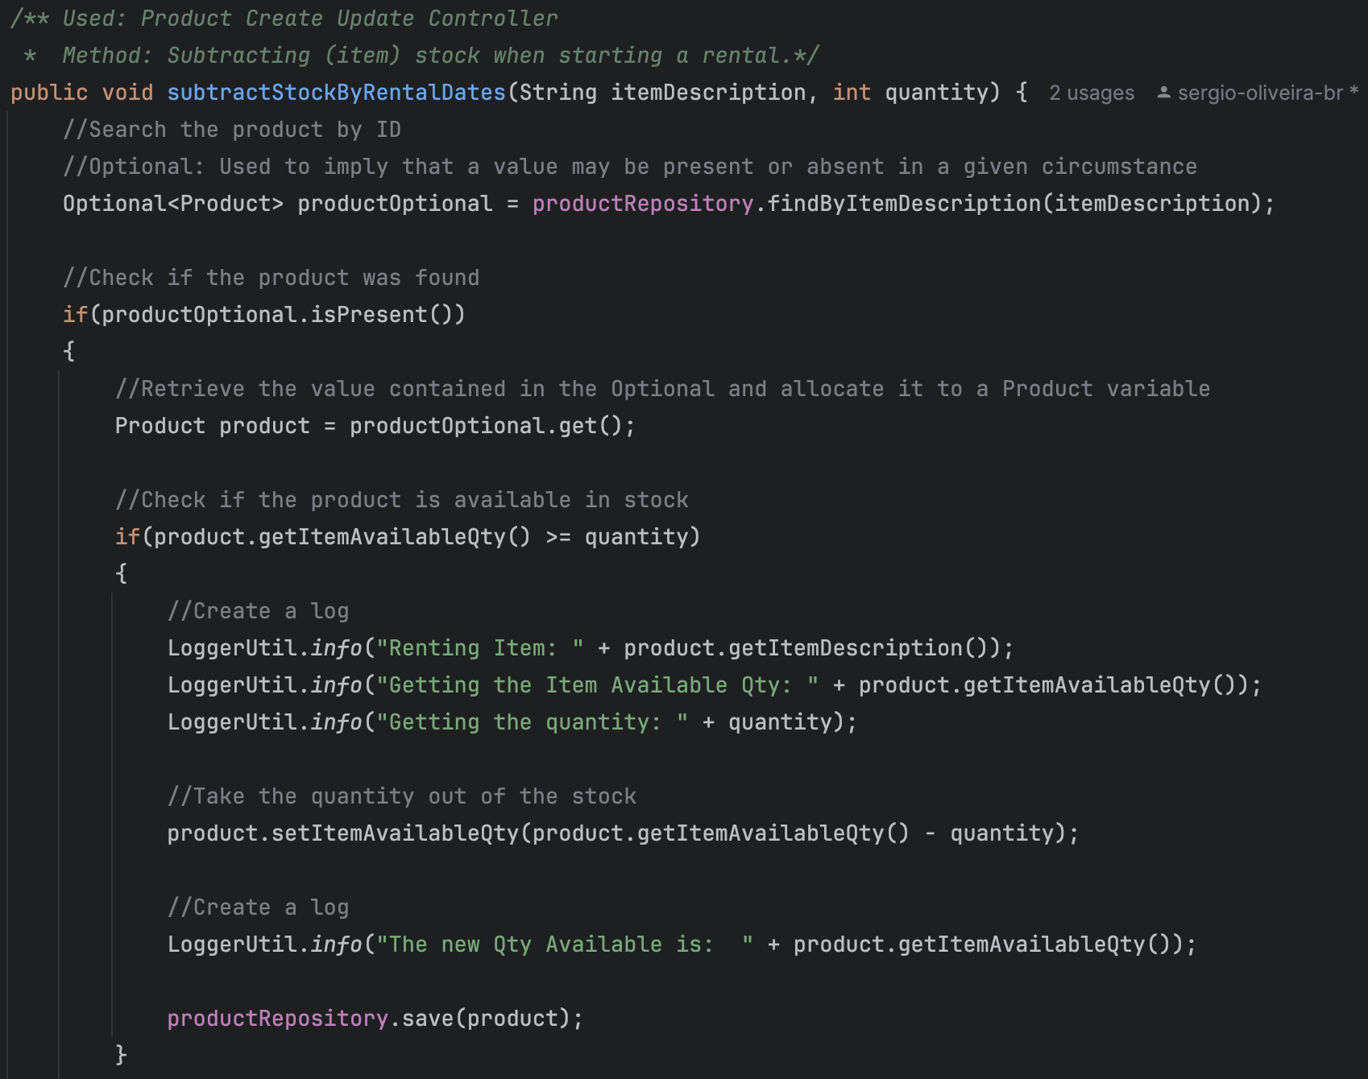

*Figure 2.3.4: SubtractStockByRentalDates method in the RentService class that reduces the stock amount of an item when starting a rental.*

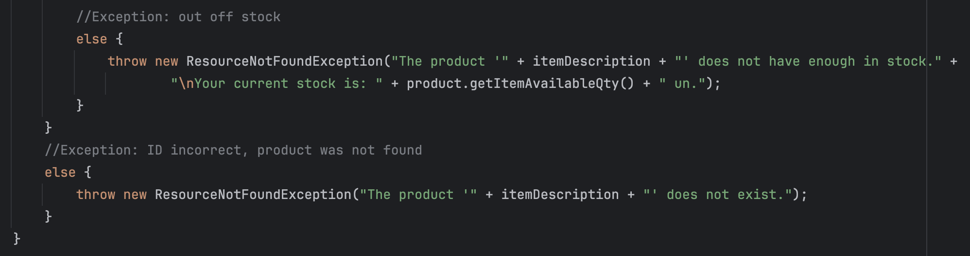

*Figure 2.3.5:* *Handling exceptions in the subtractStockByRentalDates method when stocks are insufficient or products are not found.*

#### Repositories

The repositories manage access to data, using Spring Data JPA for CRUD operations:

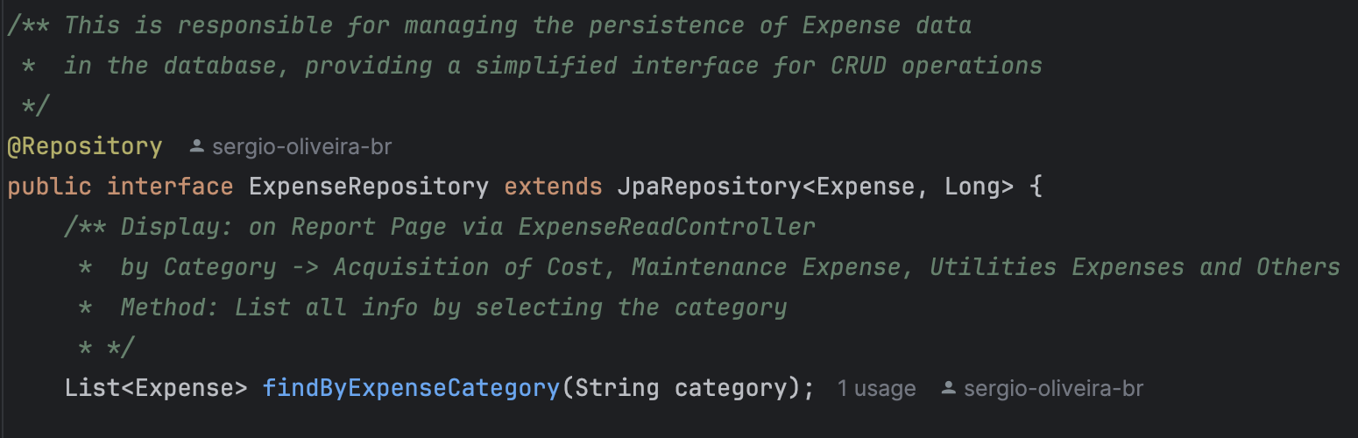

*Figure 2.3.6: The ExpenseRepository interface is responsible for maintaining Expenses data in the database.*

#### Models

The models are used to map database tables using JPA to represent the system entities.

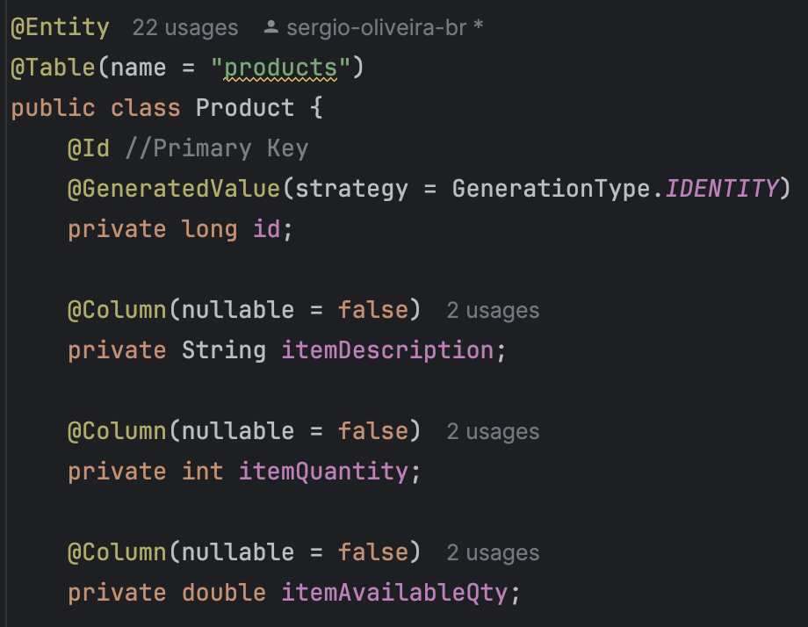

*Figure 2.3.7: Product class representing the product entity in the database.*

#### Projections

Projections are used to define specific views of data. They allow efficient data retrieval, considering only the necessary fields:

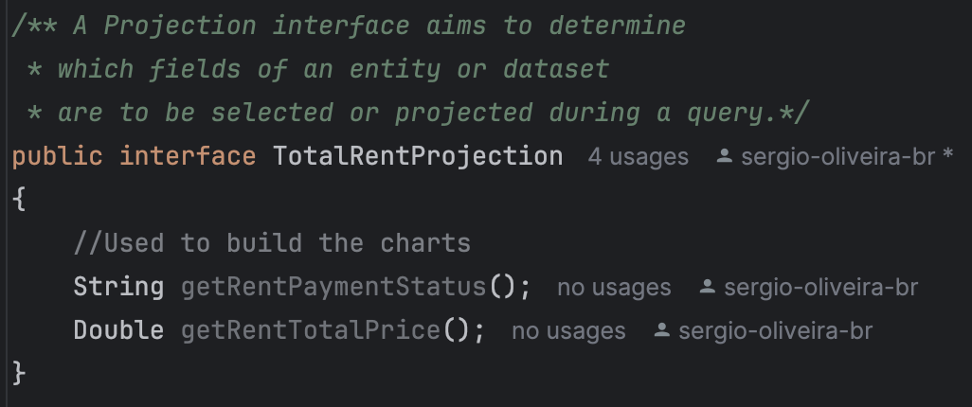

*Figure 2.3.7:* *TotalRentProjection interface used to design rental-related data.*

#### Utilities

The util classes are responsible for providing additional functions that are utilized in various areas of the system. In this example, a logger class to monitor activities, providing a centralized and consistent configuration for generating logs in an application. It also includes a method for logging error messages and exceptions, making it easier to track issues:

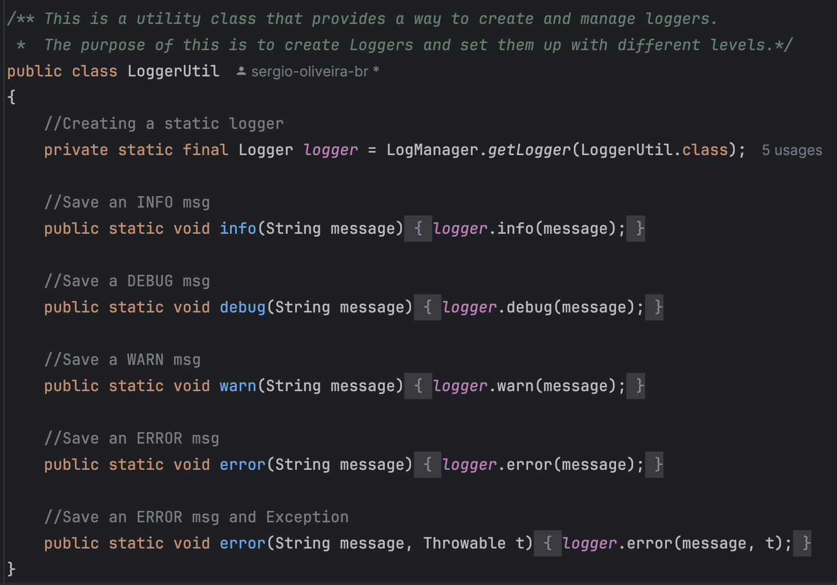

*Figure 2.3.7: Utility class LoggerUtil for creation and management of loggers.*

#### Exceptions

Exceptions are managed using the @ControllerAdvice annotation to handle errors centrally. It includes methods for handling generic exceptions, logging errors with LoggerUtil, and returning appropriate HTTP responses to improve system reliability and usability.:

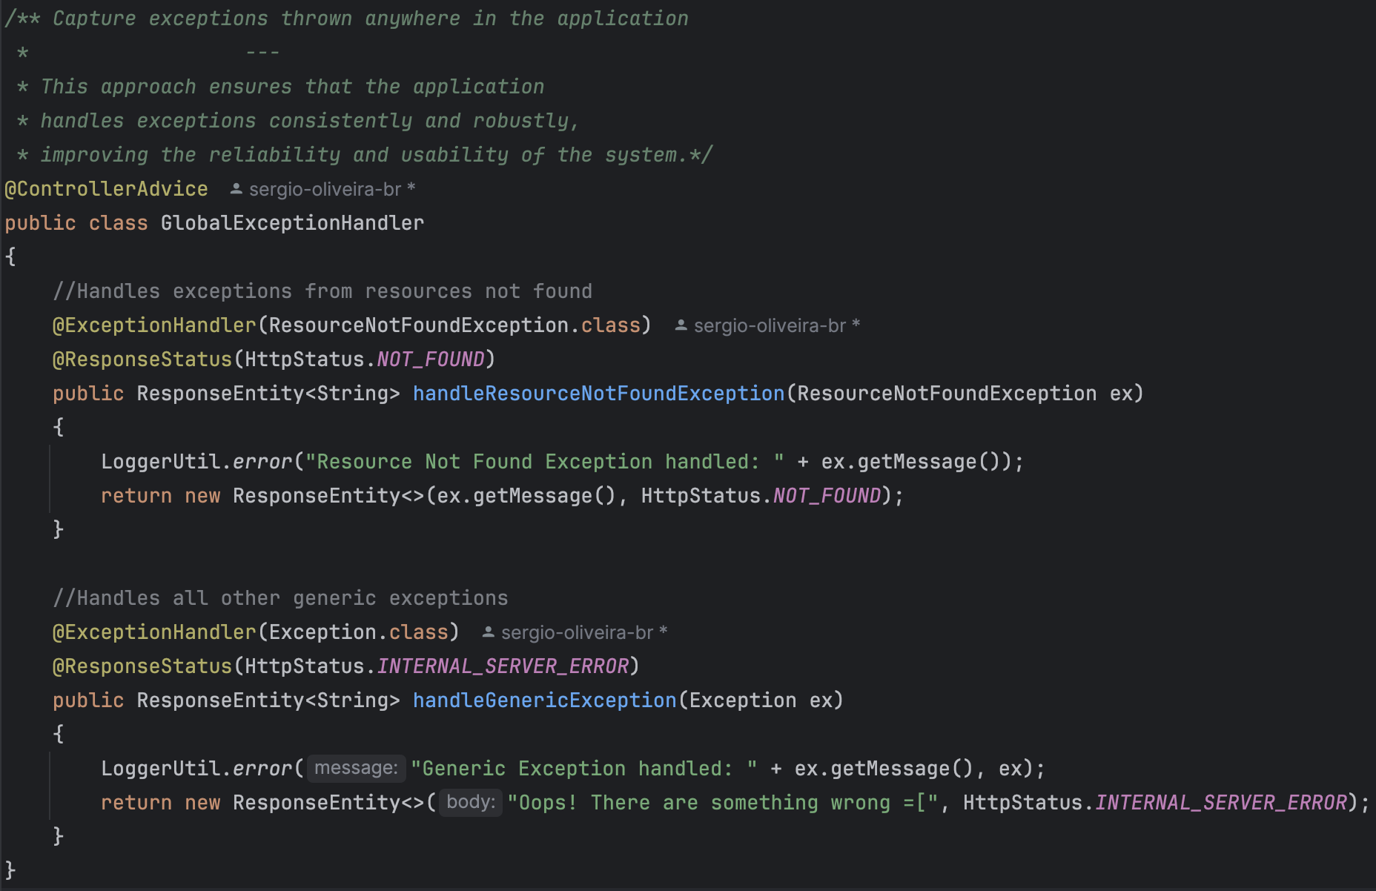

*Figure 2.3.8: The GlobalExceptionHandler class captures and handles exceptions thrown across the application.*

#### Spring Boot Properties

The Spring Boot settings are fundamental to the operation of the backend. Here is the example where is establishes the application's name, static resource configurations, and modifies database settings for both local (MySQL) and production environments (PostgreSQL in Heroku).

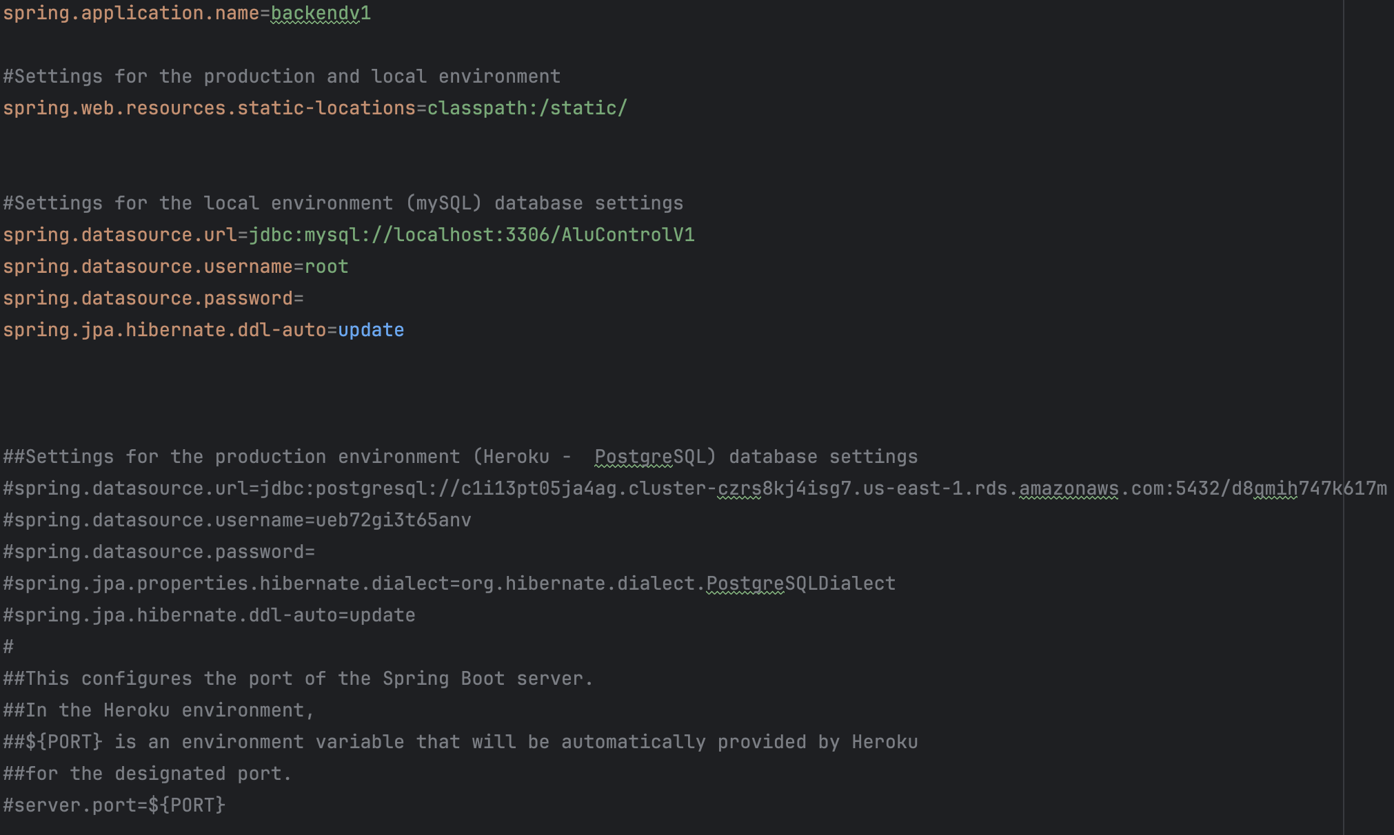

*Figure 2.3.9: Configuration file application.properties for a Spring Boot application.* *Setting up databases in local host (MySQL).*

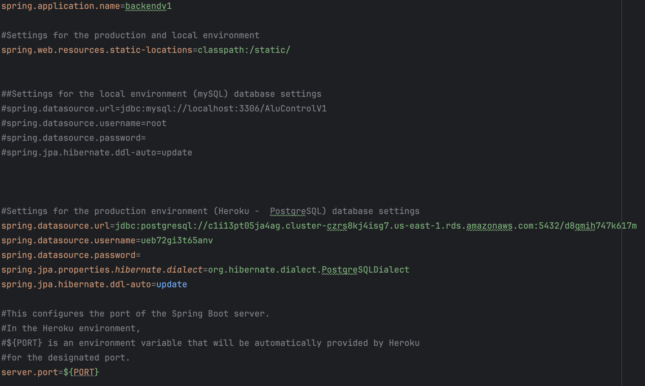

*Figure 2.3.10: Configuration file application.properties for a Spring Boot application.* *Setting up databases in production (PostgreSQL).*

#### Dependencies

The Maven pom.xml file contains the main dependencies required for the Spring Boot application:

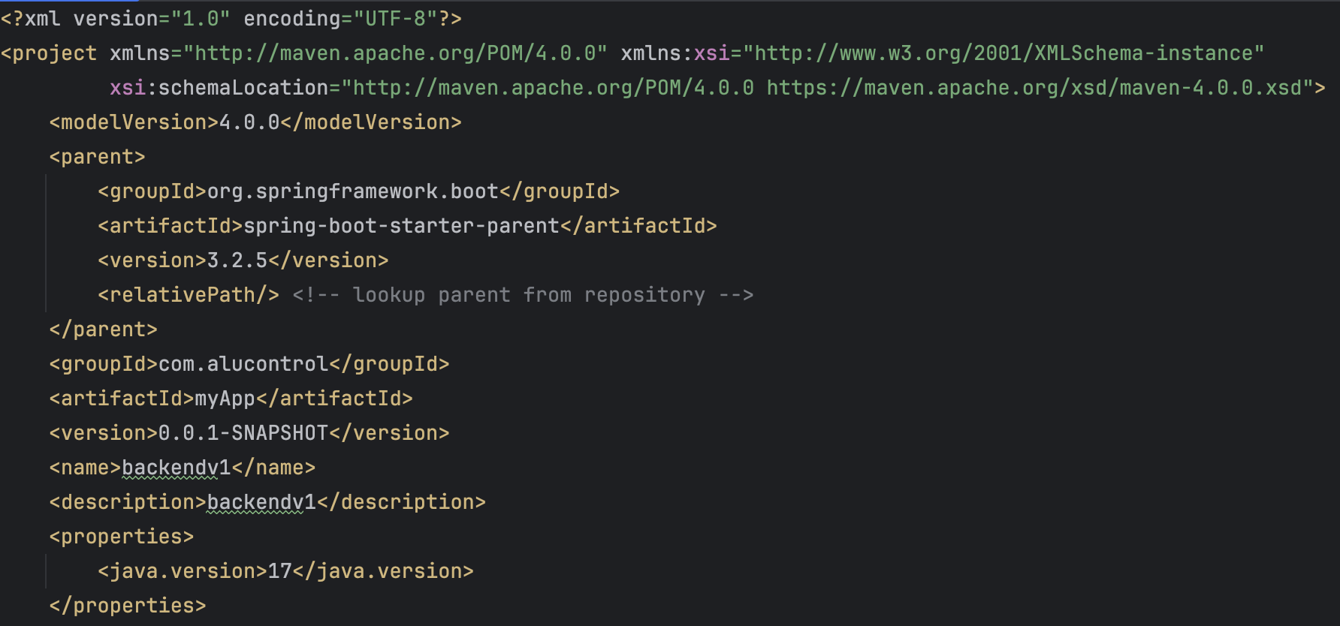

*Figure 2.3.11: Pom.xml file header for a Maven project of a Spring Boot application.*

Despite that fact that the project includes essential libraries and dependencies such as Starter Web, DevTools, and Test Starter, plus Mockito for testing, connectors for MySQL and PostgreSQL, and JPA support, the image below depicts the configuration of the pom.xml file, which contain highlights the importance of spring-boot-starter-web in developing web applications with Spring Boot. This dependency helps create RESTful APIs and configure the web environment, which includes integration with servlets, JSON, and other functionalities needed for robust web applications.

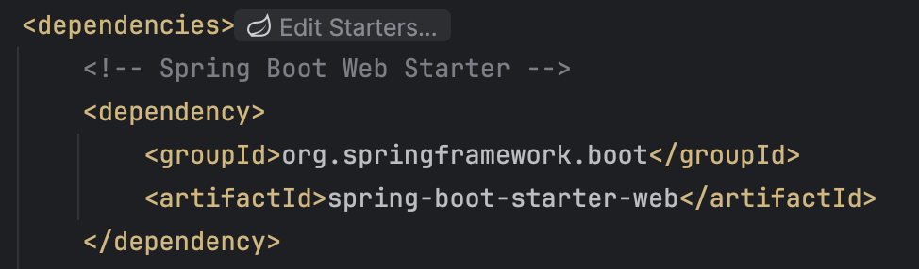

*Figure 2.3.13: The dependency on Spring Boot Starter Web.*

### *Implementation of the Database*

*The database is designed to ensure integrity, performance, and scalability. The system uses MySQL for development and PostgreSQL for production.*

*As previously mentioned, there were specific requirements for the deployment in Heroku, particularly for the PostgreSQL database.*

#### Database Structure

Tables have clear relationships and the database structure was modelled to meet the system's needs. Here is an example of tables created on local host by using MySQL.

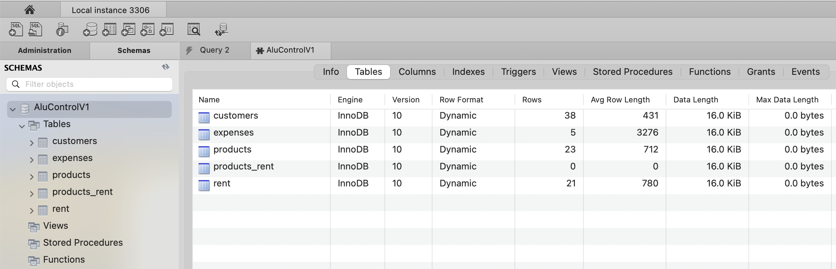

*Figure 2.3.14: Summary of information about the tables created on local host by using MySQL.*

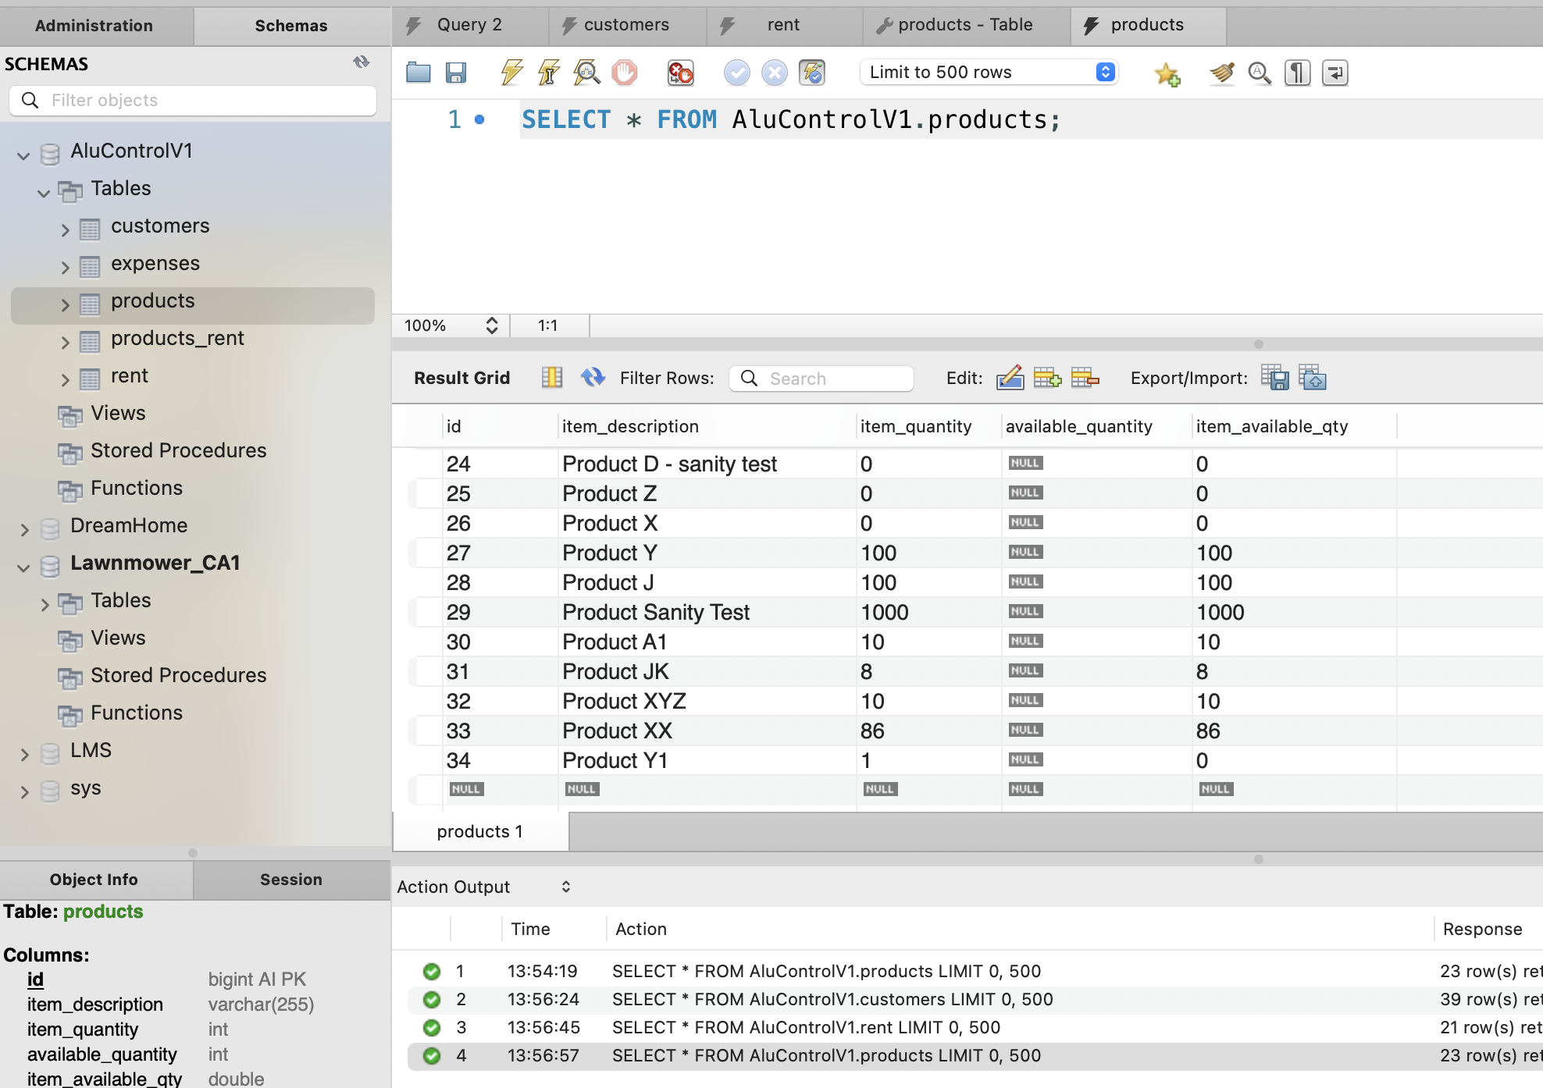

*Figure 2.3.15: A product table hosted locally.*

These are the queries that have been generated in PostgreSQL.

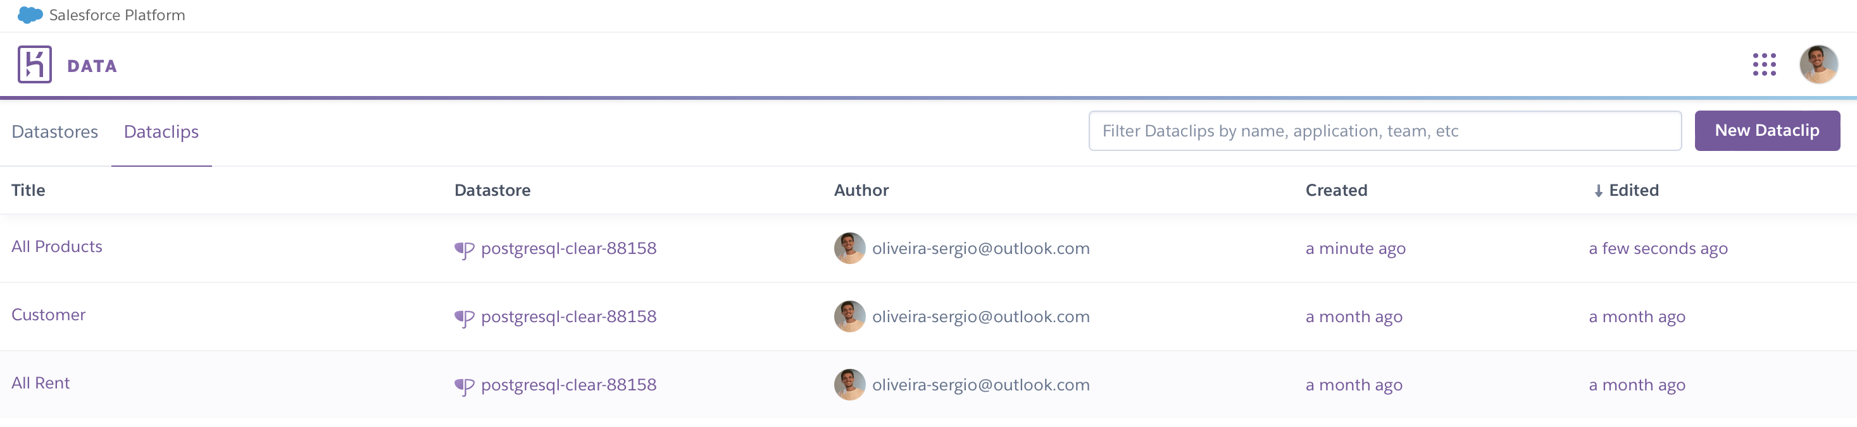

*Figure 2.3.16: Dataclips available on PostgreSQL.*

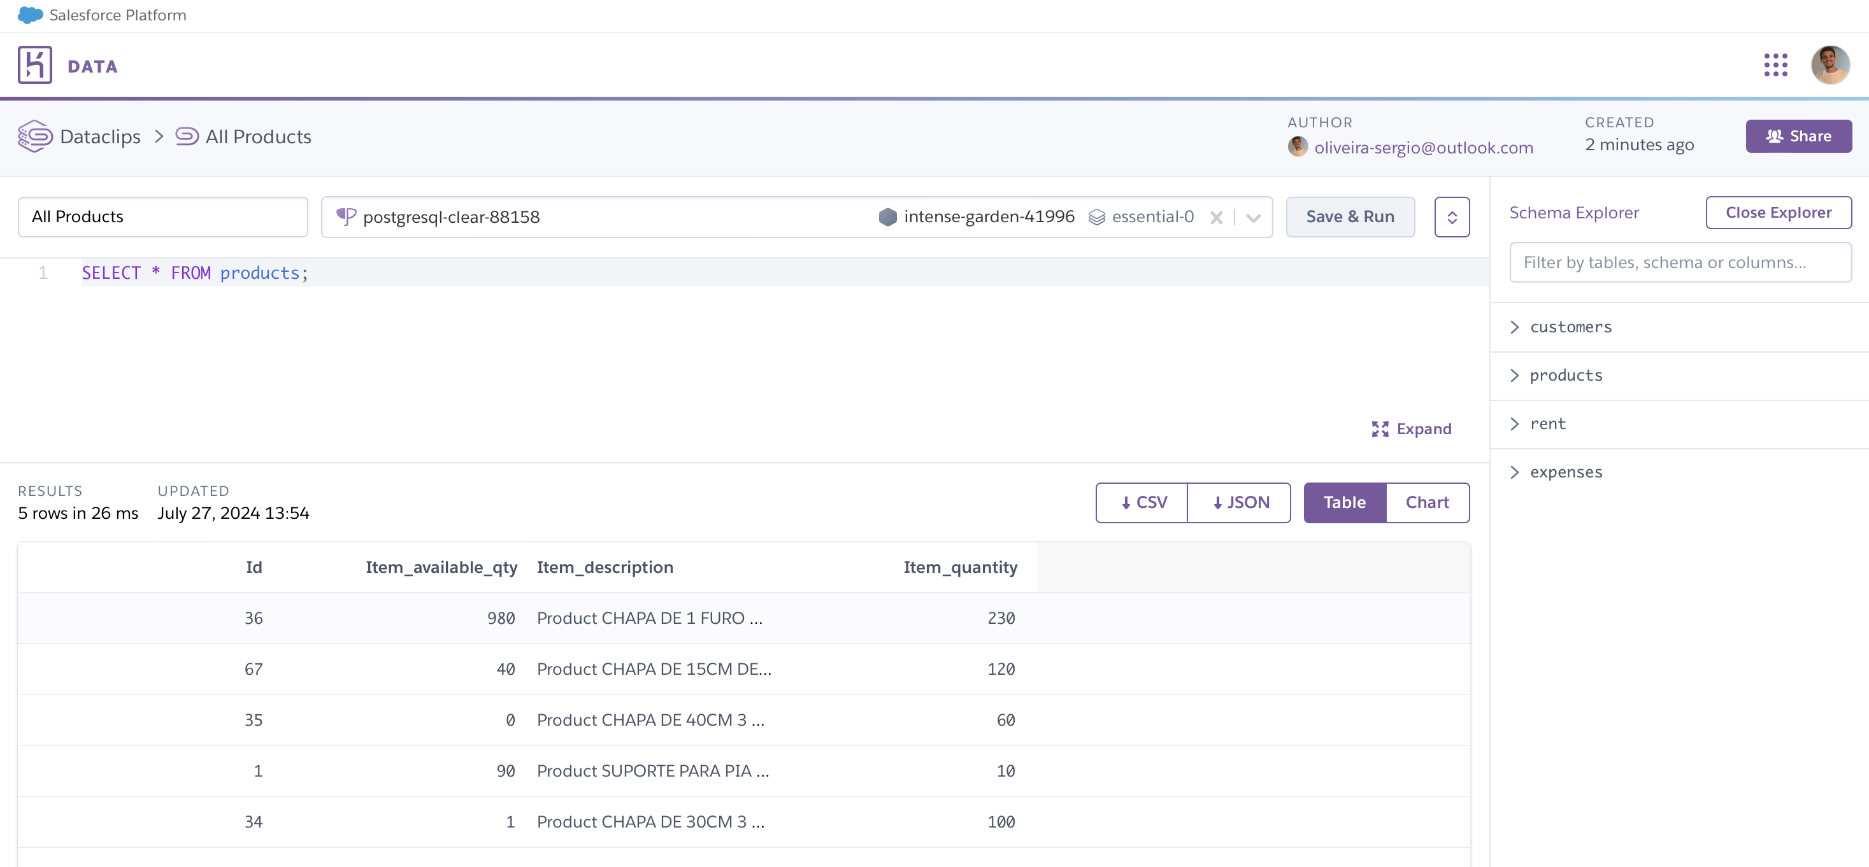

*Figure 2.3.17: PostgreSQL query execution.*

### *Version Control and Deploy*

The use of GitHub for version control and code management was fundamental to the development of AluControl, and can be accessed through the URL <https://github.com/sergio-oliveira-br/myApp>.

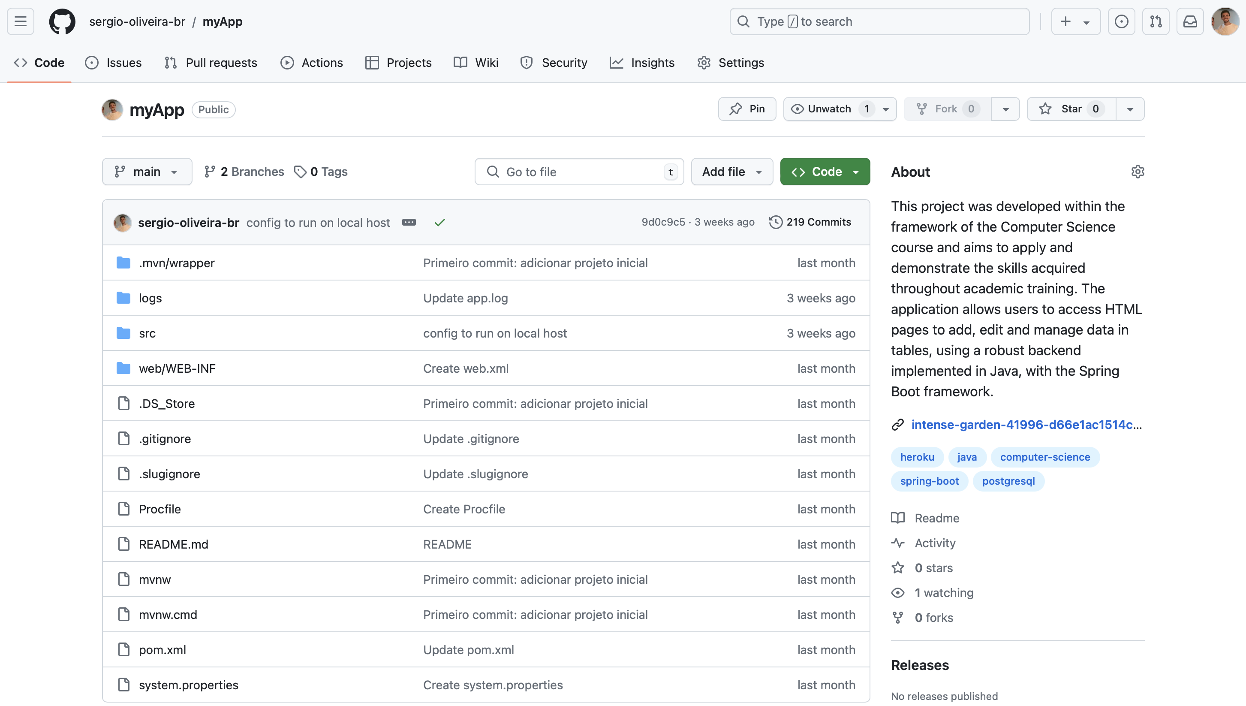

*Figure 2.3.18: The production repository on GitHub*

Before the final version established, this repository <https://github.com/sergio-oliveira-br/aluControl> was build process and as a backup during deployment.

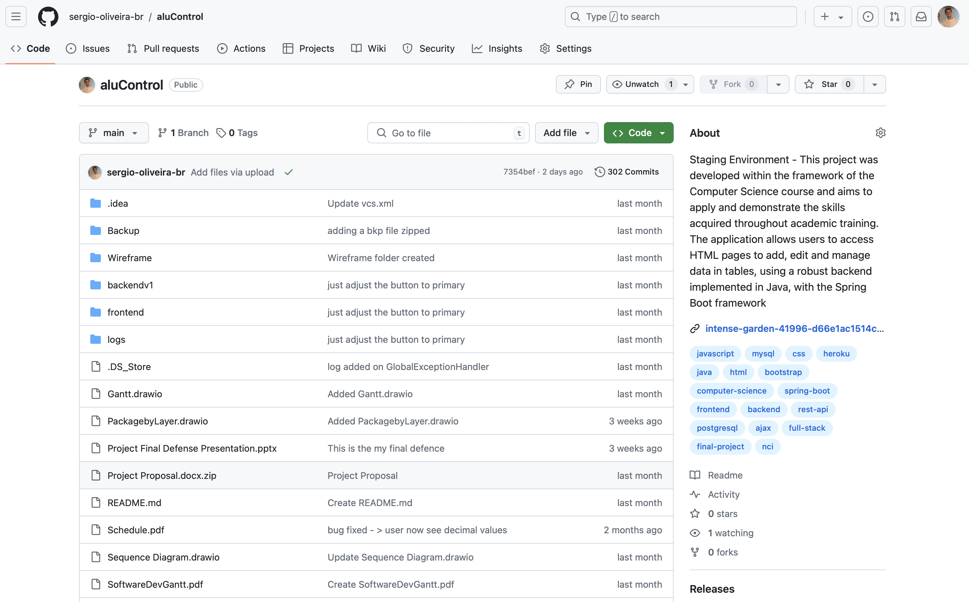

*Figure 2.3.19: The staging repository on GitHub*

#### Branches and Merges

The “main” branch contains the code that has been stable and revised. New features and bug fixes are created in the “development” branch and then merged back into the main branch after review and testing. The interaction between branches is summarized by the image below.

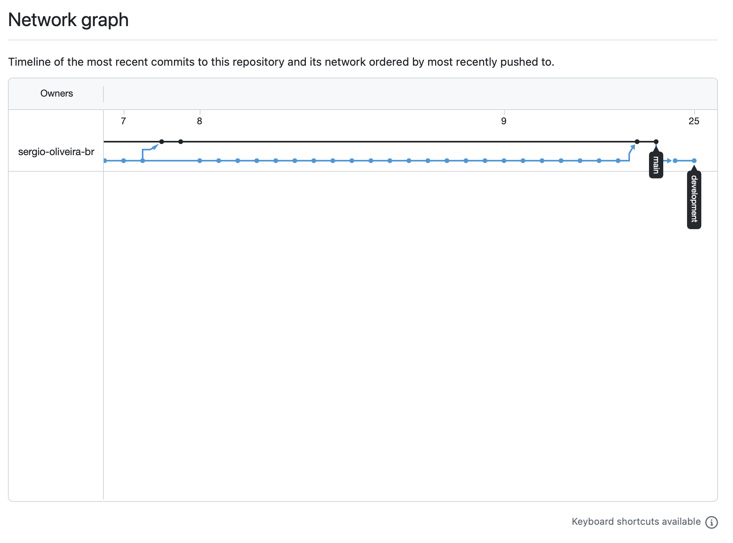

*Figure 2.3.20: Network graph in production repository on GitHub Repository.*

#### Release Management

Each release involves a merge from the development branch to the main branch. The code in the main branch is set to be deployed in the production environment, with the assurance of only testing and approved code being made available.

The Maven plugin supported the deployment, and the integration process was automatically implemented in the production environment through Continuous Deployment (CD).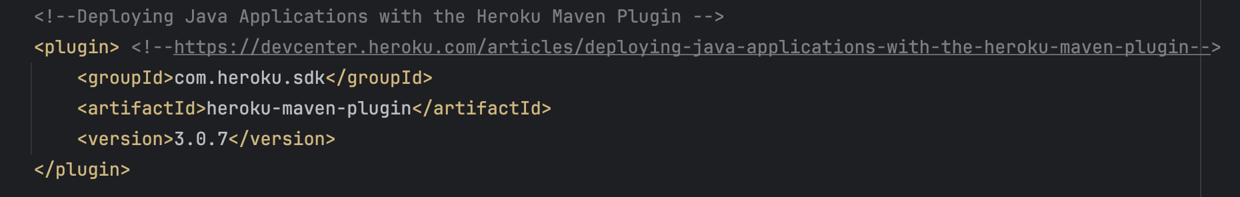

*Figure 2.3.21: Maven plugin used to deploy AluControl in Heroku.*

The *'mvn heroku:deploy'* command is used to deploy AluControl application on a Heroku server using Maven, which is a build automation and dependency management tool.

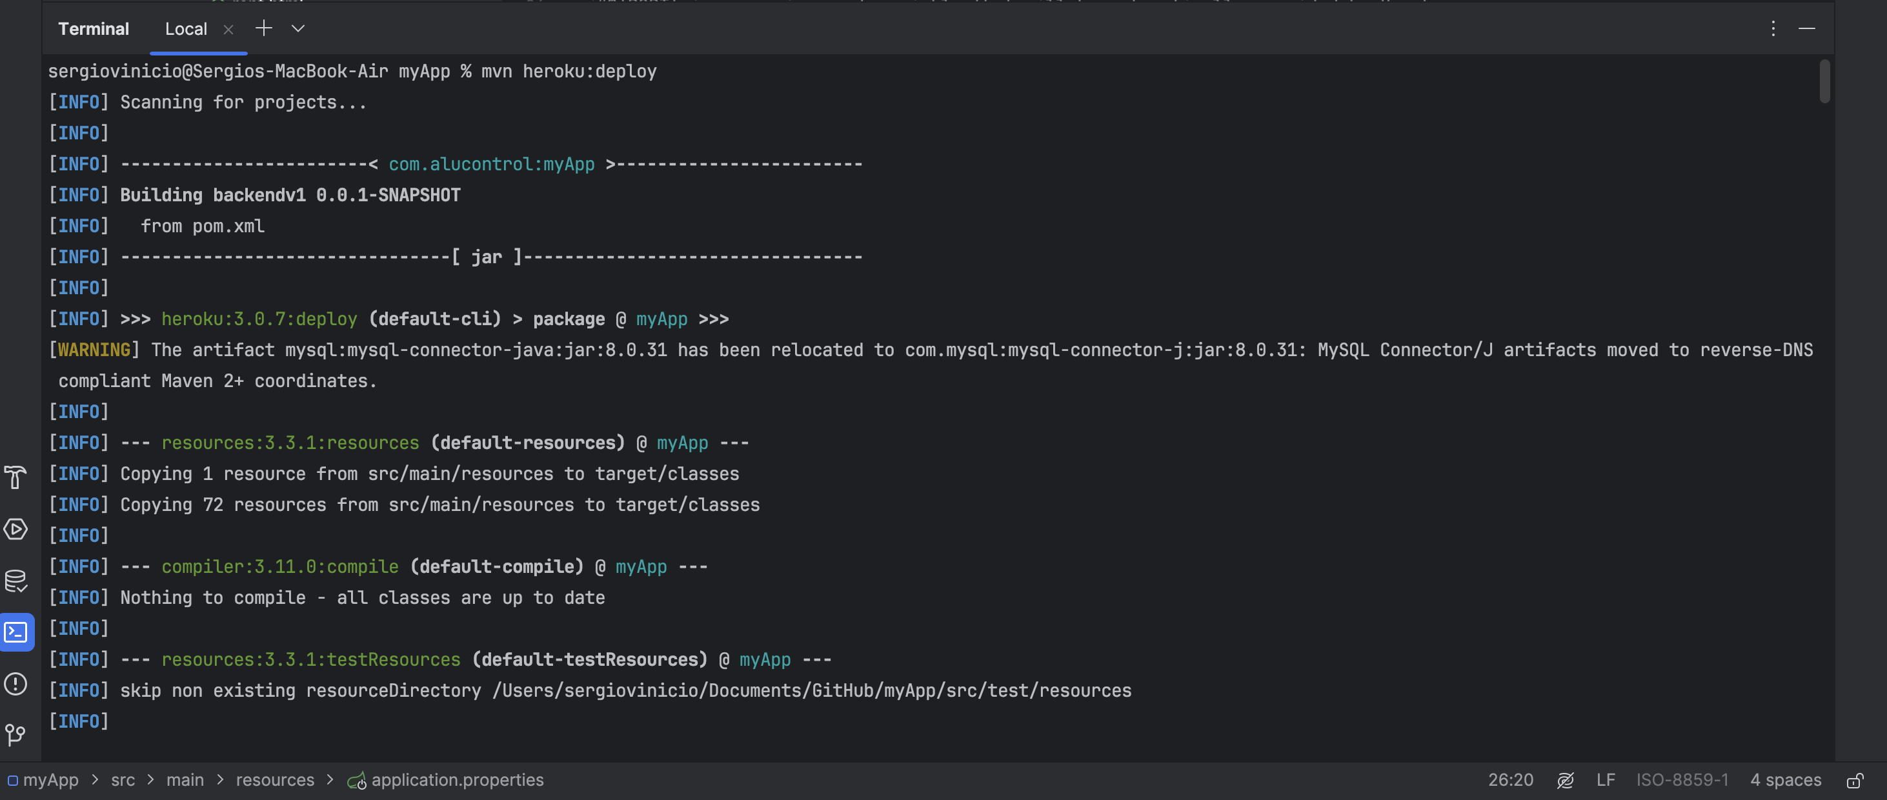

*Figure 2.3.22: Execution of the deploy command.*

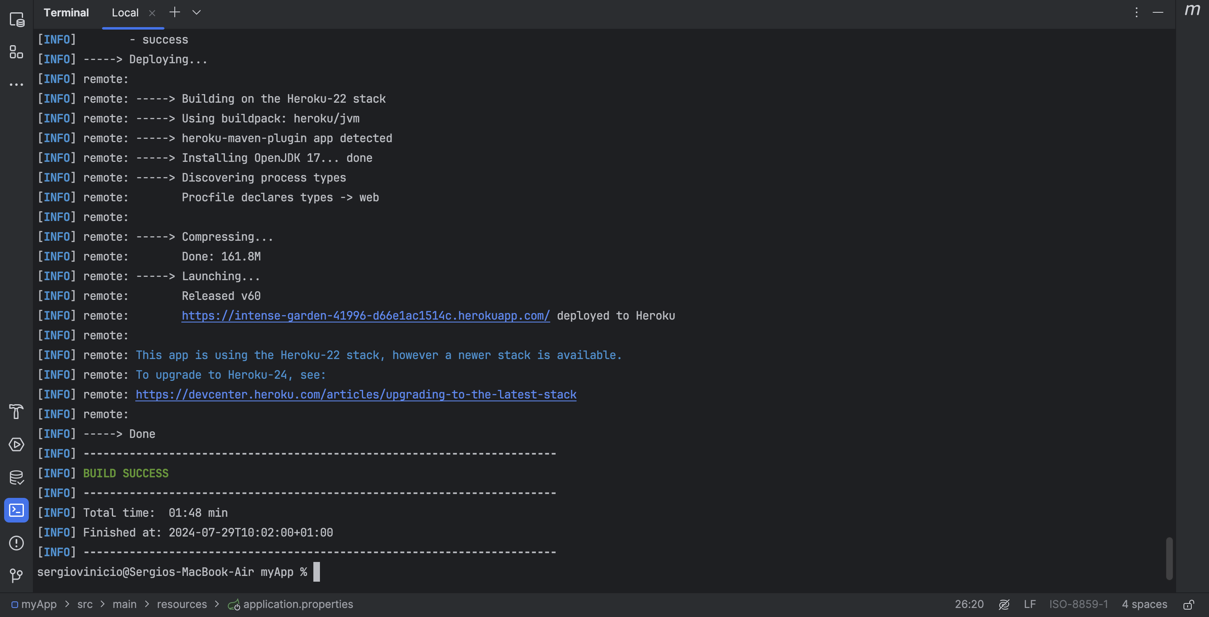

*Figure 2.3.23: Feedback and logs of Maven deployment command*

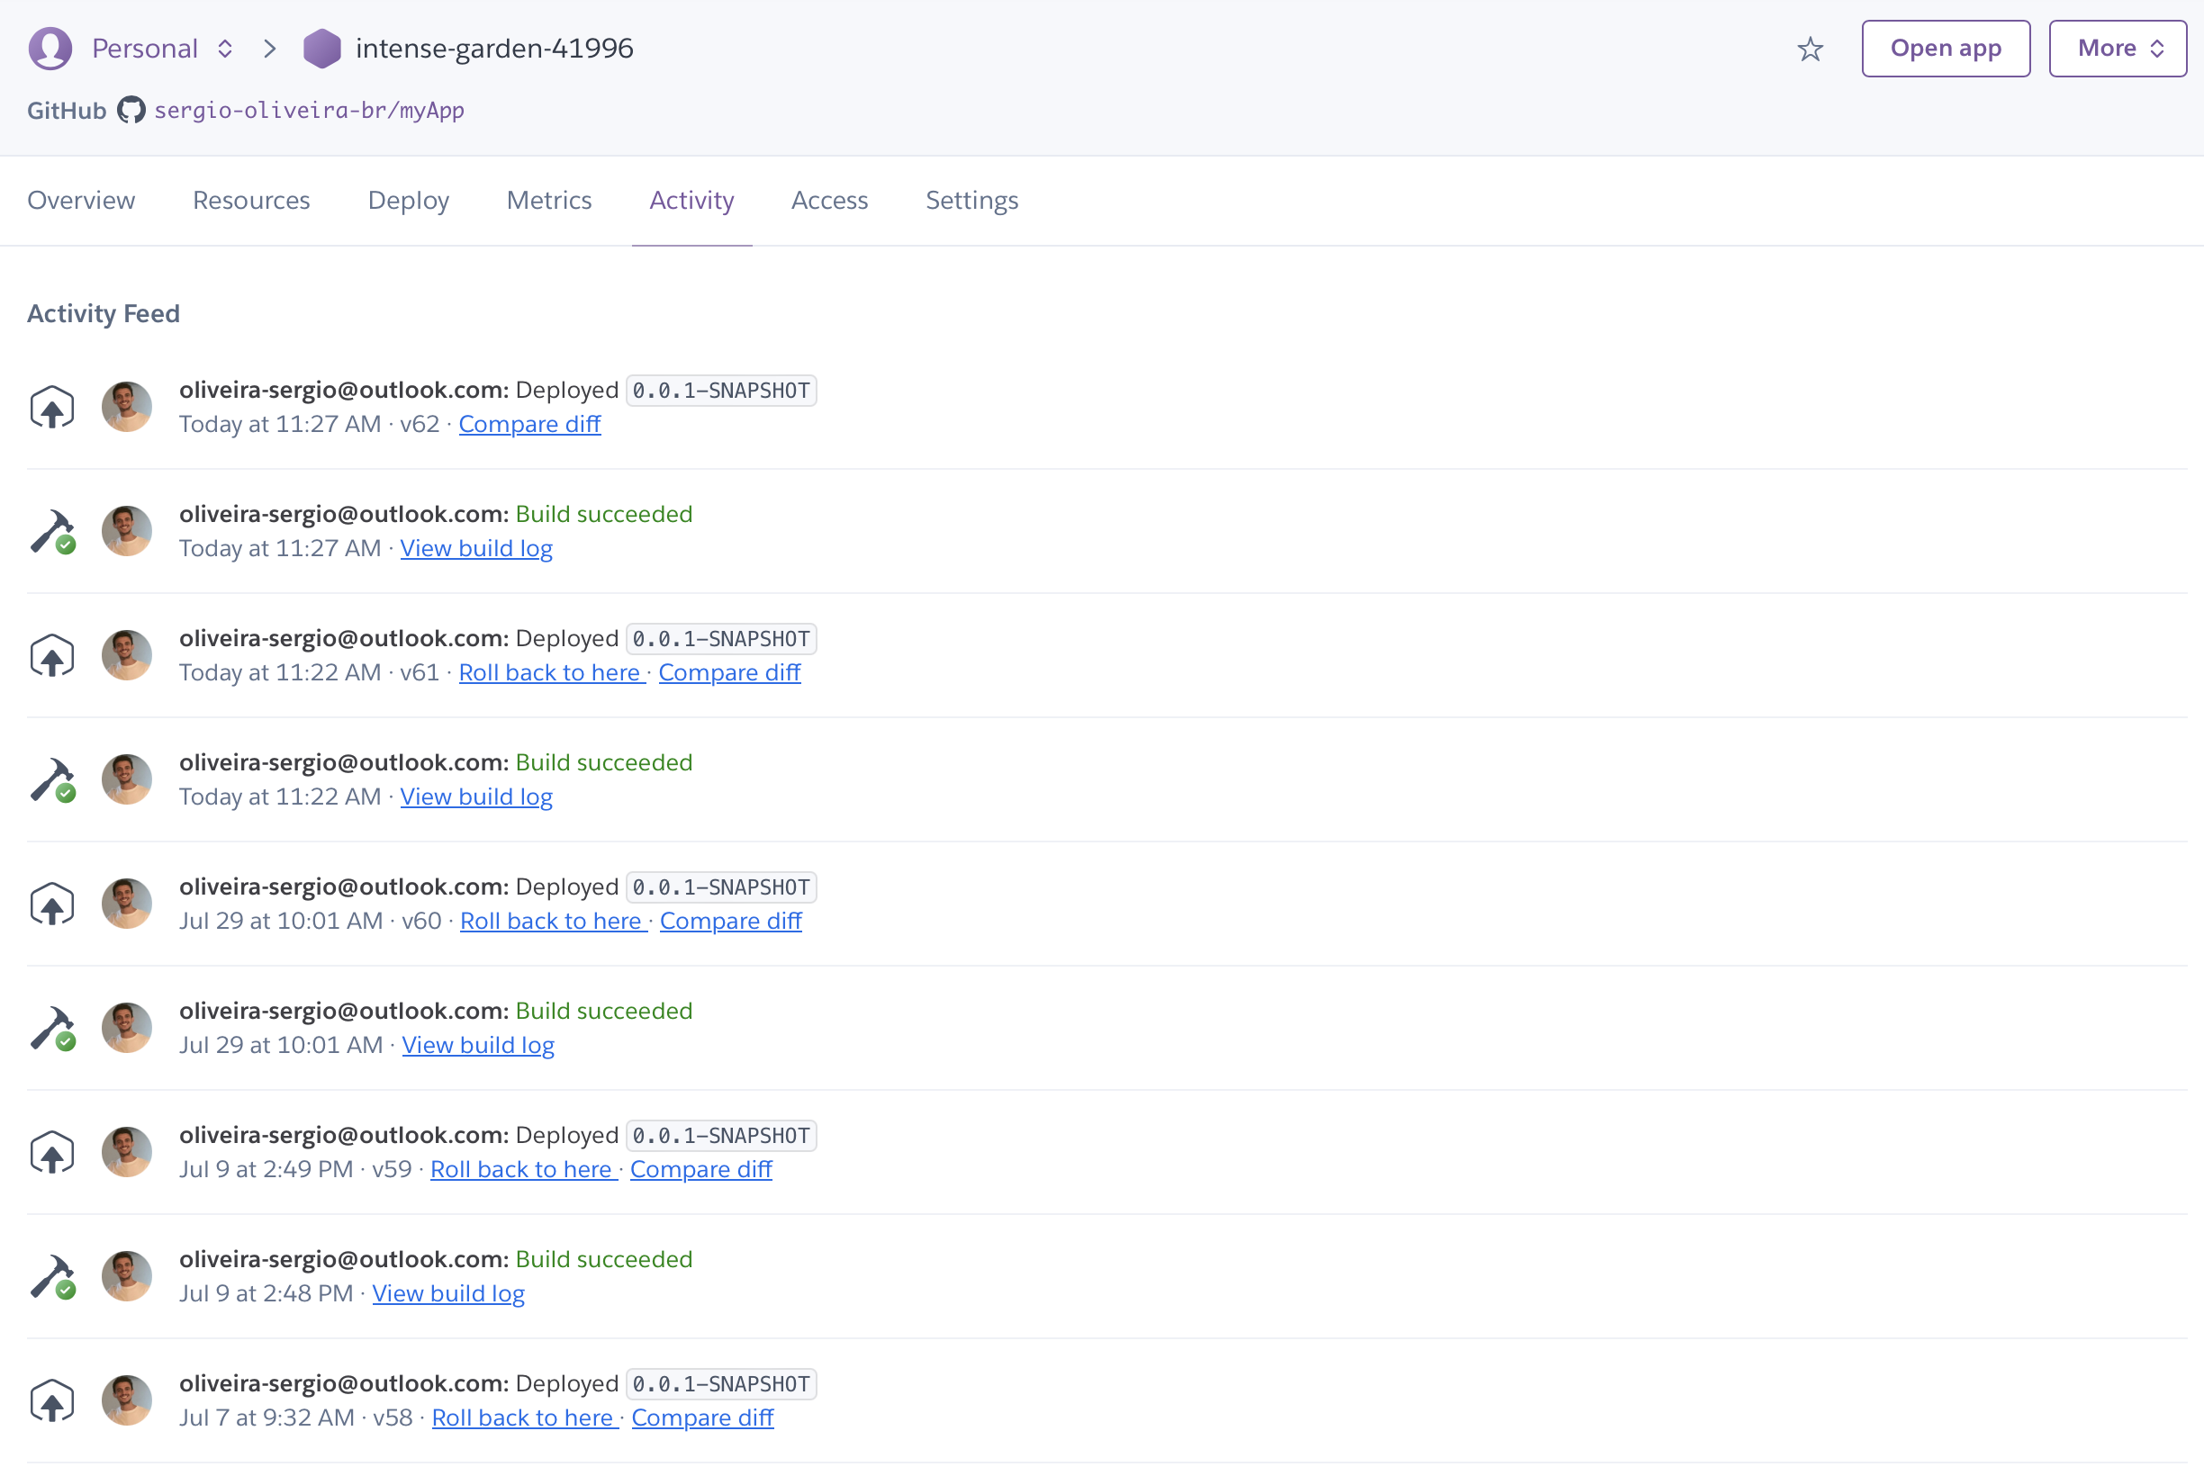

*Figure 2.3.24: Heroku activity feed.*

The process can be summarized in the following way:

Maven authenticates the user in Heroku using credentials stored in the ~/. netrc file or configured directly in pom.xml. Then compiles the project’s source code, runs automated tests (if configured), and packages the application in a format suitable for execution. This includes setting environment variables, process configuration and any other parameters required for the application to run correctly.

Finally, Heroku performs the application deployment in the production environment and starts the configured processes, such as the web server.

#### Access URL to the Application

AluControl can be accessed by using the URL <https://intense-garden-41996-d66e1ac1514c.herokuapp.com> and it is hosted on the Heroku server.

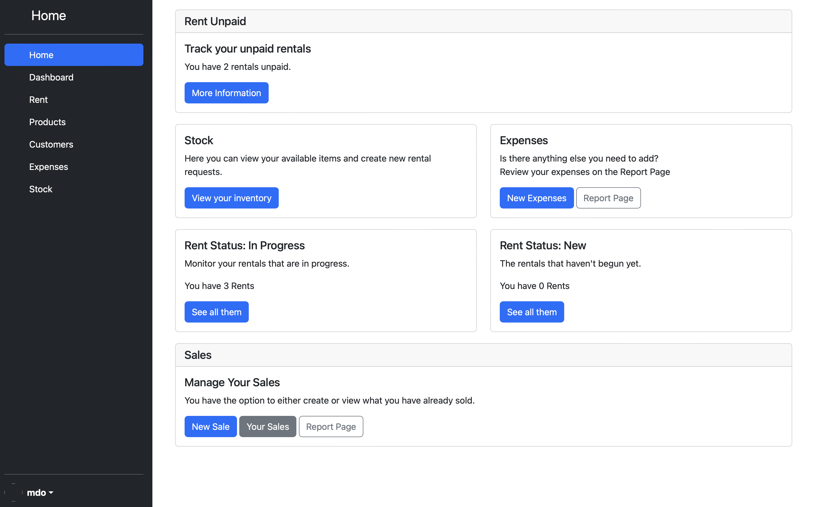

*Figure 2.3.25: AluControl home page.*

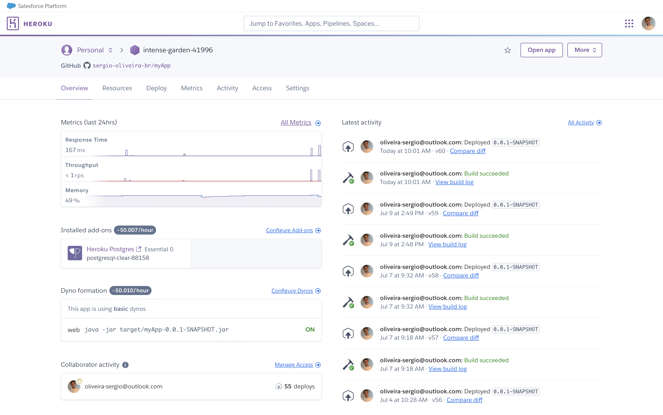

*Figure 2.3.26: Heroku dashboard.*

## Testing

The testing phase is crucial for ensuring that the AluControl system meets the established requirements and operates as expected. This section provides a description of the testing approach used for the system, which includes the testing plan, types of tests performed, execution of tests, and analysis of results.

### *Test Plan*

The test plan is the blueprint for validating the AluControl system. The objective is to ensure that all features are checked and that the system functions correctly in different situations. The test plan includes:

* **Objective:** Ensure that every system function is in compliance with the specified requirements, identify and fix any issues, and check the integration of components.
* **Scope:** Test all aspects of unit, integration, system, acceptance, ad hoc, and sanity.
* **Acceptance Criteria:** Based on functional and non-functional requirements, which include performance, safety, and usability.
* **Resources:** Testing environment, test tools, and end users.

### *Test Type*

Different tests were conducted to guarantee the system's quality and integrity.

#### Unit Test

The objective of unit tests is to validate the individual functionality of each code unit as part of the testing strategy. The use cases defined for the system were directly connected to unit tests to ensure complete coverage and alignment with requirements. The advantages of this approach include:

**Coverage of Requirements**

* **Compliance Assurance:** The purpose of each unit test is to validate the specific functionalities described in the use cases. This ensures that the system meets the functional and non-functional requirements established.
* **Identification of Gaps:** Enables the detection of test coverage gaps and ensures that all use cases are properly tested.

**Documentation and Maintenance**

* **Documentation:** The tests act as living documentation, reflecting the functional requirements of each feature according to use cases.
* **Maintenance:** Supports maintaining system integrity during changes and refactoring.

**Facility of Development**

* **Test-Driven Development:** It allows the use of practices such as Test-Driven Development (TDD) to ensure that the implementation meets the requirements of the use cases from the start.
* **Quick Feedback:** It is easy to fix problems before they become critical by providing immediate feedback during development.

**Priority and Focus**

* **Focus on Critical Features:** Ensures that the system operates as expected by rigorously testing critical and high priority functions.

The tables below highlight some of the mapped tests.



*Figure 2.4.1: JUnit, Mockito Test.*



*Figure 2.4.2: Sanity Test.*

A case study of unit tests that are linked to use cases:

The application must enable users to create product records that can then be linked to rentals or sales.



*Figure 2.4.3: Use case description of the product management.*

The saveProduct method is responsible for checking the availability of the item and saving the record to the database. The unit test must ensure that both conditions are met: whether the item is saved correctly or if an error on conflict on dates or lack of stock occurs, throw an exception.

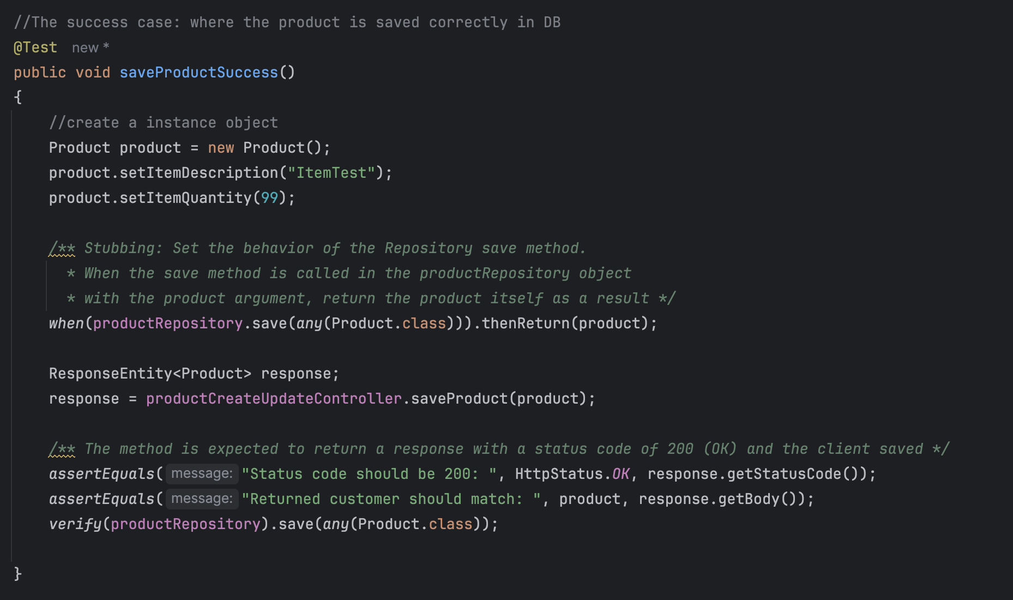

*Figure 2.4.3a: Test method to check if the product is saved correctly.*

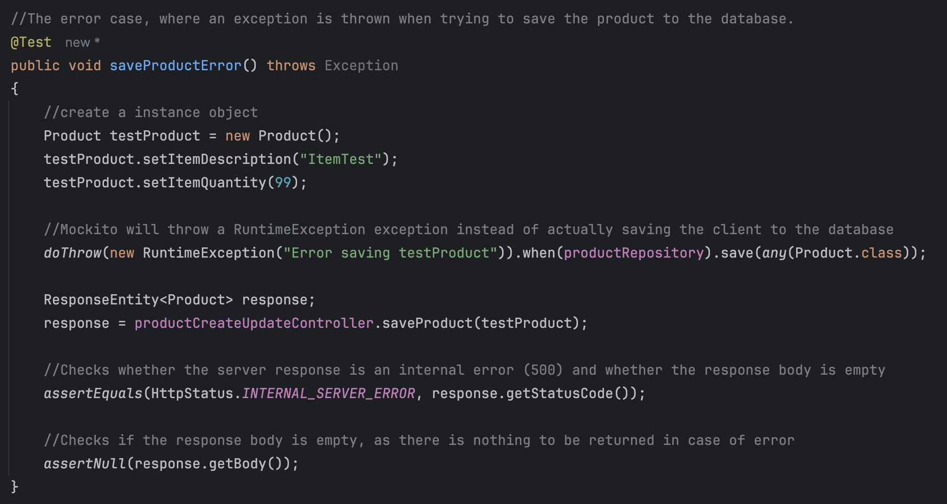

*Figure 2.4.3b: Test method to check if an exceptions is thrown in case of error.*

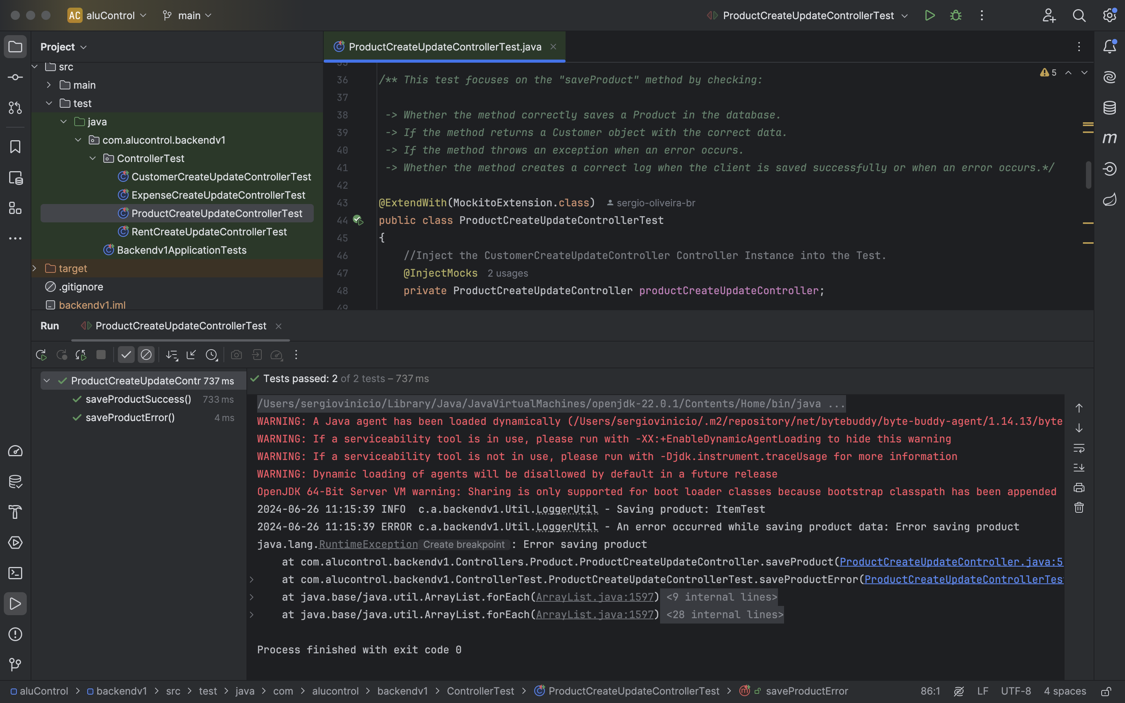

*Figure 2.4.4: JUnit test results of the product tests*

Customers can be created using the app to link them to rentals or sales as described in the use case below.



*Figure 2.4.5: Use case description of the customer management.*

The saveCustomer method is responsible for recording customer data in the database. Therefore, the unit test should ensure that the information is sent and saved correctly or in case of errors an exception must be thrown.

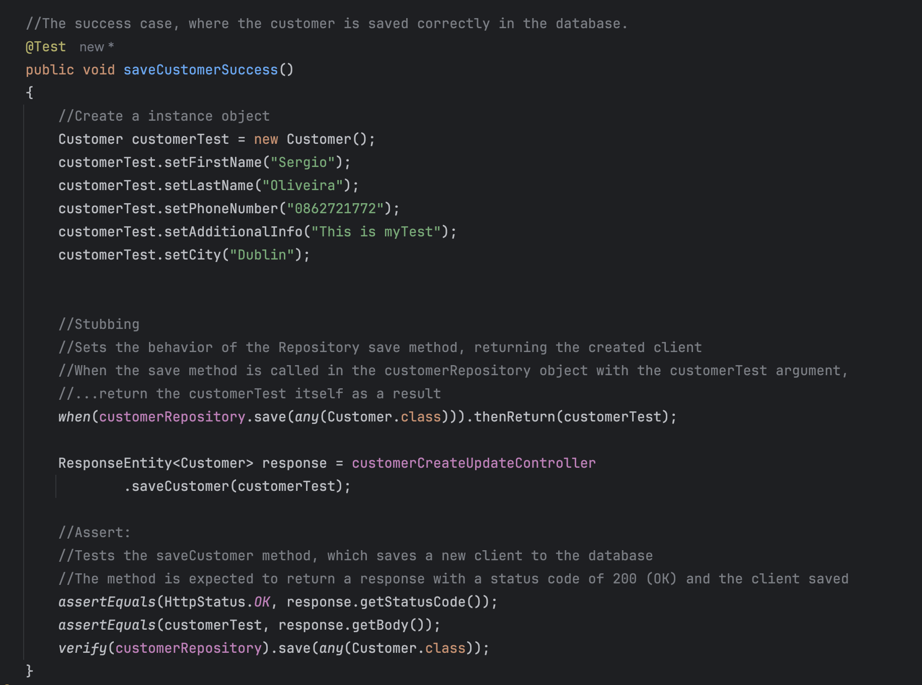

*Figure 2.4.5a: Test method to check if the customer is saved correctly.*

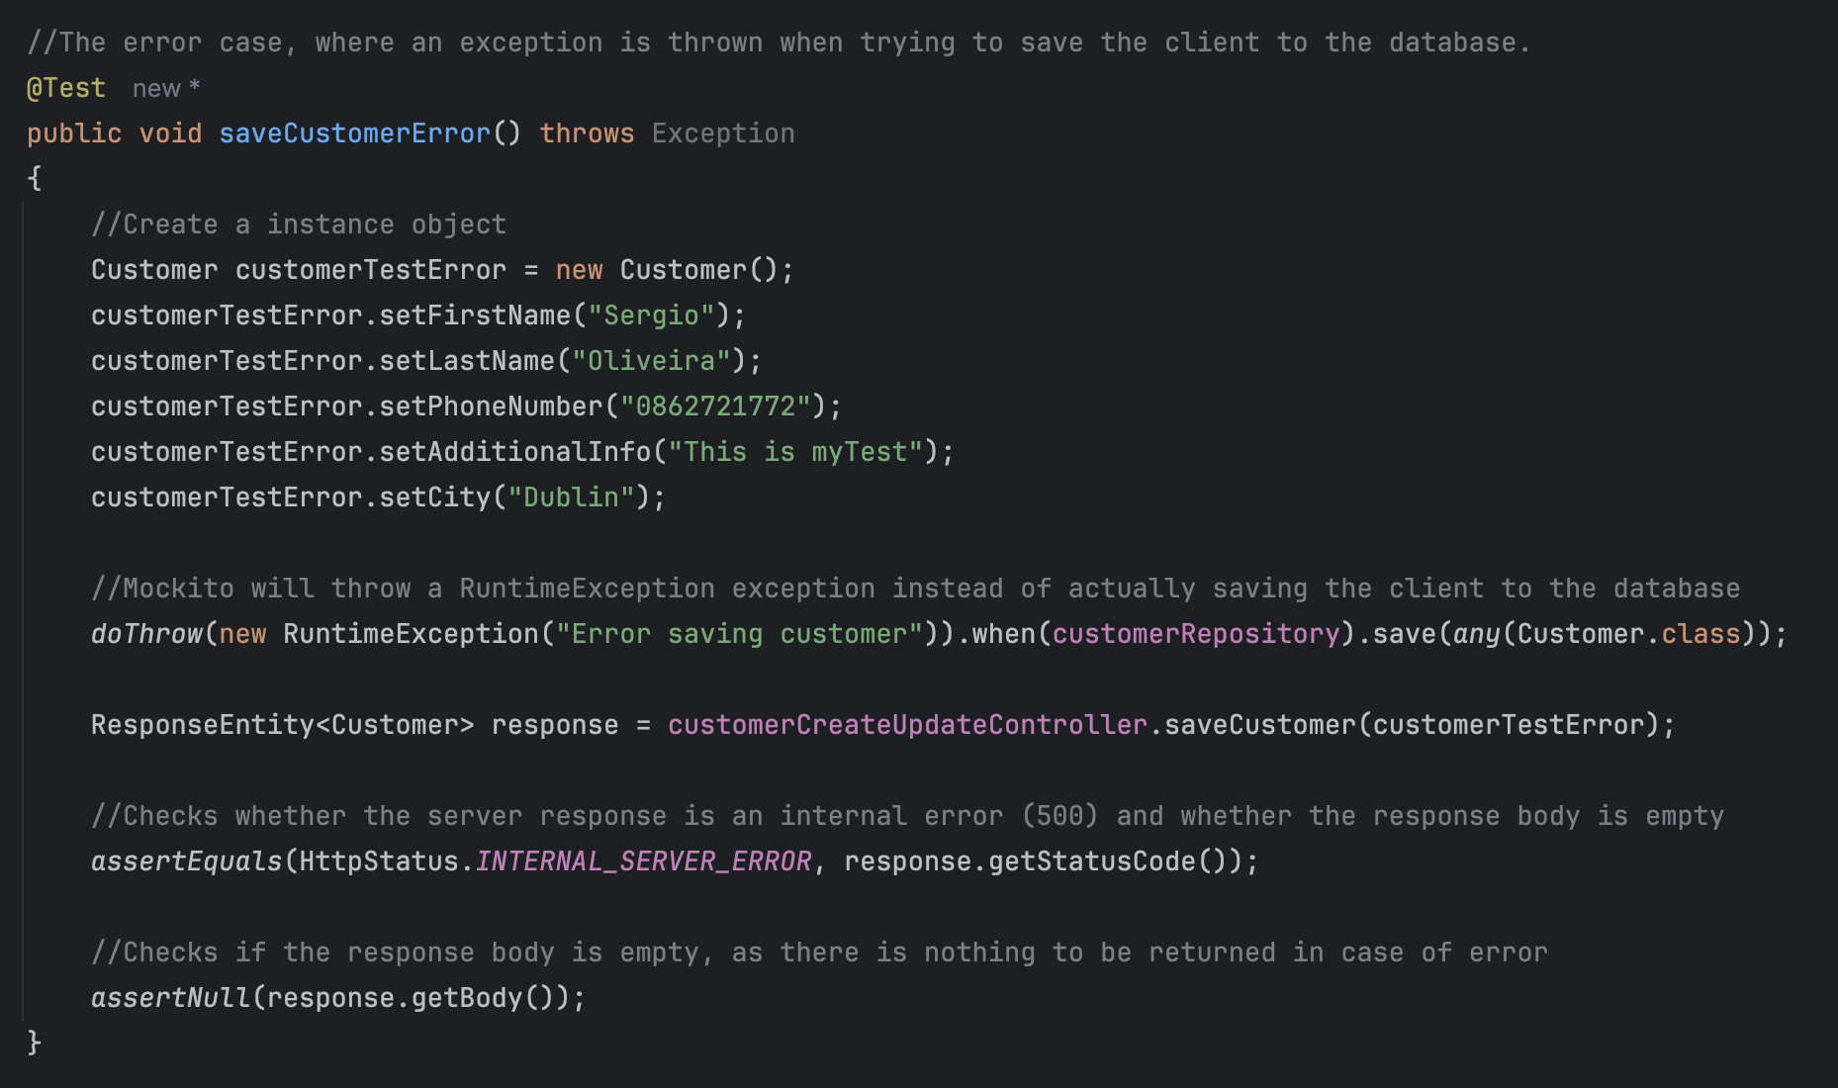

*Figure 2.4.5b: Test method to check if an exceptions is thrown in case of error.*

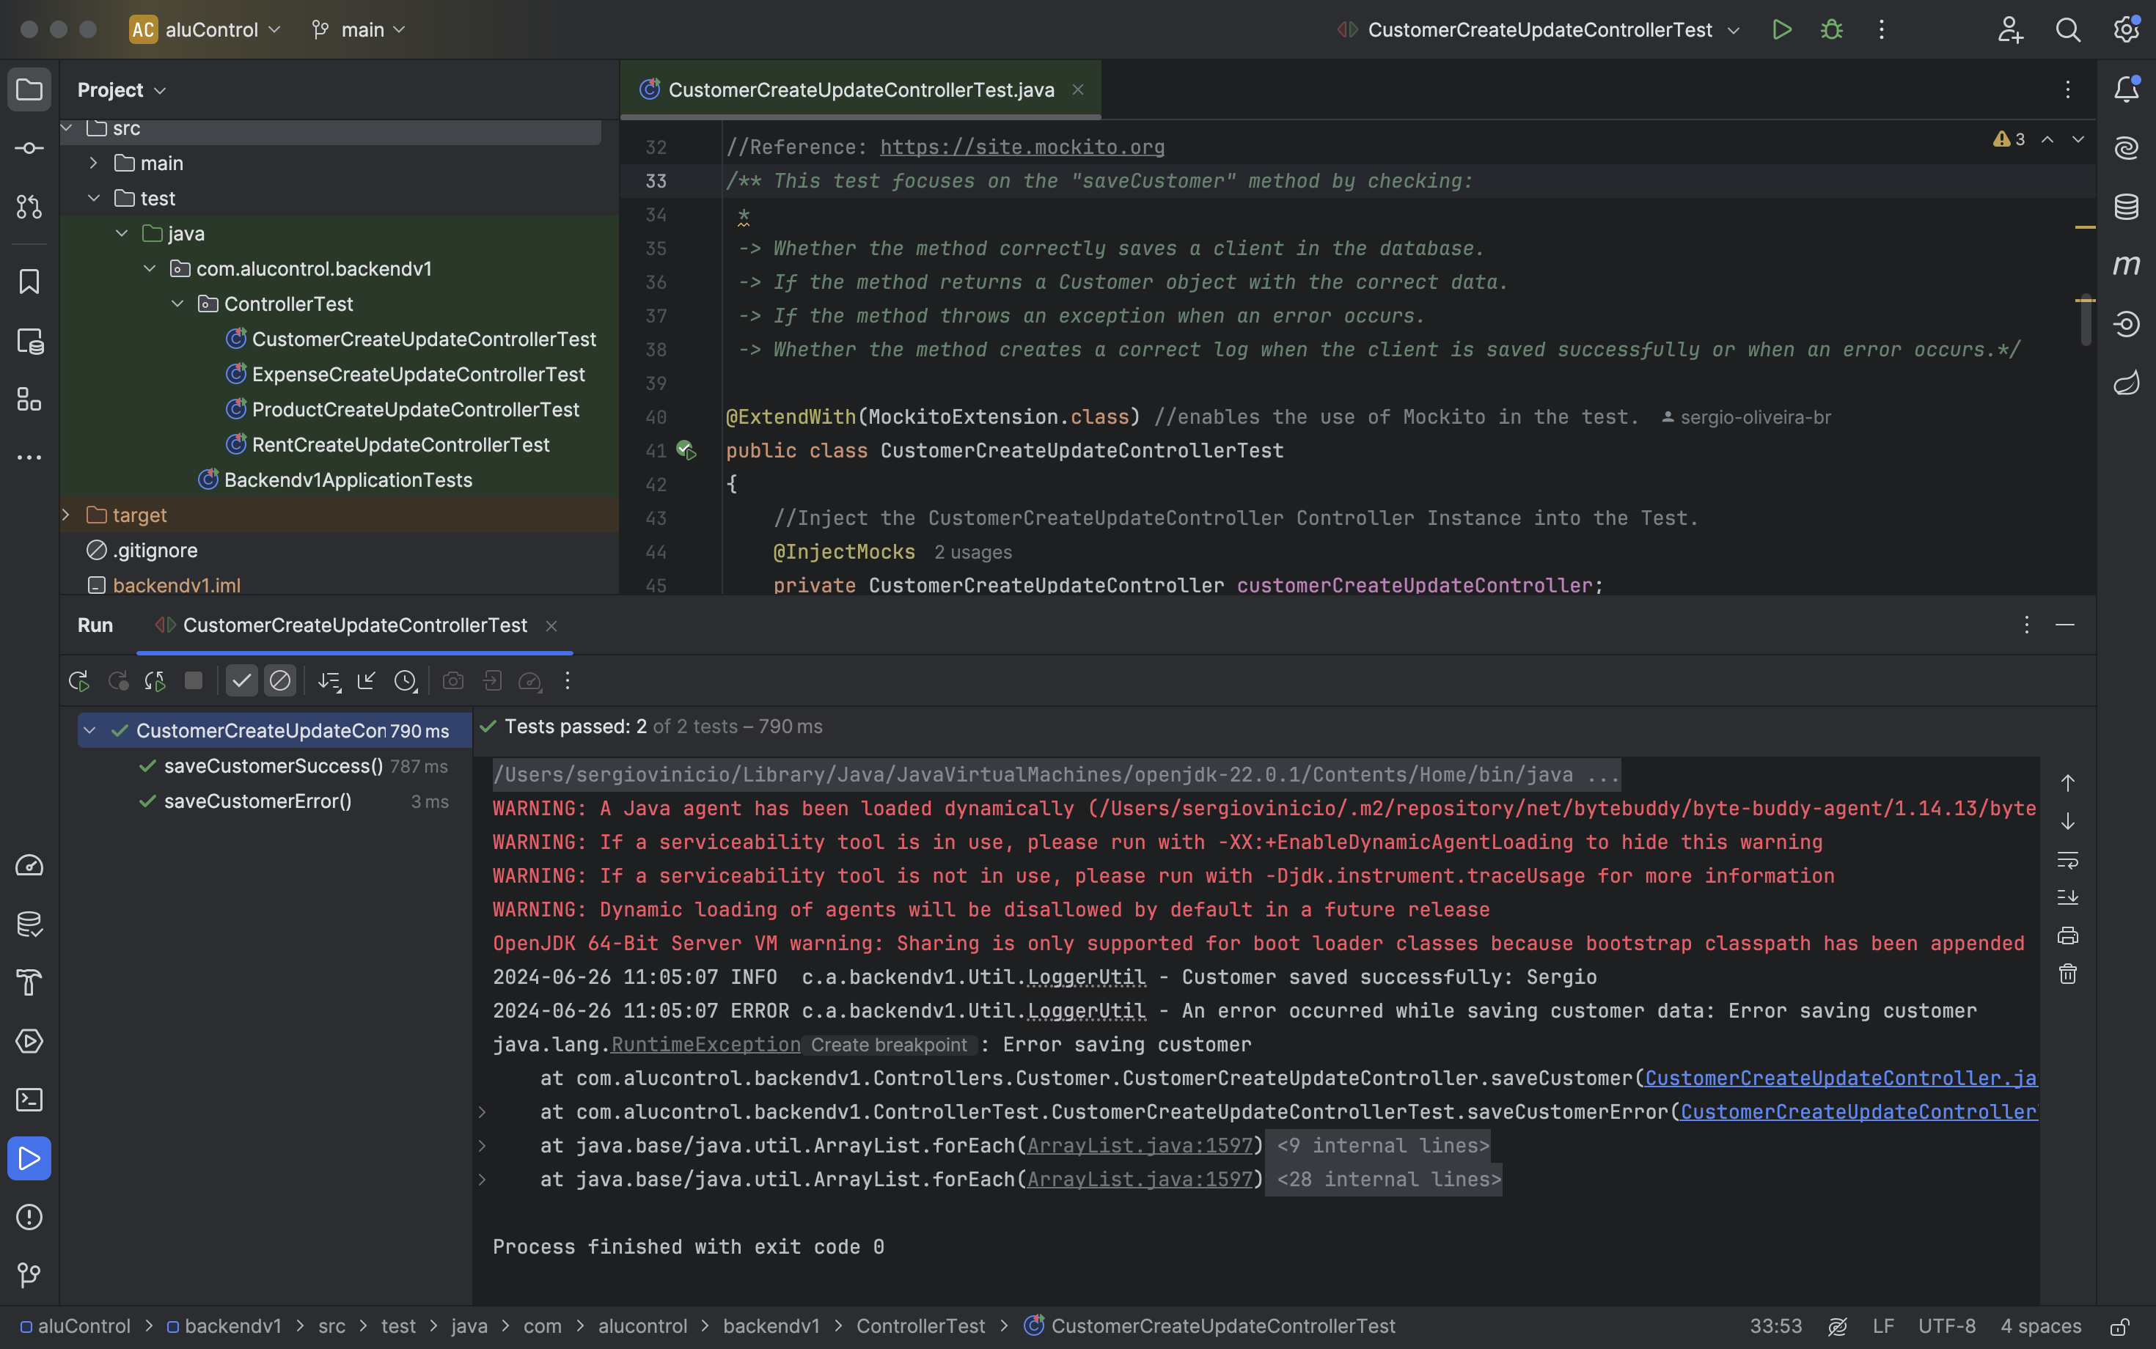

*Figure 2.4.6: JUnit test results of the customers tests.*

AluControl must have the capability to generate rentals or sales, as outlined in the use case below.



*Figure 2.4.7: Use case description of the rent and sales management*

The saveRent method is responsible for recording the rental data in the database. Therefore, the unit test must ensure that the information is sent and saved correctly or in case of errors an exception should be thrown.

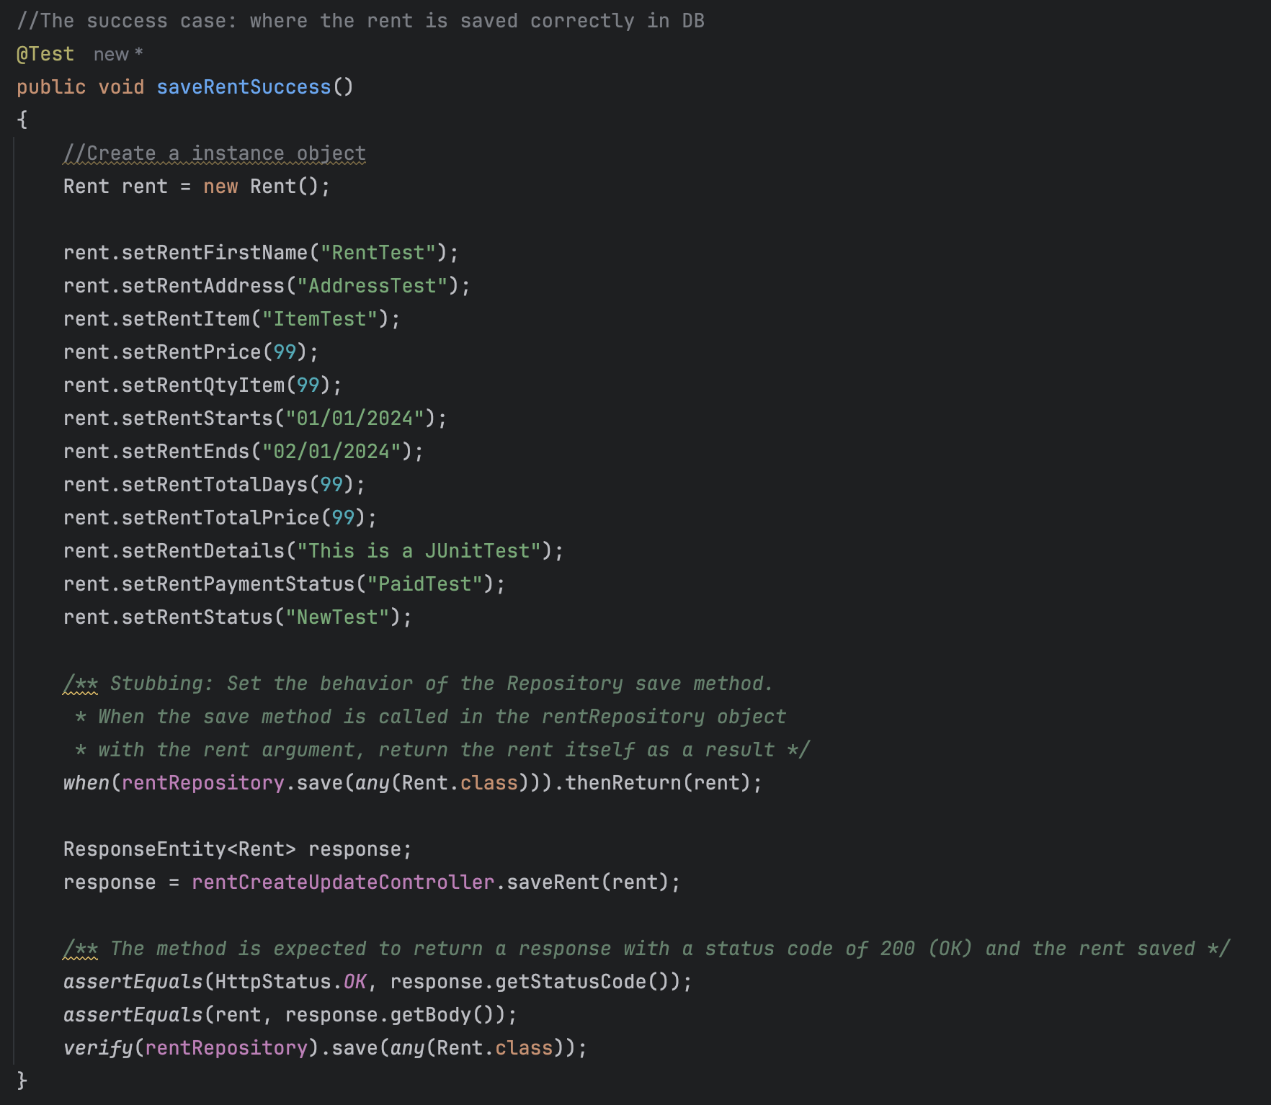

*Figure 2.4.5a: Test method to check if the rent or sales is saved correctly.*

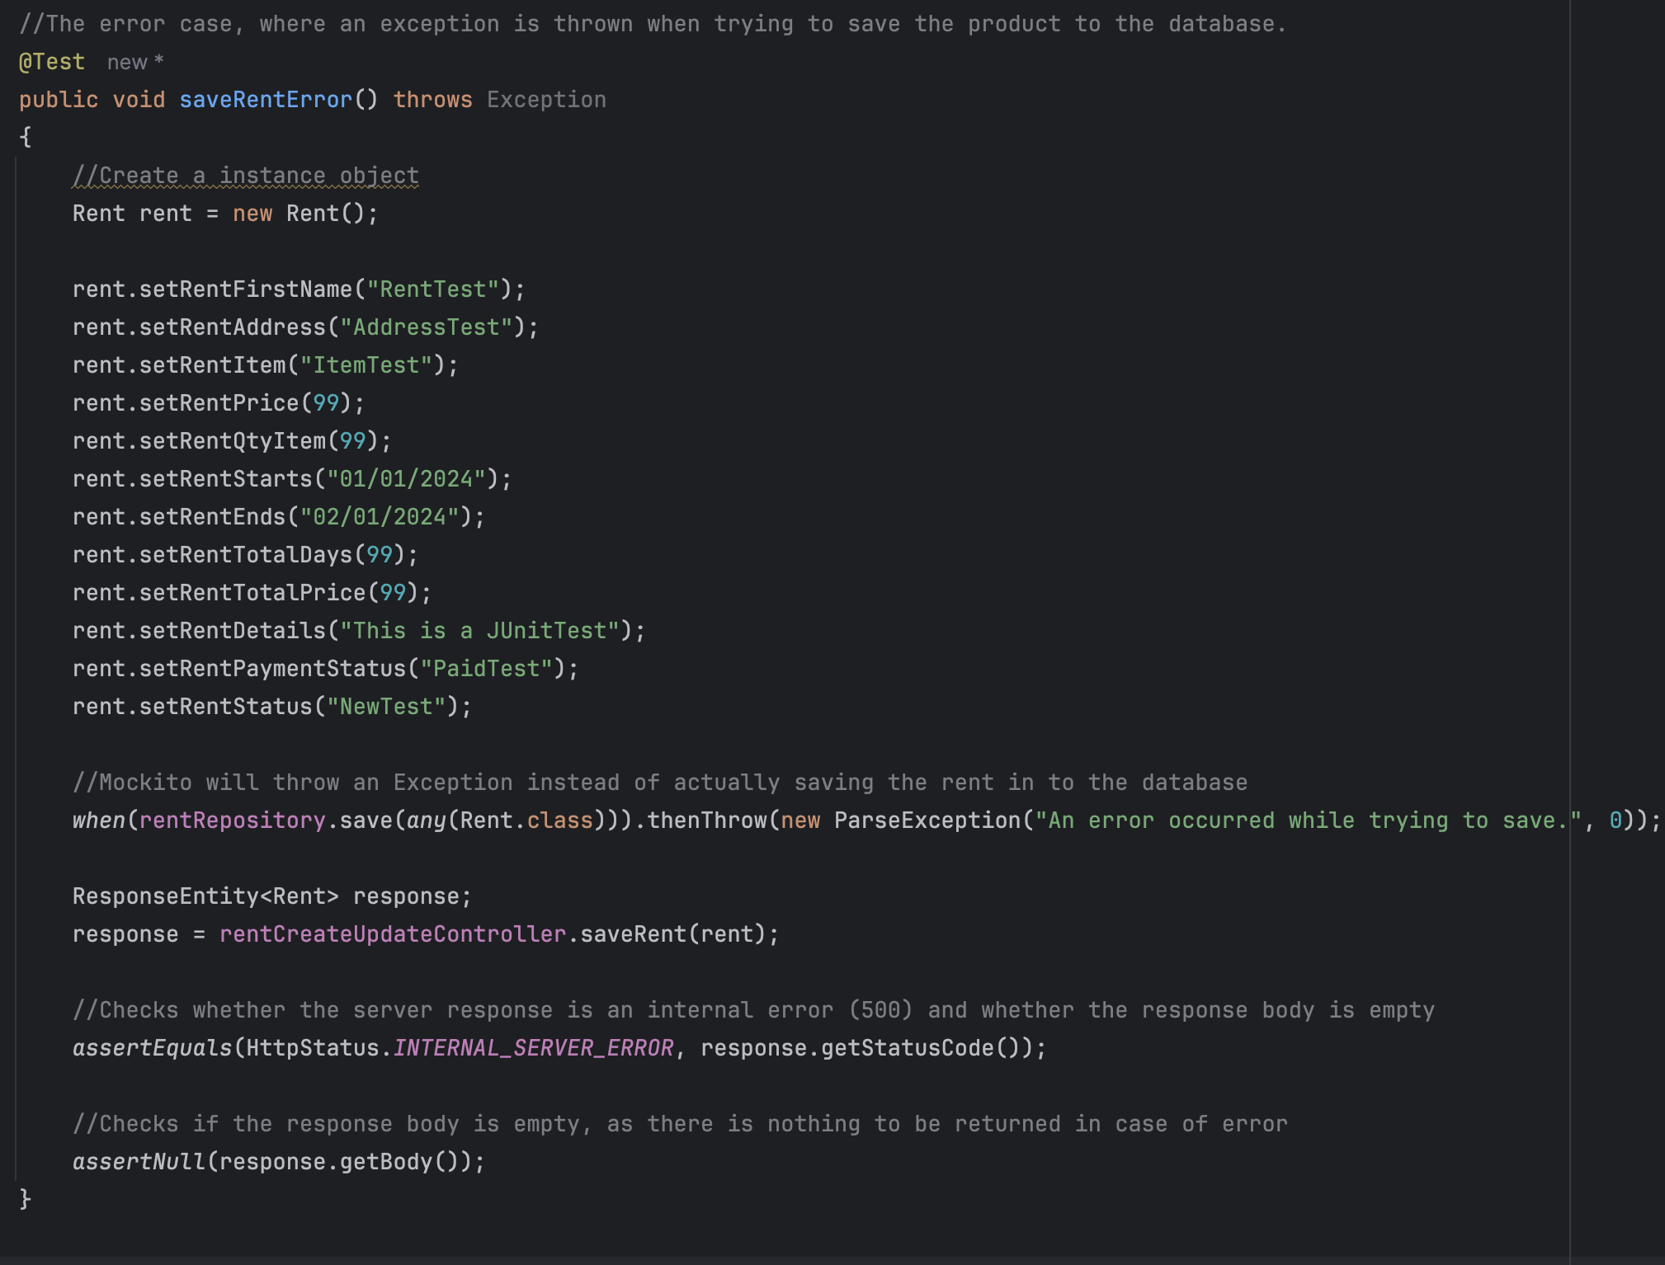

*Figure 2.4.7b: Test method to check if an exceptions is thrown in case of error.*

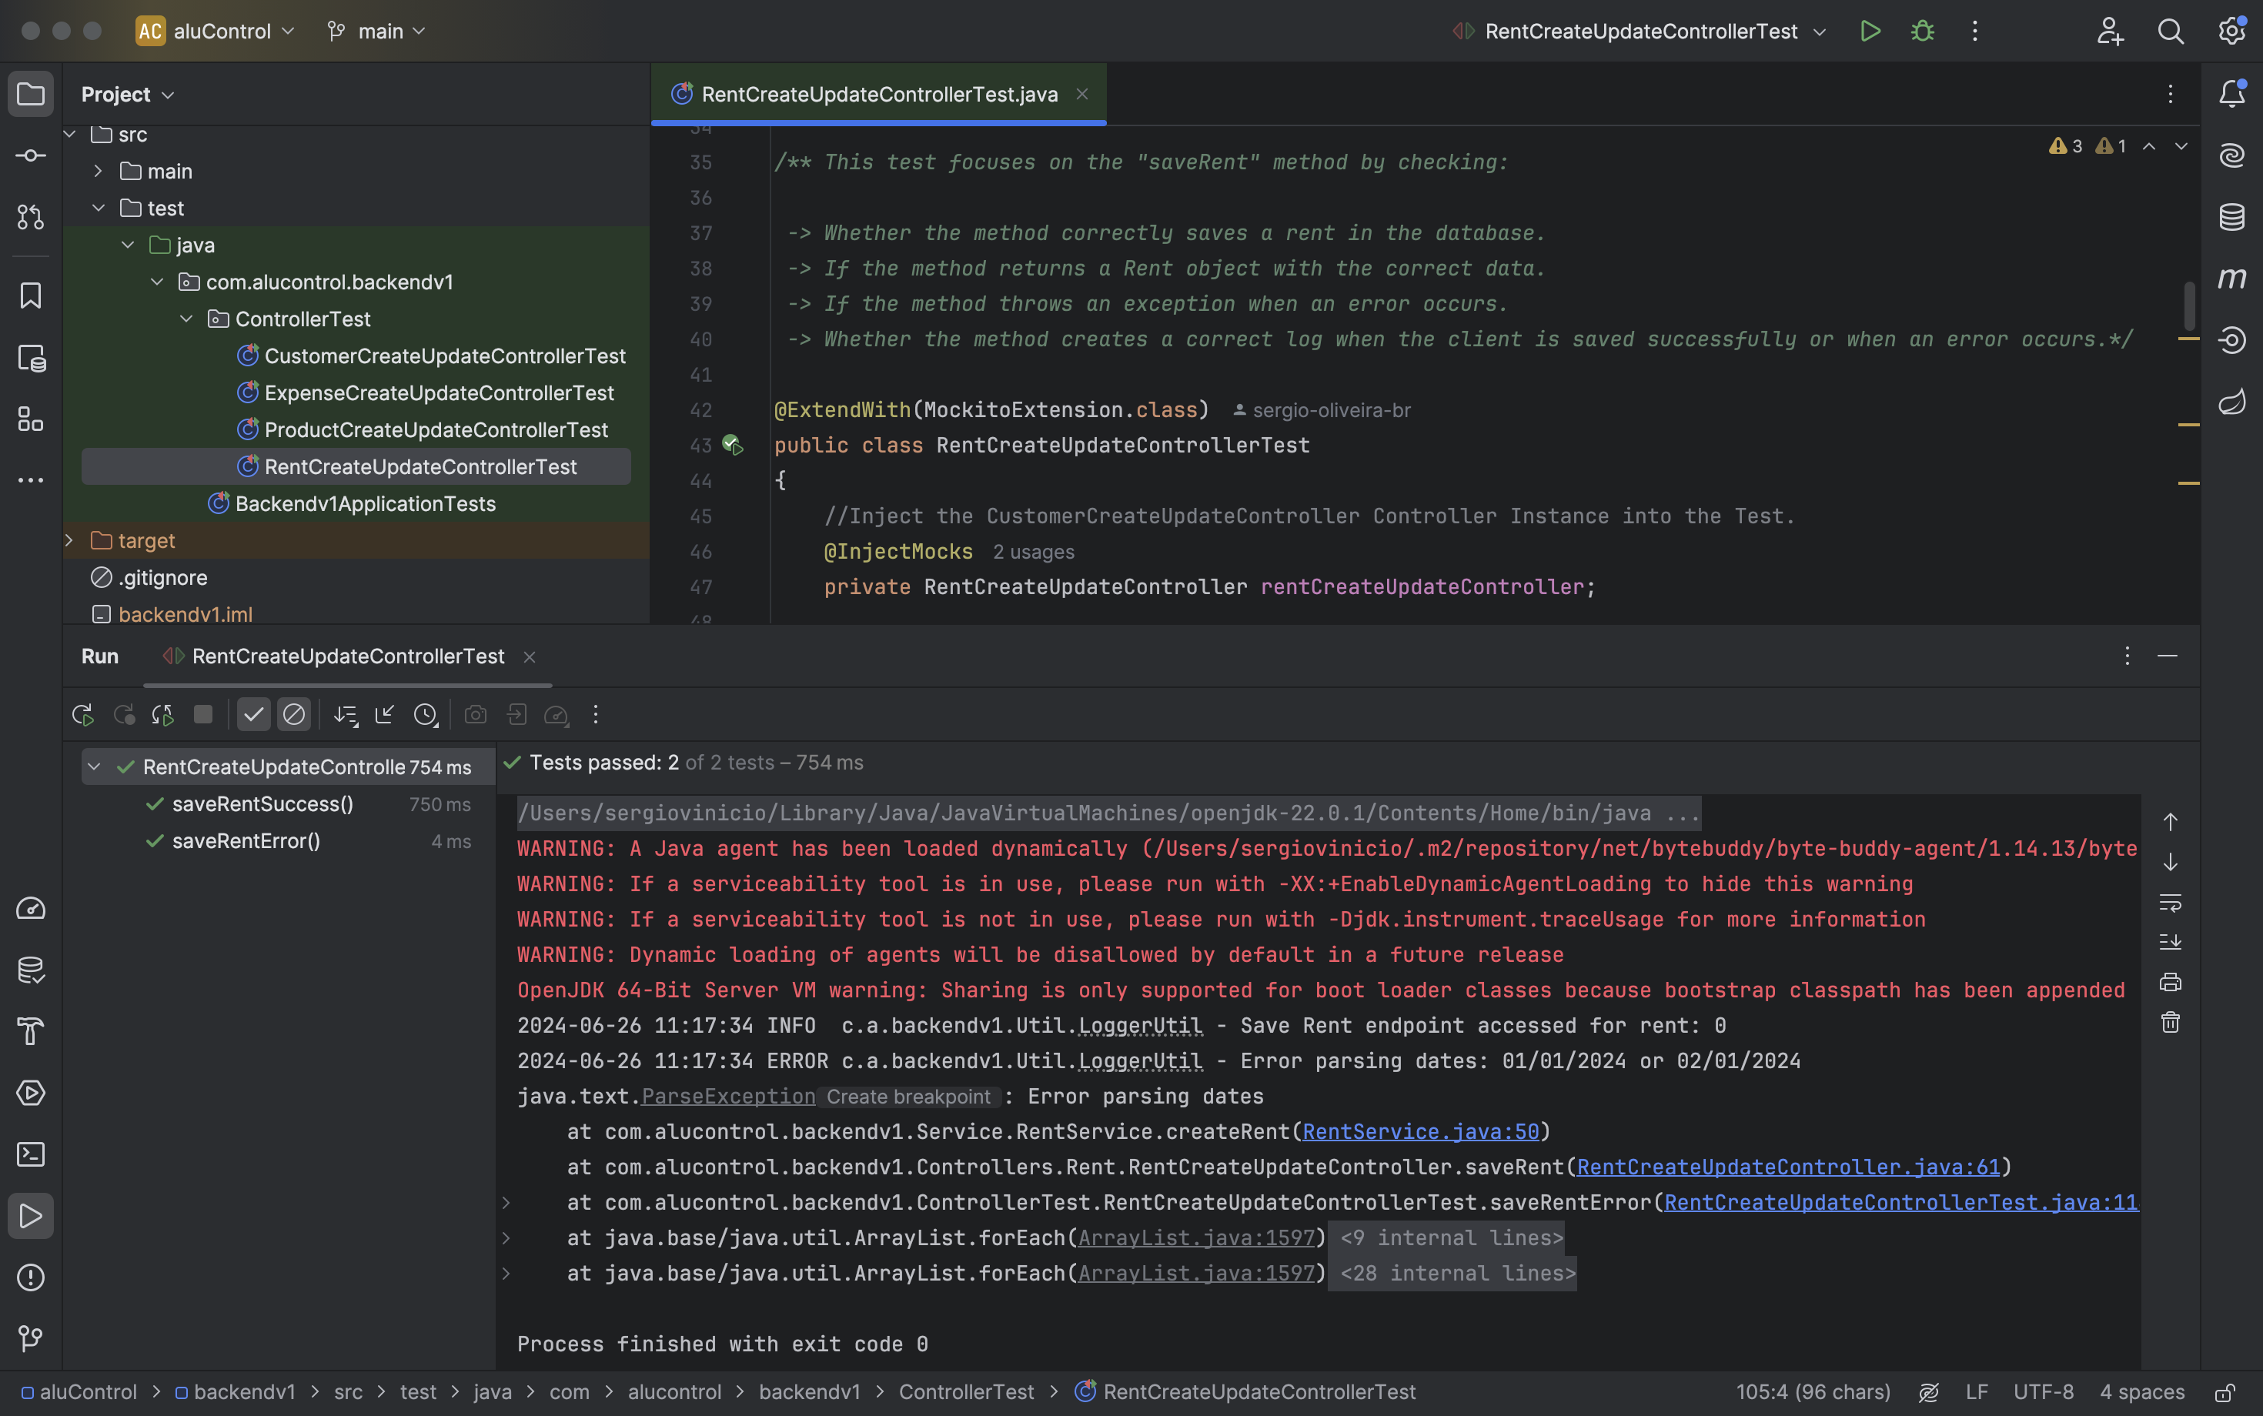

*Figure 2.4.8: JUnit test results of the rent and sales tests.*

AluControl offers a module that enables users to keep track of expenses, as described in the use case below.



*Figure 2.4.9: Use case description of the expenses management.*

The saveExpense method is responsible for recording expenses related to the business. Therefore, the unit test must ensure that the information is sent and saved correctly or in case of errors an exception should be thrown.

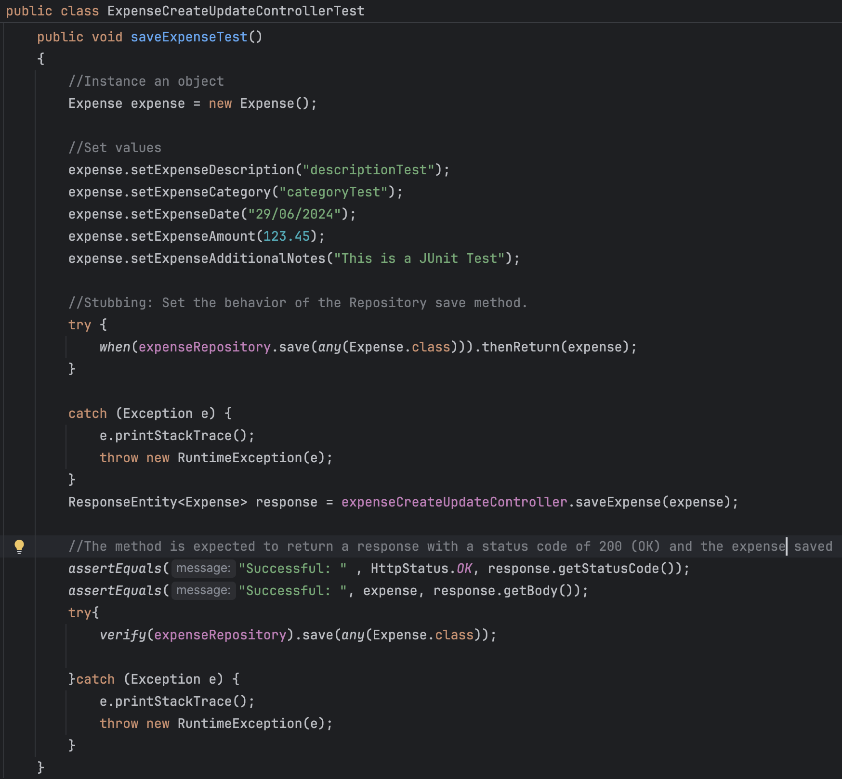

*Figure 2.4.9a: Test method to check if the expense is saved correctly.*

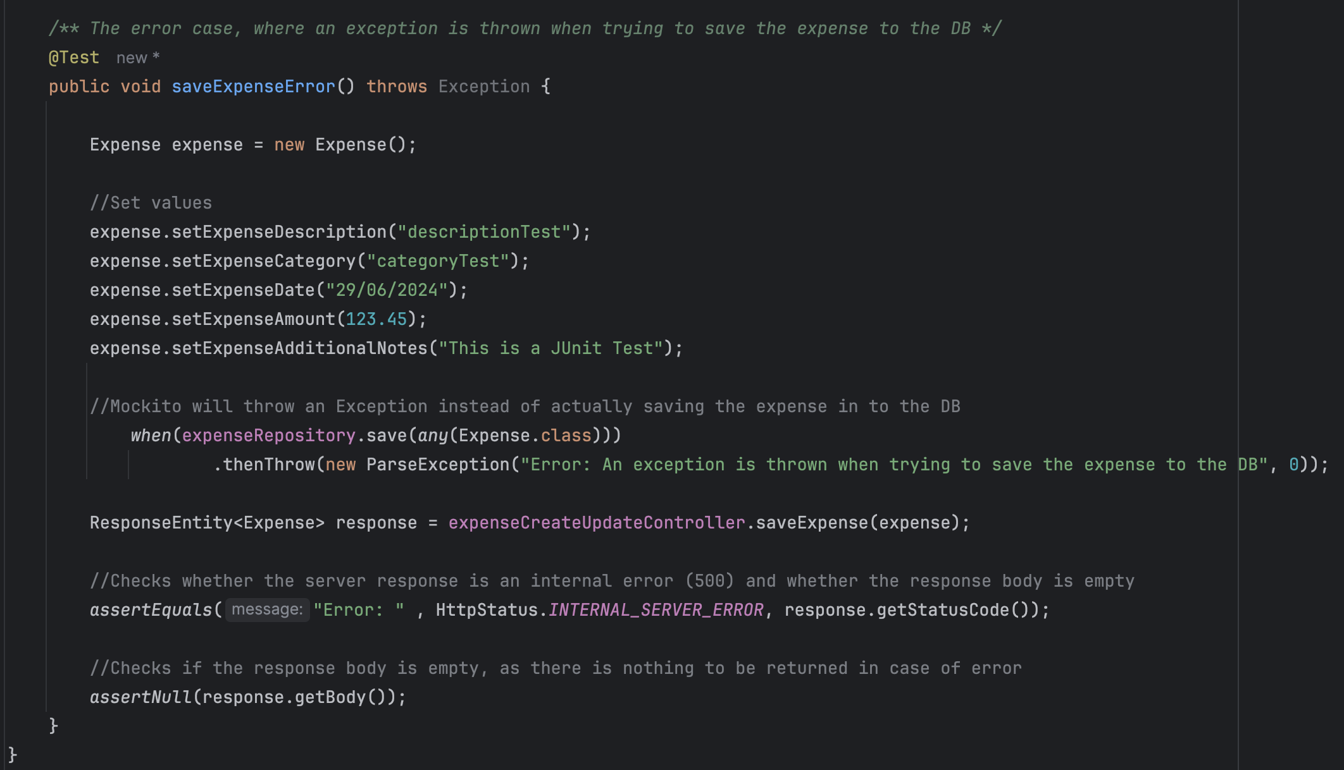

*Figure 2.4.9b: Test method to check if an exceptions is thrown in case of error.*

### *Integration Test*

Integration tests are used to check the interaction between different system modules and the integration with external systems. These tests are crucial in proving that the communication between components works as expected.

* **Integration test with database:** Verify that the data entered through the user interface is stored correctly and retrieved from the database.

### *System Test*

System tests assess the entire system, verifying that all components work together to meet specified requirements.

* **Full Flow Test:** To ensure that all functionality is working together correctly, simulate a complete workflow, such as the creation of customer and product and liked with rent or sale.

### *Acceptance Test*

To ensure that the system meets the acceptance criteria defined by stakeholders and is ready for delivery, acceptance tests were conducted.

* **User acceptance test:** Check if the user interface and functionality meet the expectations of end-users.

### *Ad Hoc and Sanity Test*

In addition to the structured tests, Ad Hoc and sanity tests were conducted to quickly assess the system's integrity and find any unexpected issues. Logs were created and analysed to aid in the identification and resolution of defects for both types of tests.

**Ad Hoc Test**

* **Target:** Find issues that were not captured by the structured tests. These tests were conducted in an exploratory way to evaluate areas that were not formally covered.
* **Logs:** To record actions and events in the system, detailed logs were created during the Ad Hoc tests. These logs helped identify unexpected behaviours and made it easier to investigate problems encountered during testing.

**Sanity Test**

* **Target:** Ensure that any new code modifications do not cause significant errors in the system. Quick tests were conducted to ensure that the system is still working as expected after the recent changes.

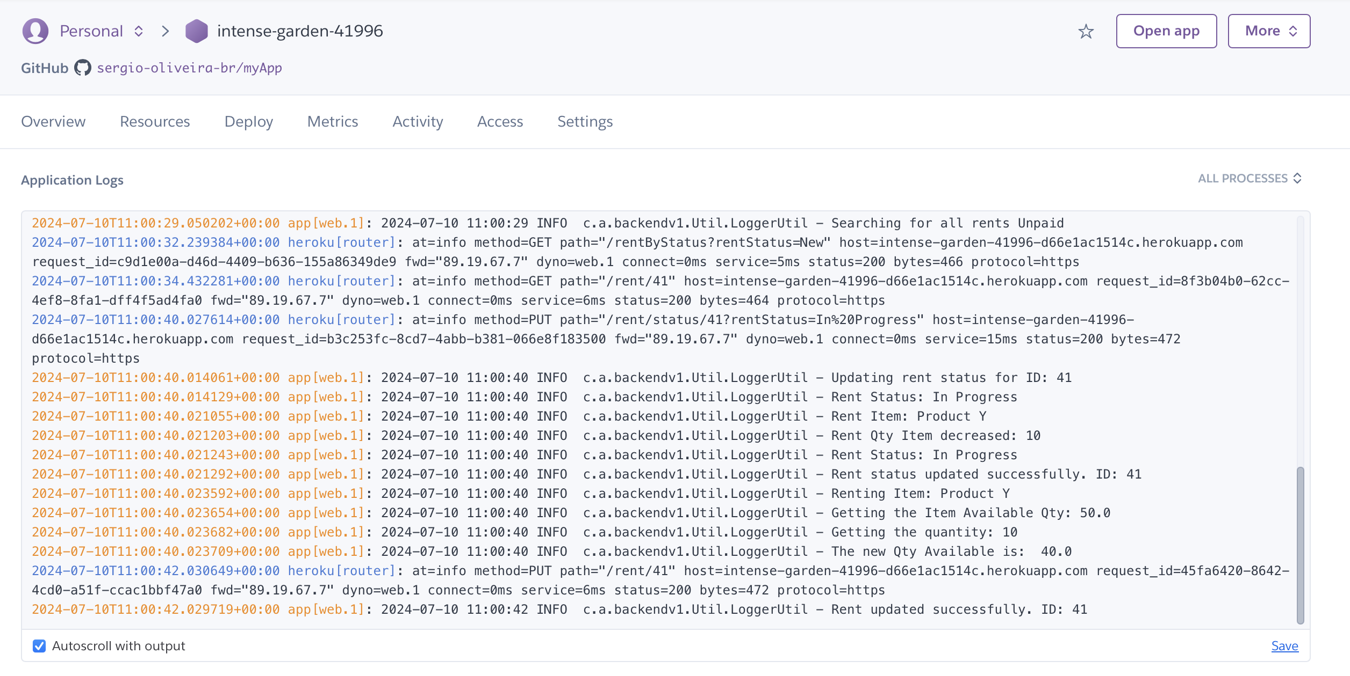

*Figure 2.4.11: An example of ad hoc and sanity. Logs were created to document system behavior, and can be access on host page Heroku.*

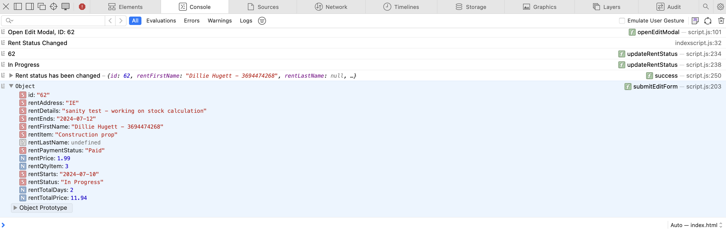

*Figure 2.4.12: An example of ad hoc and sanity. Logs were created to keep track of system behaviour.*

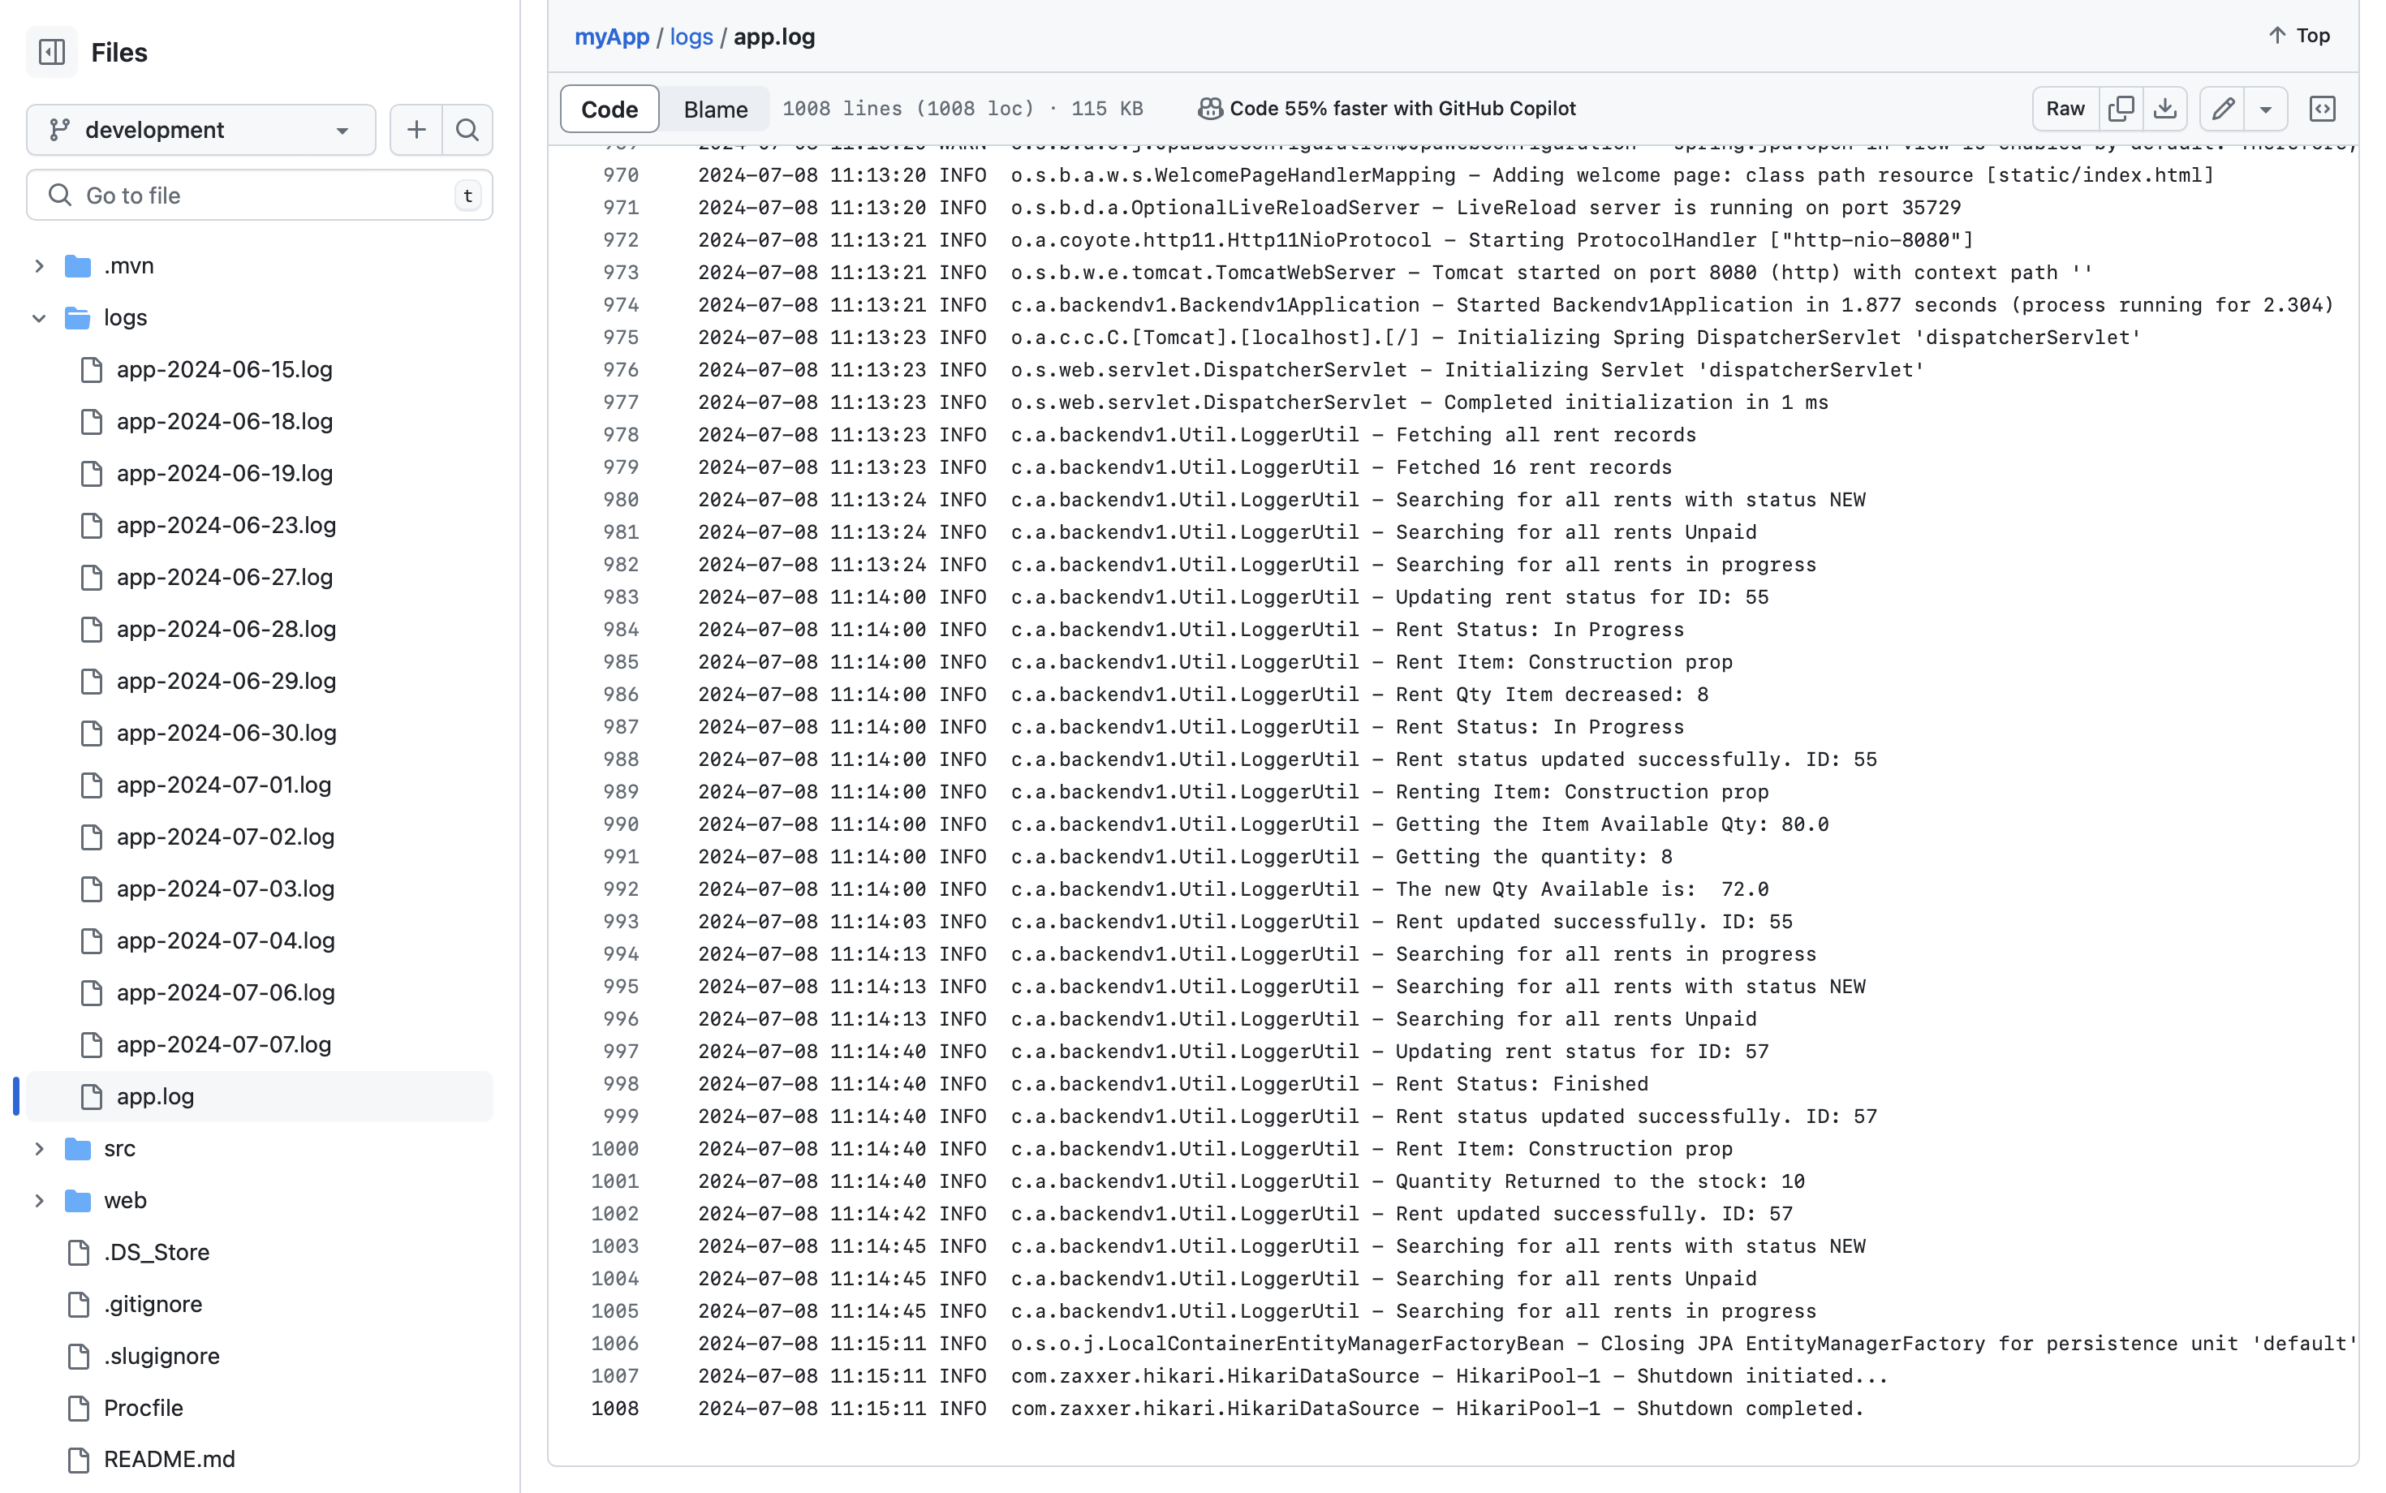

*Figure 2.4.13: An example of ad hoc and sanity. Logs were created to document system behavior, and can be accessed in my GitHub Repository.*

### *Conclusion*

By adopting the testing approach in the AluControl system, complete and effective coverage is guaranteed, in line with the requirements and defined use cases. The association of unit tests to use cases provides a precise and robust validation of functionalities, while integration tests, system and acceptance ensure the overall quality and compliance of the system. Ad hoc and sanity testing, along with detailed logs, are complementary to the strategy and ensure quick problem identification and system integrity maintenance.

## Graphical User Interface (GUI) Layout

The focus of this section is on the layout of the GUI and how users interact with the AluControl system. The main screens of the system are shown below, with explanations of their functions and design provided. Furthermore, the relevant wireframes are presented to demonstrate the design and development process.

### *Index Page*

The initial page provides a summary of the primary metrics and features that are available.



*Figure 2.5.1a: Wireframe of index page.*

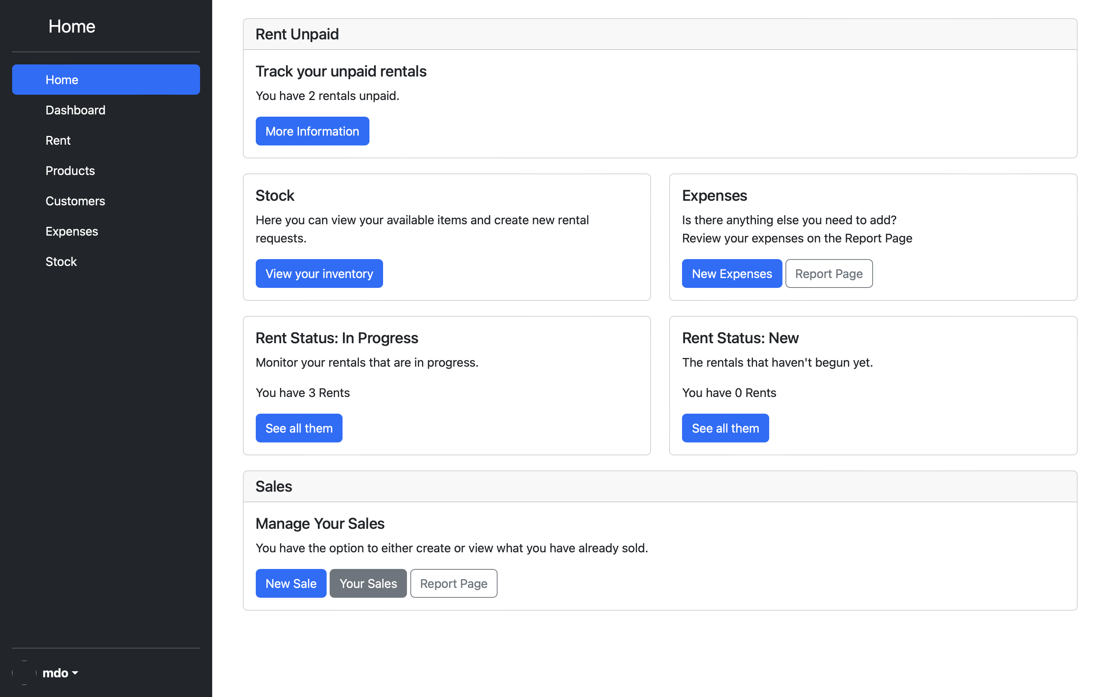

*Figure 2.5.1b: Index screen.*

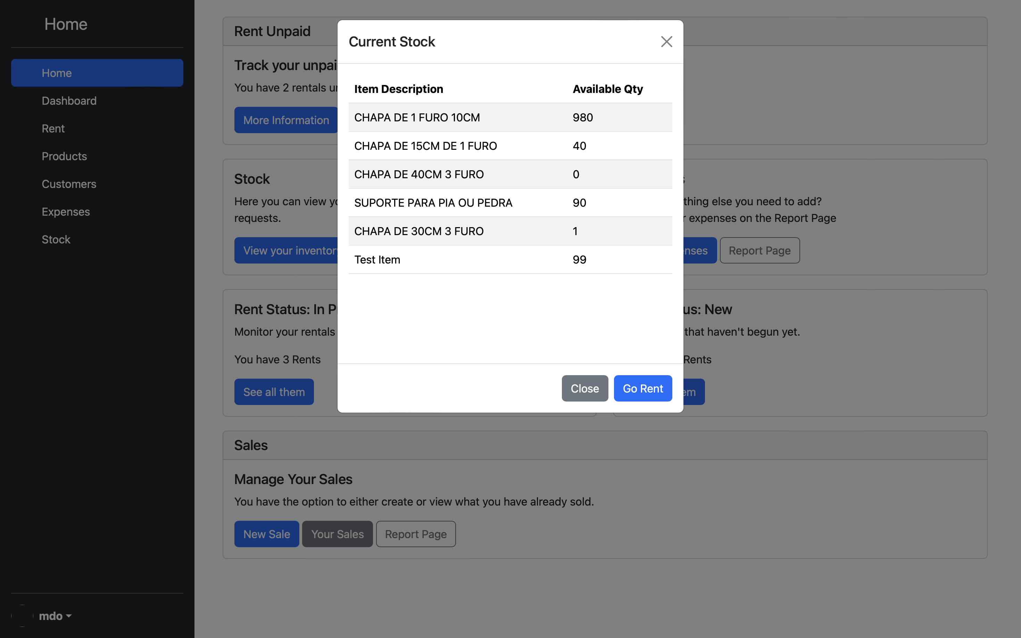

*Figure 2.5.2* *Table displayed by clicking on the “View your inventory” button on Index Page.*

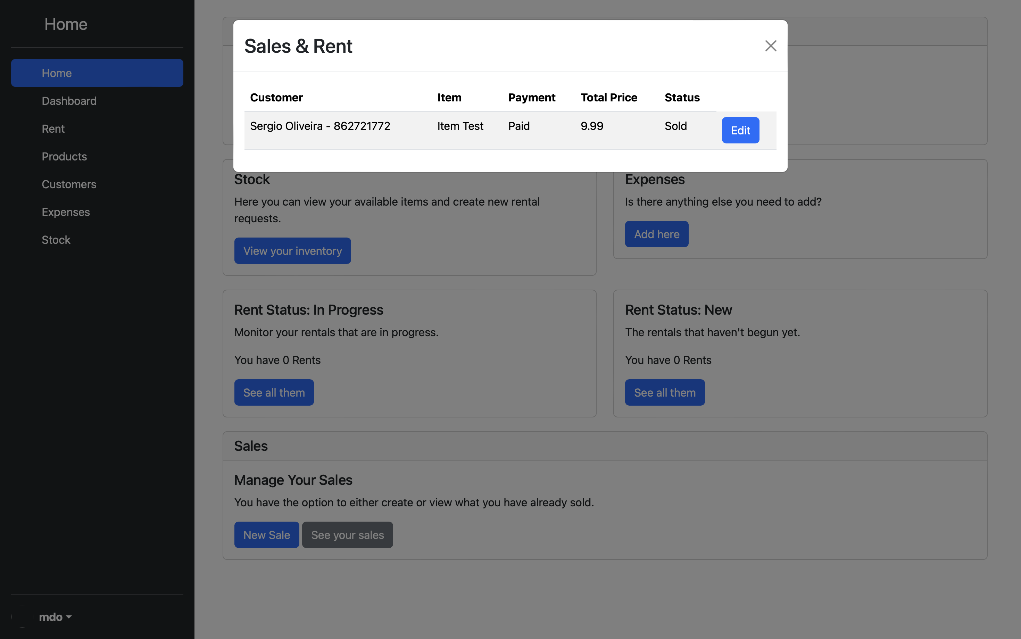

*Figure 2.5.3* *Table displayed by clicking on the “See your sales” button on Index Page.*

**Description and Features**

The index page is the core of the system management, providing users with a clear and immediate view of critical information. Includes a side navigation menu for easy access to different sections of the system, management indicators such as the rent status, available stock and payment details, and quick access buttons for frequent actions, such as creating a new sales/rent or registering a new expense.

### *Dashboard Page*

The dashboard page contains graphic resources that logically illustrate current business data to help users make decisions.



*Figure 2.5.2a: Wireframe of dashboard page.*

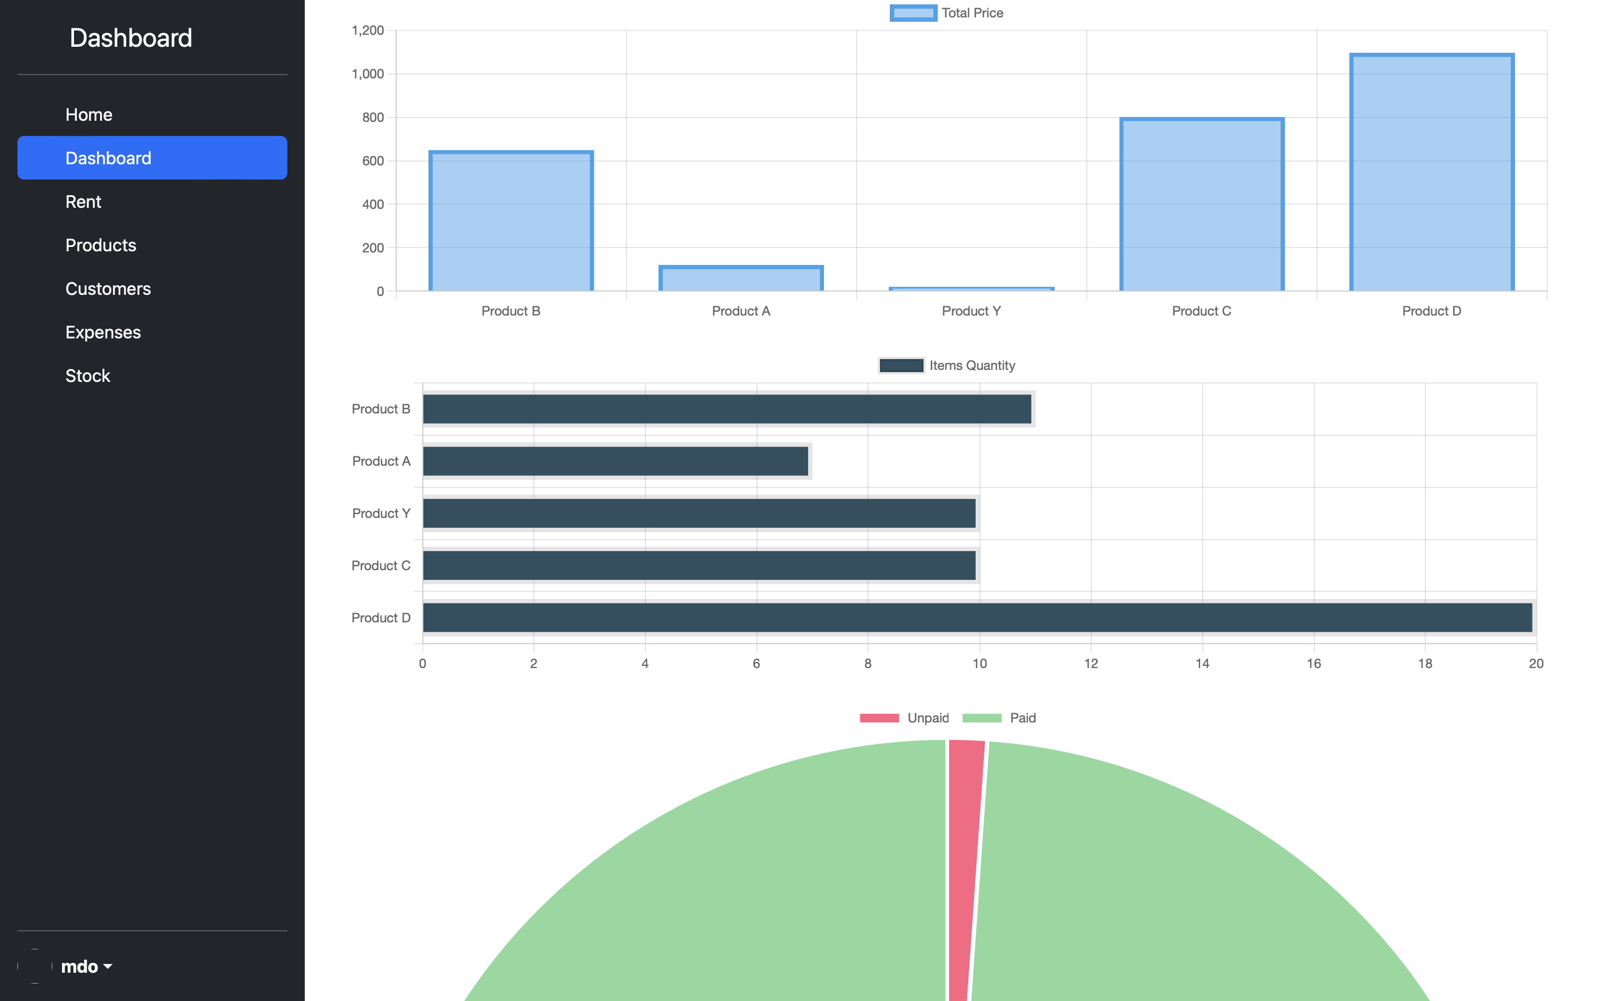

*Figure 2.5.2b: Dashboard screen.*

**Description and Features**

The page of dashboard has a proposal to present to users a graphical view of the relevant information for the management of the business. Includes a side navigation menu for easy access to different sections of the system, and key indicators such as the aggregate value and quantity of each item sold or rented, and the revenue billed and expected to receive.

### *Product Page*

Users can add and edit products as needed on the product management screen.



*Figure 2.5.3a: Wireframe of products page.*

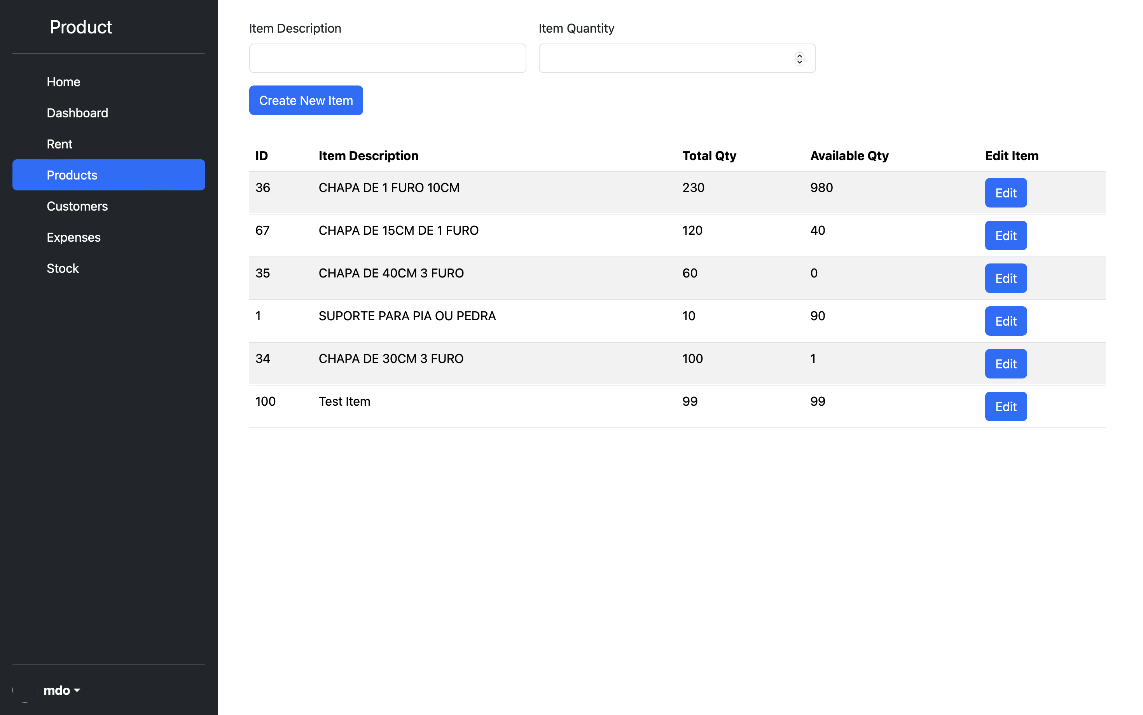

*Figure 2.5.3b: Products page.*

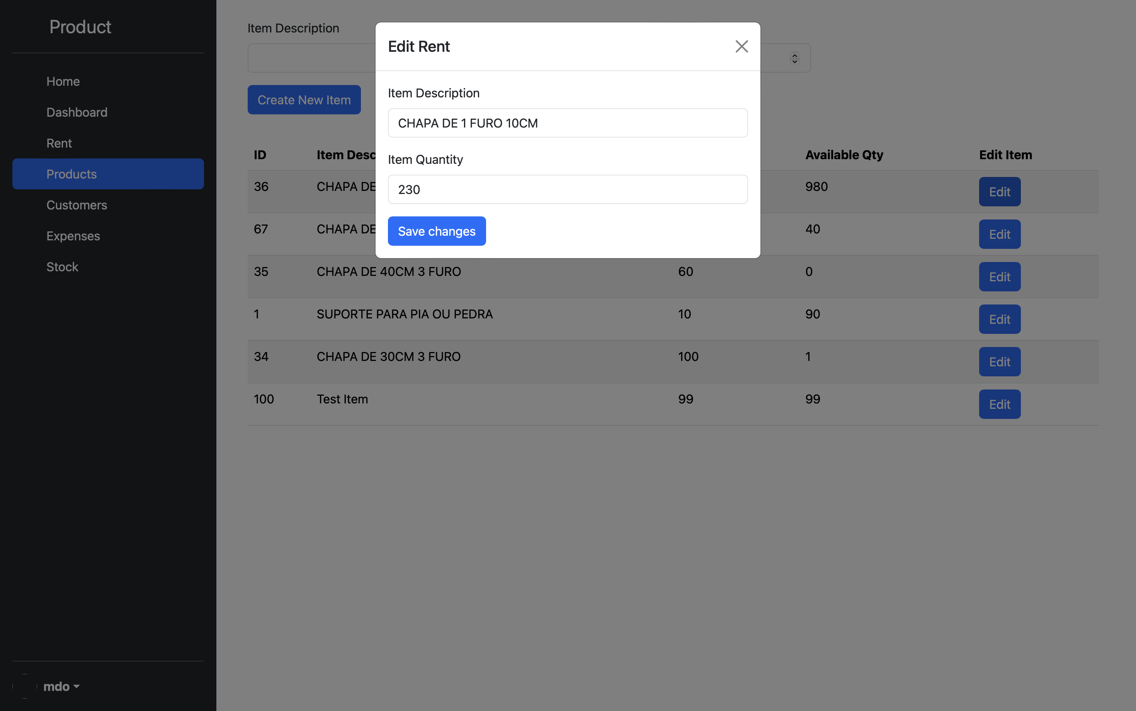

*Figure 2.5.3c: By clicking on the 'Edit' button, the user can access a popup that allows them to edit the product information.*

**Description and Features**

This interface displays a form that allows the user to create a product by entering description and quantity. It also displays a table with all registered products, showing detailed information such as description, quantity in stock and available quantity. Product information can be updated or added through the use of an edit form button. Also includes a side navigation menu for easy access to different sections of the system.

### *Customer Page*

In the customer management screen, users have the ability to add and edit customers as needed.



*Figure 2.5.4a: Wireframe of customer page.*

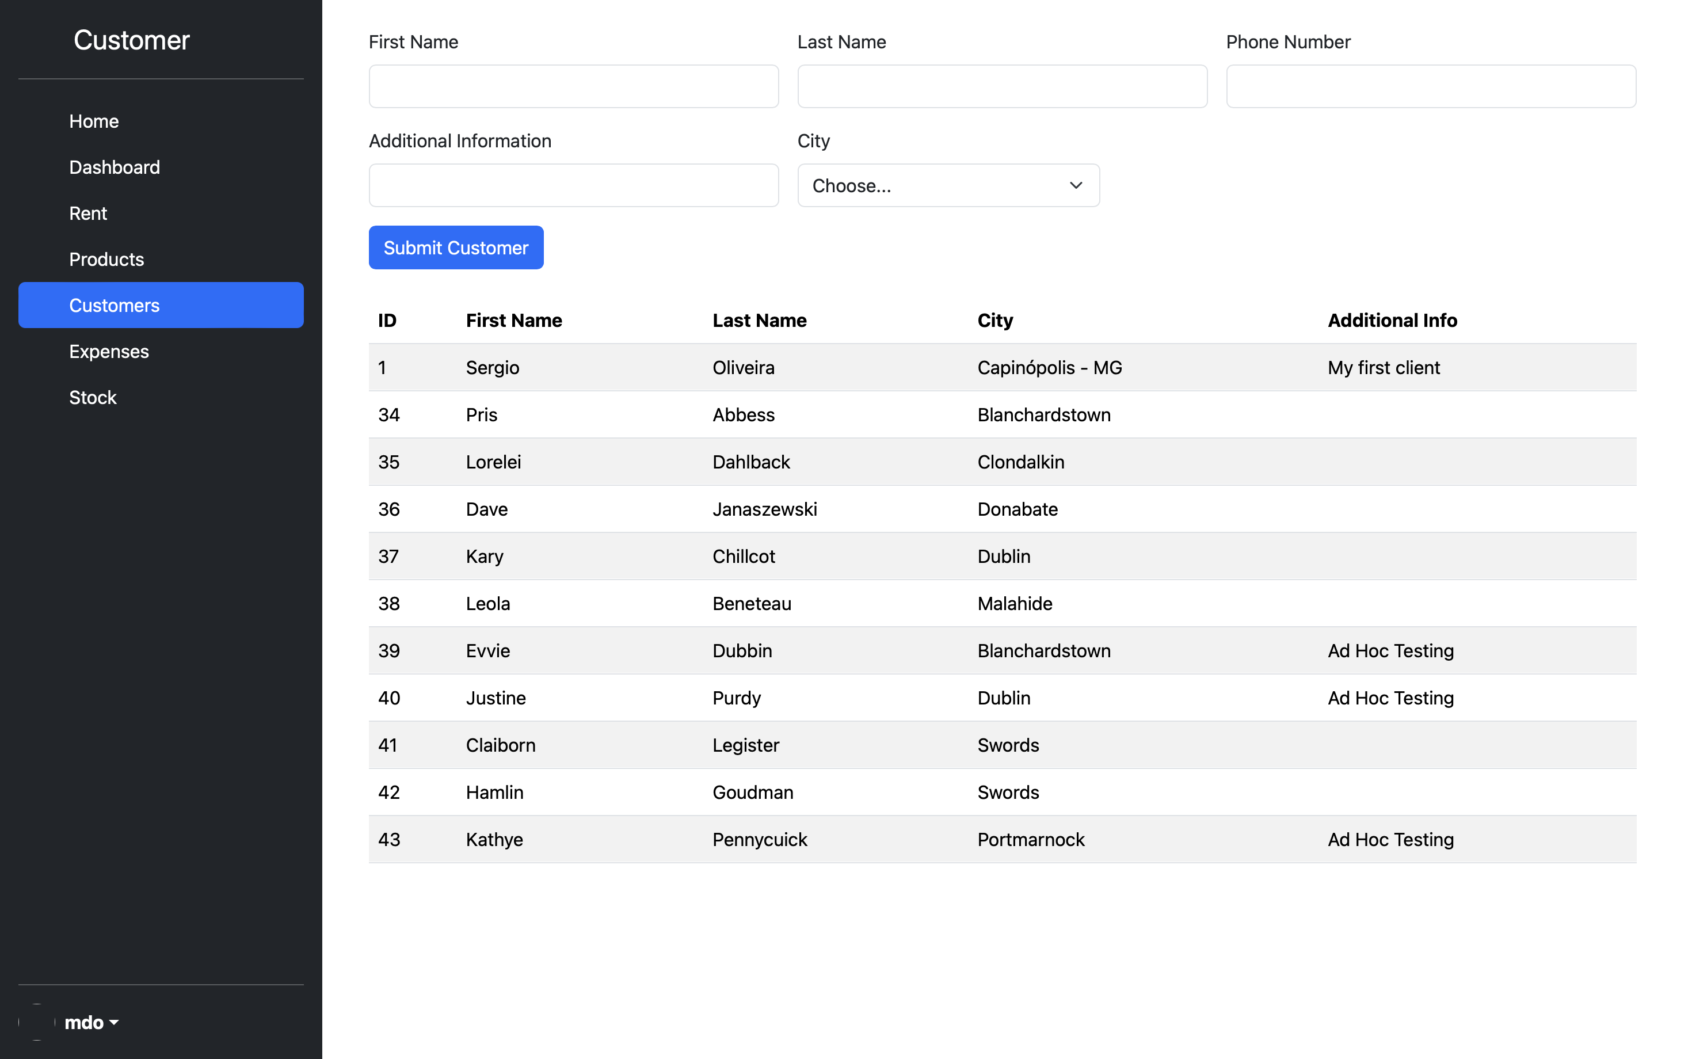

*Figure 2.5.4b: Customer page.*

**Description and Features**

This interface displays a form that allows the user to include new clients in the database. It also displays a table with all registered customers showing detailed information. It also includes a side navigation menu for easy access to different sections of the system.

### *Rent and Sales Page*

In the rent and sales page, users have the ability to create and edit sales or rents by associating items and customers present in the database.



*Figure 2.5.5a: Wireframe of rent and sale page.*

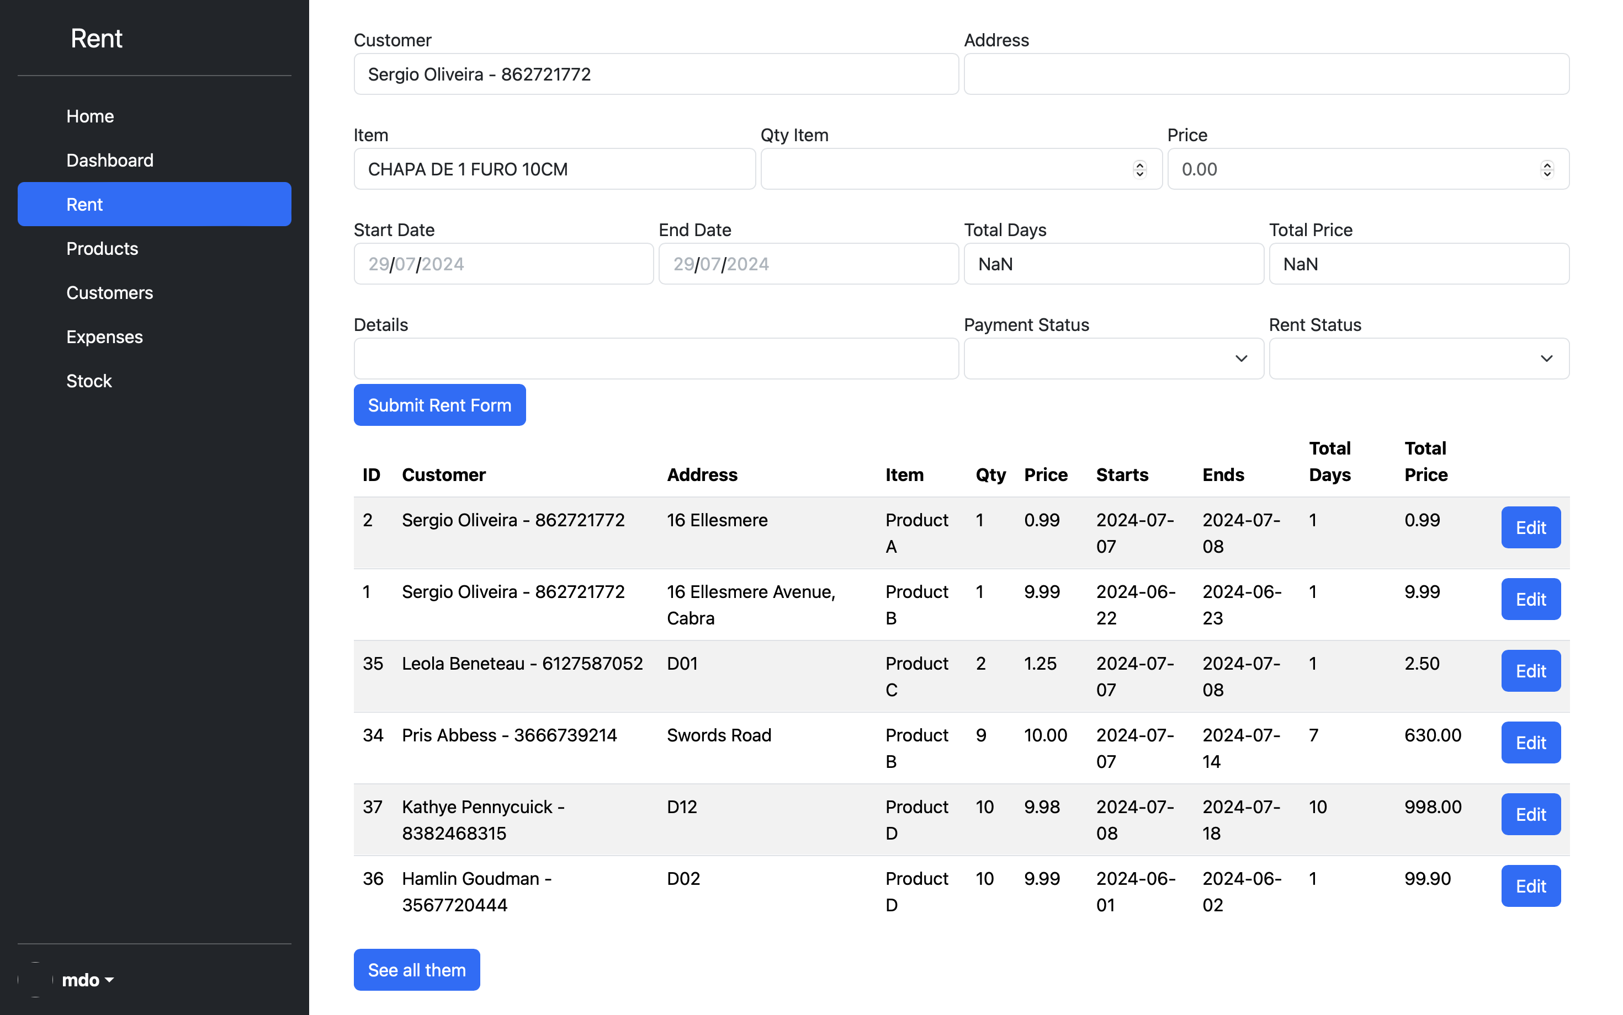

*Figure 2.5.5b: Rent and sale page.*

**Description and Features**

This interface displays a form that allows the user to create records of rentals and sales associating items and customers already present in the database. In addition, it provides resources that calculate the period and values for rentals, including rental status and payments.

It also displays a table with the registered carried out showing the principal information regarding the sale or rent. It includes a side navigation menu for easy access to different sections of the system as well. In addition, the user is directed to the reports page by clicking on “see all them” button.

### *Rent and Sales Report*

The report page enables users to access sales and rent records.

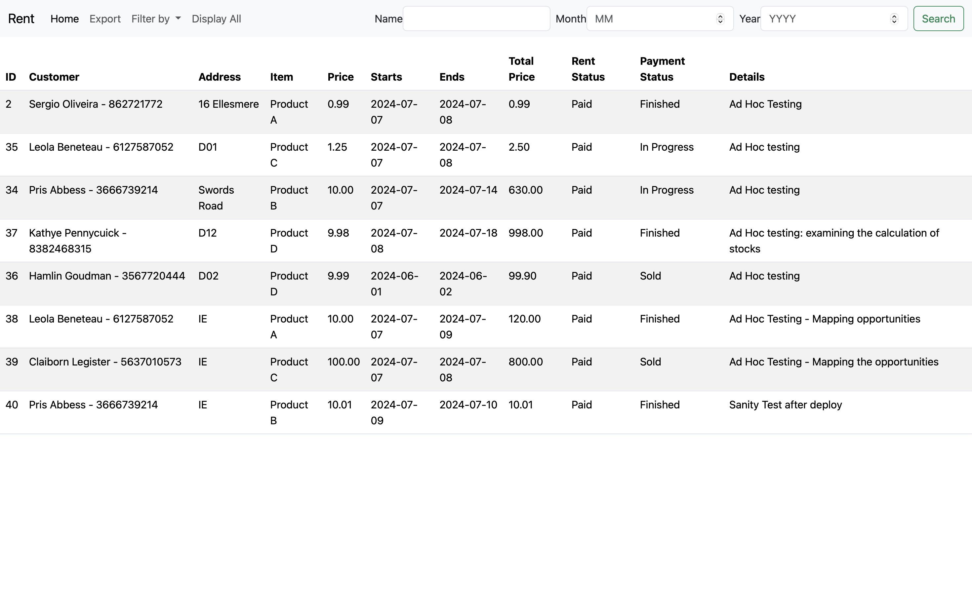

*Figure 2.5.6: Report page.*

**Description and Features**

This page presents a table with the records of rentals and sales made showing all the associated information. The page has filter features that allow the user to select data by period, payment status or related to the rental process, or even by the name of the customer.

### *Expenses*

The expense screen allows the user to keep track of expenses incurred.



*Figure 2.5.7a: Wireframe expenses of expenses page.*

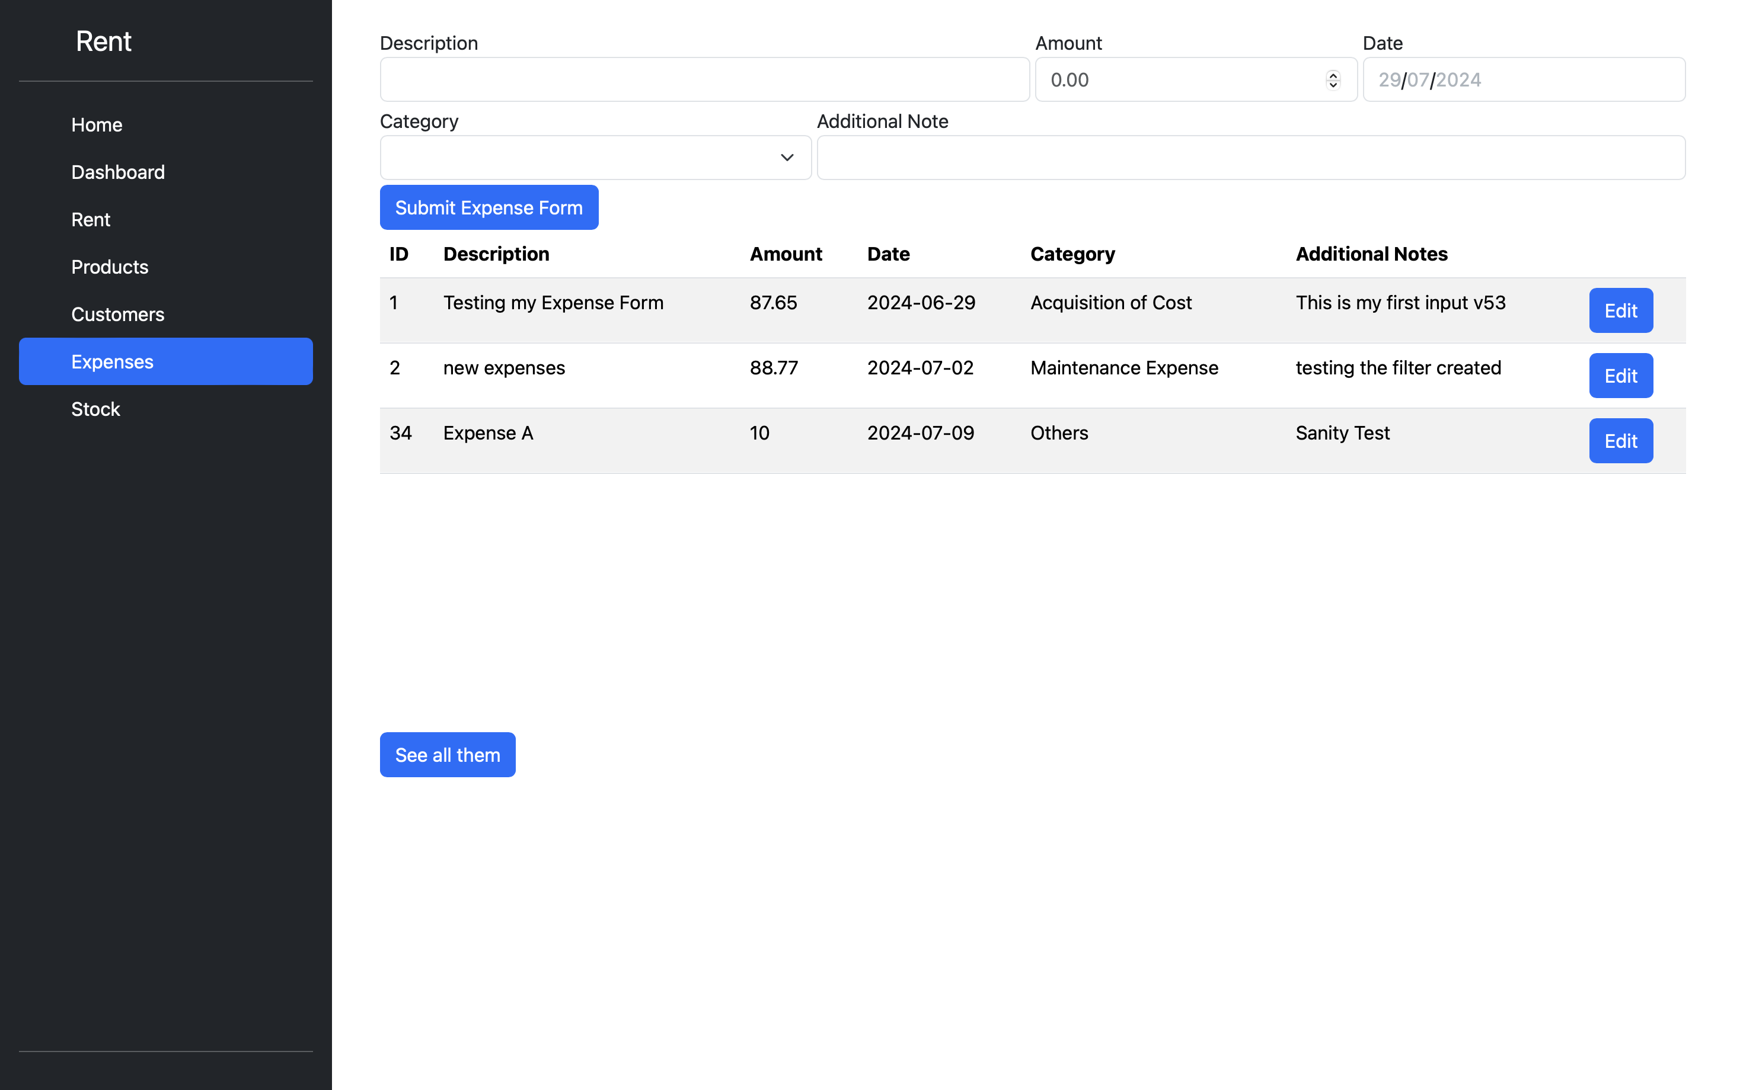

*Figure 2.5.7b: Expenses page.*

**Description and Features**

This page features a form that allows users to record expenses by linking them to the date and type established by the client, as well as facilitating the visualization of the created records. It also includes a side navigation menu for easy access to different sections of the system.

In addition, the user is directed to the reports page by clicking on “see all them” button.

### *Expenses Report*

Users are able to access expense records through the report page.

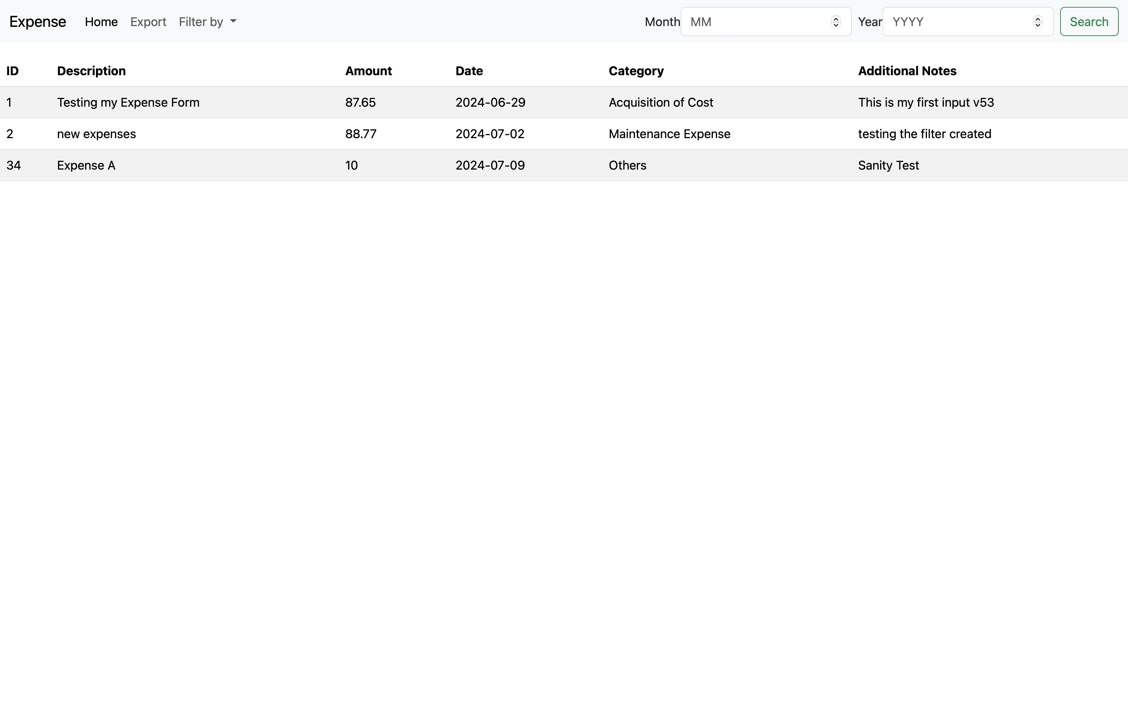

*Figure 2.5.8: Expenses report page.*

**Description and Features**

The records regarding the business expenses can be accessed through this page. The page has filter features that allow the user to select the type or period of the expense.

## Customer testing

To ensure that the AluControl system meets the needs of end users, a comprehensive testing process was conducted with a representative user. The objective of this test was to evaluate how well the system works in a real environment.

### *Staging Process*

A user with a system-relevant profile was involved in the test process and performed typical tasks that AluControl must be able to support. The tasks included:

* Creating and updating customers records.
* Creating and updating products records.
* Create and updating rent and sales records.
* Generation of sales and expense reports.
* Expenses input.
* Navigation and use of user interfaces to ensure a smooth and intuitive experience.

### *Evidence of Test*

The performance and usability of the system were evaluated by collecting both qualitative and quantitative evidence during the testing process. Some of the evidence include:

* **Verbal feedback:** The user gave detailed feedback on their experience, highlighting positive points and areas that need improvement.
* **Activity Logs:** Detailed logs of user activities were analysed to monitor the system behavior in real use situations.

### *Test Result*

The user tests were positive, indicating that the system fulfills expectations in terms of functionality and usability. Here are some points that have been highlighted by users:

* **Easy to use:** The interface was intuitive and easy to navigate, with the instructions being clear and the functionalities organized logically.
* **Performance:** In the performance assessment section, the system demonstrated a response time that was both quick and efficient, with short response times.
* **Functionality:** The tested functions, like customer and inventory management, were successful without any significant errors or failures.

### General User Rating

In terms of satisfaction, the user gave the system a score of average 4 out of 5. Some comments include:

* “The interface is simple and straightforward to use.”
* “Although the features partially met my needs, the overall experience of using was positive”.

### *Conclusion*

The tests with the representative user were fundamental to validate the usability and functionality of the AluControl system. The testing process will result in positive feedback and suggestions for improvements, which will be incorporated into future system releases to ensure an even better experience for future users.

## Evaluation

The AluControl system was evaluated in multiple ways, including performance metrics, scalability tests, correctness verification, and detailed logging for ad hoc and sanity testing. This multidimensional evaluation aimed to ensure that the system not only meets the initial requirements, but also work reliably under various conditions and scales to effectively accommodate future growth.

### *Performance Evaluation*

The performance of AluControl was assessed by conducting load tests and response time analysis in different scenarios. The main metrics that were taken into account were the average response time, throughput, and memory utilization.

To provide a clear and concise summary of the system’s performance, key performance metrics are presented through the following figure 2.7.1.

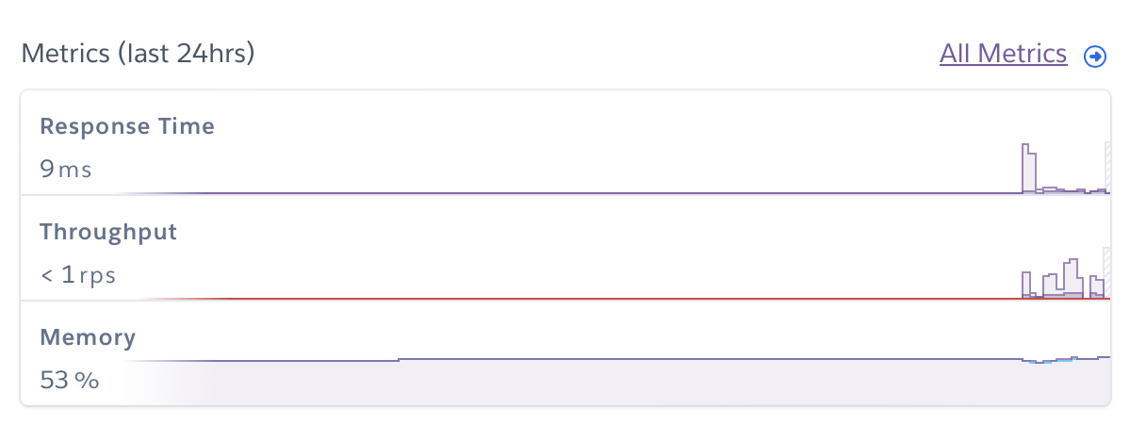

*Figure 2.7.1: Overview Metrics available on Heroku. Evaluation performed on 07/06/2024.*

**Response Time**

Taking a closer look, the average response time revealed the following performance metrics.

* **Median (50th%) Response Time**: 5 ms
* **Minimum (95th%) Response Time**: 8 ms
* **Maximum (99th%) Response Time**: 143 ms
* **Response Time at 95th%**: 9 ms
* **Response Time at 99th%**: 15 ms

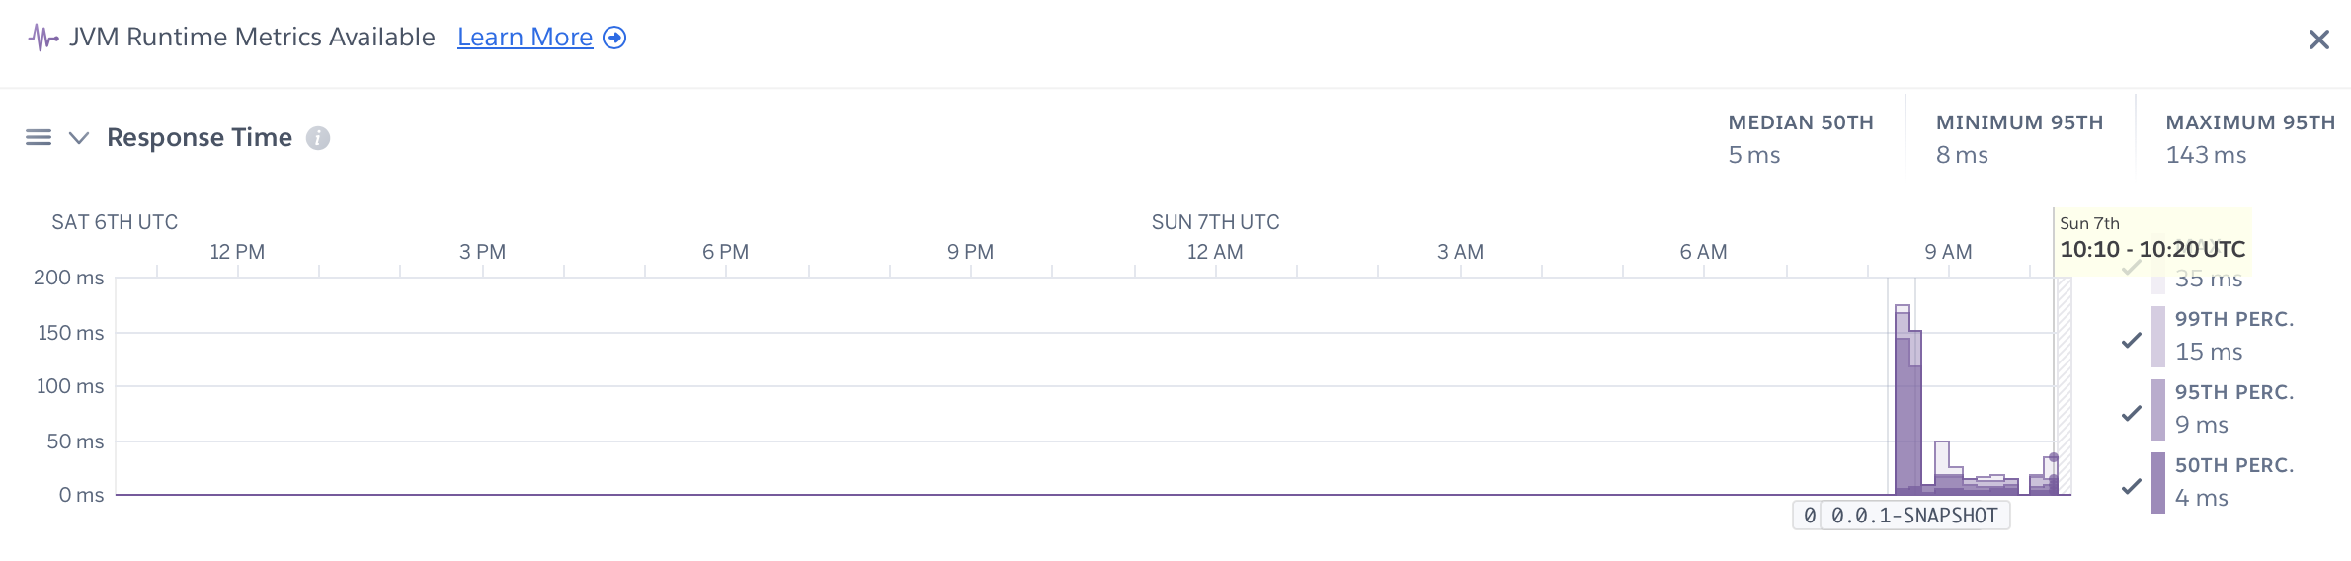

*Figure 2.7.2: Response time of one hour of execution. Evaluation performed on 07/06/2024*

According to these results, the system performs exceptionally well in typical usage scenarios, with most requests being processed in under 15 milliseconds. It is important to monitor the peak maximum response time, although it is an anomaly, to ensure it doesn't have a significant impact on the user experience.

**Throughput**

To understand how many requests the system can process per second under different conditions, the system's throughput rate was measured. The key observations are as follows:

* **Average Throughput**: 1.2 requests per second (rps).
* **Peak Throughput**: A small change has been noticed, but the system consistently maintained around 1 rps under load.

* **Error Rates**: During the test period, there were no 4xx or 5xx errors reported, which shows high reliability in handling requests.

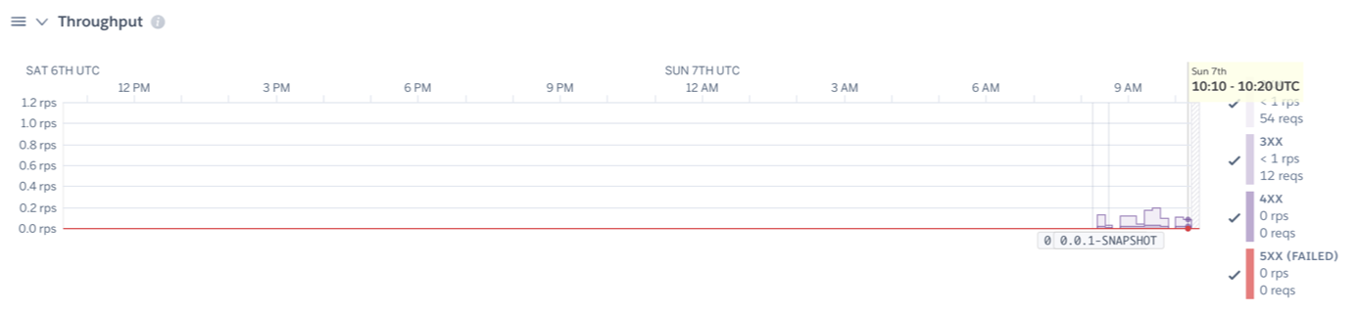

*Figure 2.7.3: Throughput of one hour of execution. Evaluation performed on 07/06/2024*

The throughput results indicate that the system is capable of handling a consistent amount of requests, with reliable performance even during peak times. The absence of failed requests highlights the robustness of the system.

**Memory Usage**

The memory usage analysis (24hrs) provides insight into how the system manages its resources.

* **Average Memory Usage:** 245.3 MB (47.9% of quota)
* **Maximum Memory Usage:** 272.1 MB (53.1% of quota)
* **Latest Memory Usage:** 217.3 MB (42.4% of quota)
* **Memory Quota:** 512 MB
* **Max Swap Usage:** 0 MB
* **Max RSS (Resident Set Size):** 217 MB

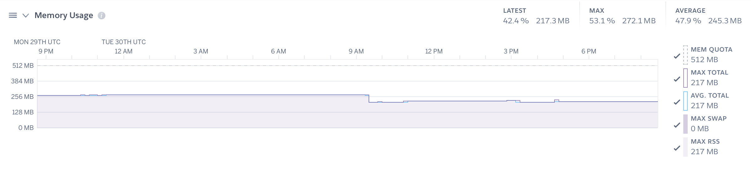

*Figure 2.7.4: Memory Usage. Evaluation performed on 30/07/2024*

The results show that the system utilizes the allocated memory with efficiency, and the average utilization falls within acceptable limits. The absence of swap usage suggests that the system did not experience significant memory pressure during the evaluation period.

### *Testing Coverage and Results*

The testing phase included unit tests, integration tests, ad hoc tests, and sanity tests.

* **Unit Test:** To confirm the functionality of individual components, 10 high-priority unit tests were carried out, each focused on the main methods of the controllers. Mockito was used to simulate dependencies and ensure isolated test conditions. The system use cases were closely linked to these tests to ensure that all core functionalities were fully validated.
* **Integration Tests**: Its purpose is to verify the interaction between various components of the system. Although formal integration tests were limited due to resource constraints, ad hoc tests provided a practical assessment.
* **Ad Hoc Testing:** To identify defects, detailed logs were generated through exploratory tests. This included critical error checking, alerts, informative messages, and general activity logs.
* **Sanity Testing**: Checked that the main functionalities worked as expected after minor changes. This involved creating logs to monitor activities and ensure that no critical issues were introduced.

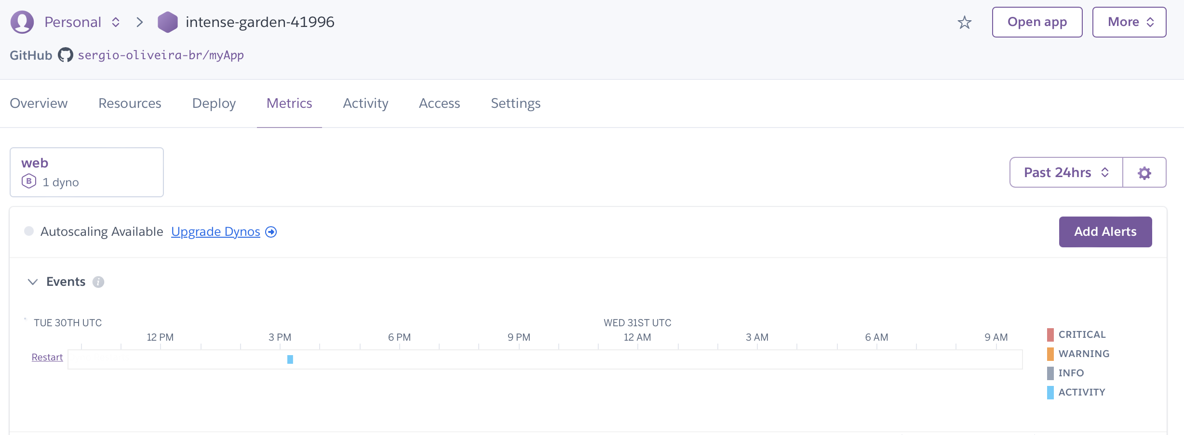

*Figure 2.7.5: Critical error checking. Resource available by Heroku.*

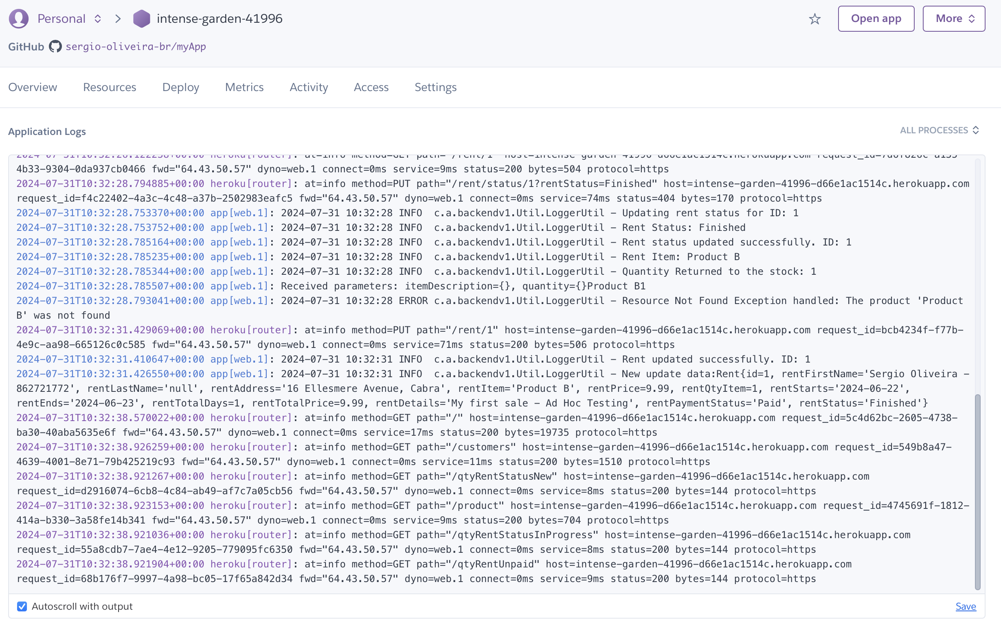

*Figure 2.7.5: General activity logs. Update rent highlighted. Resource available by Heroku.*

# Conclusions

Developing and implementing AluControl is a significant accomplishment in both academic and practical areas. This project, conceived as a final year academic requirement, has expanded beyond its original purpose to become a functional application that is actively used by real-world users. The structured approach to its development, leveraging a three-tier architecture, modern web technologies and robust frameworks, ensured a clear separation of concerns, facilitating the maintenance, scalability and comprehensive robustness of the system.

**Advantages**

* **Modularity and Maintainability:** The three-tier architecture made it possible to distinguish between frontend, backend, and database responsibilities. The flexibility of this modularity enables easier upgrades and maintenance, as changes to one layer have no impact on others.
* **User Experience:** The frontend, which is constructed using HTML, CSS, JavaScript, and is supported by Bootstrap and jQuery, offers an intuitive and responsive user interface that enhances user satisfaction and engagement.
* **Scalability:** The system can efficiently handle load and increasing volumes of data with the use of MySQL and PostgreSQL as well as the robust structure of Spring Boot.
* **Comprehensive Testing:** The application was made reliable and stable by rigorous testing that involved unit, integration, system, ad hoc, and sanity tests. By using Mockito for unit testing and detailed logging for ad-hoc and sanity testing, significant progress could be made in identifying and resolving defects.
* **Real-World Application: The practical application and reliability of the system are demonstrated by the successful deployment of Heroku and active use by real-world users.**

**Disadvantages**

* **Resource Intensive: Integrating multiple technologies and creating separate development and production environments can be resource-intensive, requiring careful management and resource allocation.**

**Opportunities**

* **Feature Expansion:** The robust foundation of the system provides ample opportunities to expand its capabilities, including the addition of advanced reporting tools and integration with other systems.
* **User Personalization:** The current version of AluControl is designed for a single user only. The creation of a multi-user environment with each user having their own dedicated database is a significant opportunity. This customization would improve the user experience and expand the applicability of the system.
* **Wider Deployment:** The ability to scale deployment to a wider user base or different market segments can be achieved by demonstrating proven reliability in real use, potentially turning AluControl into a commercial product.
* **Continuous Improvement:** Continuous improvement is possible with continuous feedback from real users, which ensures that the system evolves to meet user needs and industry standards.

**Limits**

* **Dependency on External Services:** If third-party deployment frameworks and libraries change their terms, become obsolete, or experience downtime, AluControl may face limitations in access or performance.
* **Scalability Constraints: Despite the system being designed for scalability, its actual scalability will be dependent on the available infrastructure and resources. Scaling to a large number of users or dealing with extremely large data sets may present limitations.**

**Final Thoughts**

The effectiveness of theoretical knowledge in a practical environment is demonstrated by the AluControl project. It demonstrates how academic projects can be applied in real-world scenarios, providing tangible benefits and learning opportunities. The extensive approach to development, with a focus on modular architecture, rigorous testing, and real-world deployment, emphasizes the importance of best practices in software engineering. AluControl can stay relevant and valuable in its application domain by continuously improving and expanding features based on user feedback in the future. Developing a multi-user environment with dedicated databases for each user is a promising opportunity to improve the utility and scalability of the system.

# Further development or research

With more resources, where could the results of this project lead to?

# References

It is recommended that students use the APA, Berkeley, Harvard or other internationally approved style. Here is an example of the APA citation style:

Wilcox, R. V. (1991). Shifting roles and synthetic women in Star Trek: The Next Generation. *Studies in Popular Culture, 13*(2), 53-65.

In the text this article can be cited as “Wilcox (1991)” or “(Wilkox, 1991)”.

References to web sites must include the access dates.

The library provides a study guide on Harvard style referencing.

Buschmann, F., Meunier, R., Rohnert, H., Sommerlad, P., & Stal, M. (1996). Pattern-Oriented Software Architecture: A System of Patterns. John Wiley & Sons.

Fowler, M. (2002). Patterns of Enterprise Application Architecture. Addison-Wesley Professional.

Gamma, E., Helm, R., Johnson, R., & Vlissides, J. (1994). Design Patterns: Elements of Reusable Object-Oriented Software. Addison-Wesley.

Geeks for Geeks (2024) *Three-Tier Client Server Architecture in Distributed System.* Available at: <https://www.geeksforgeeks.org/three-tier-client-server-architecture-in-distributed-system/> [Accessed 26 Jul 2024].

Ezaouibi Yassin (2024) *Spring Boot Architecture & Annotations.* Available at: <https://ezaouibiyassin.medium.com/spring-boot-architecture-annotations-e4f5dd5c7a66> [Accessed 26 Jul 2024].

<https://maven.apache.org/plugins/maven-deploy-plugin/>

<https://devcenter.heroku.com/articles/deploying-java-applications-with-the-heroku-maven-plugin>

# Appendix

## Project Proposal

## Project Plan

## Requirement Specification

## Monthly Journal

## Other Material Used

Any other reference material used in the project for example evaluation surveys etc.

CD containing code should be glued to the technical report.